Risk mitigations for UITF irradiation beamline
G. Ciovati, F. Hannon, Xi Li, M. Stutzman, K. Welch

LOSS OF BEAMLINE VACUUM
The highest hazard related to the installation and operation of the electron beam irradiation beamline at UITF is the potential risk for sudden loss of beamline vacuum due to a mechanical or thermal failure of the thin beam exit window installed at the end of the beamline. The main concern is related to the potential for venting of the beamline of the superconducting Quarter Cryomodule (QCM), resulting in a severe degradation of the QCM performance in terms of its ability to accelerate beam. Whereas the risk for a sudden loss of vacuum is present for the operation of any accelerator, and it is addressed in the UITF Operations Directives, the installation of a relatively wide, thin beam exit window increases this risk and requires further mitigation, which is described in this technical note.
Finite-Element Analysis of the beam exit window
A commercial window-flange assembly designed to operate with a 1 atm differential pressure was selected from Atlas Technologies, WA: https://www.atlasuhv.com/products/aluminum-titanium-flanges/foil-window-flange/
The window foil is made of Grade 2 Titanium, 0.005” thick. The foil is held in place by a Cu gasket pressed by a 4.5” Conflat flange. The mechanical stability of the foil was simulated with the finite-element analysis engineering software ANSYS with the following material parameters at ambient conditions for Grade 2 annealed Ti (http://www.matweb.com/search/DataSheet.aspx?MatGUID=49a4b764217b44ee953205822af5fbc9&ckck=1 ): yield strength = 340 MPa, ultimate tensile strength = 430 MPa, Young’s modulus = 102 MPa, Poisson’s ratio = 0.34, thermal conductivity = 16.4 W/(m*K). The tensile properties were entered as a “Bi-linear stress-strain curve” in the material properties. The foil was meshed with SHELL131 elements with much finer mesh near the edge and at the center of the foil. Figure 1 shows the geometry used for the analysis. Symmetry allowed simulation of only one quarter of the full geometry. The edge of the foil has a “bonded contact” with the Stainless Steel support ring, and a “frictionless contact” was considered between the foil and the support ring.
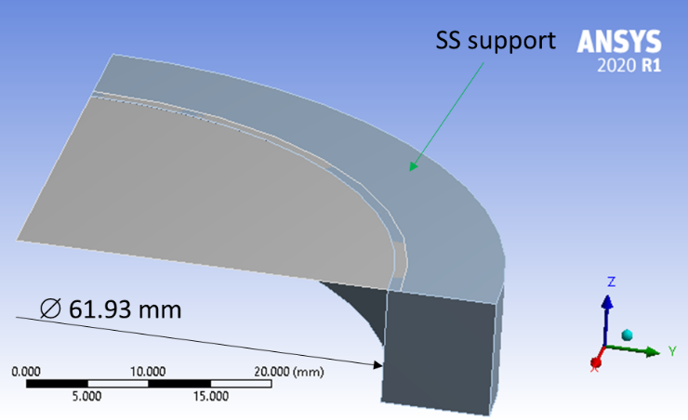
Figure 1: Geometry used for the structural and thermal analysis of the Ti window foil.

Figure 2 shows the deformation resulting from a 1 atm pressure differential, whereas the equivalent von Mises stress is shown in Figure 3. A maximum deformation of ~1.3 mm at the center of the foil and a maximum stress of ~345 MPa at the edge of the support ring resulted from the analysis. These values indicate that the foil should be able to withstand the 1 atm differential pressure without rupture.
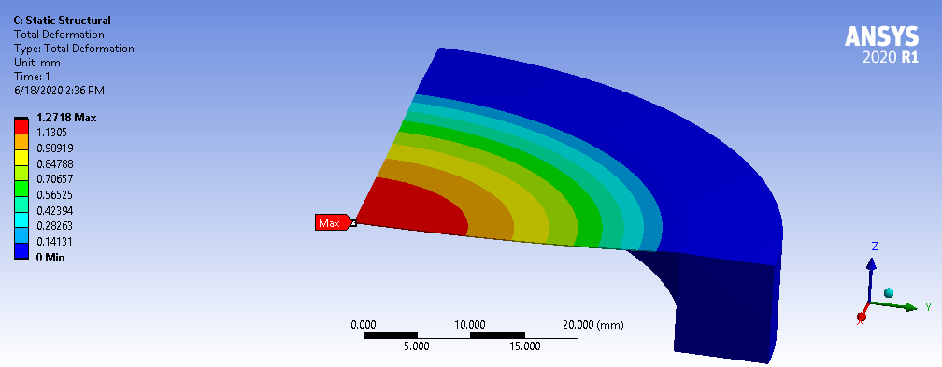
Figure 2: Total deformation of the window foil due to a 1 atm pressure applied on the top side.

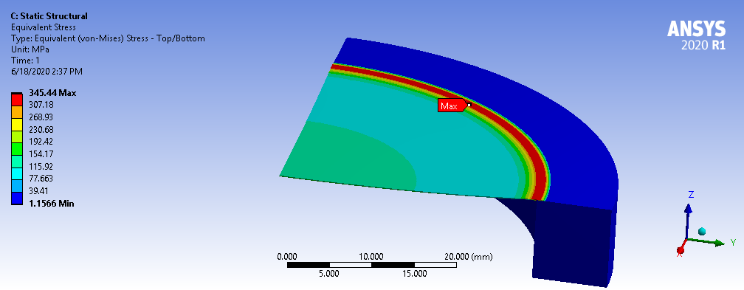
Figure 3: Equivalent stress in the window foil due to a 1 atm pressure applied on the top side.

A thermal analysis was also done using ANSYS to determine under which conditions the peak temperature of the center foil would become close to the melting temperature of Ti (1668 °C). An analysis with the Monte-Carlo simulator FLUKA was done to determine the fraction of beam power dissipated in the Ti foil for an impinging Gaussian beam of electrons at 8 MeV and resulted in 7.48e-5 W/nA. At the nominal beam current of 100 nA, the dissipated power density over one sigma is ~3 mW/cm², which results in a negligible temperature rise, given the thermal conductivity of Ti and a natural convection coefficient of air of 5 W/(m²*K).
A solenoid with a nominal field strength of 2200 G is placed ~5 m from the window to defocus the beam. However, simulation of the beam trajectory with General Particle Tracer showed that if the solenoid field is set by mistake to 1157.5 G the beam would actually be tightly focused (sigma ~66 μm) at the window. Even in such conditions, the peak temperature rise at the window would be <3 °C. The peak temperature could be significantly higher at higher beam current. For example, a peak temperature of ~200 °C would result from a beam current of 5-30 μA for a beam sigma of 0.066-9.1 mm, respectively. A peak temperature exceeding the melting point of Ti could result from the concurrence of two faulty conditions: the magnetic field of the solenoid was set to the value resulting in the most focused beam at the window and the beam current was set to ~40 μA. The beam current will be restricted in the EPICS control software at UITF such that a value greater than the nominal current of 100 nA could not be set. The chances of the two fault-modes described above to occur simultaneously are extremely small and can be further mitigated by setting HIHI and LOLO values in EPICS for the solenoid to disallow unwanted magnet settings.
The peak temperature of the window can be estimated with the following formula [1]:
$T_{max}=\frac{P_{loss}}{2πh_{air}}\int_{0}^{∞}{\frac{k t β+tanh\left(k t\right)k}{k t β+ {\left(k t β\right)}^{2}tanh\left(k t\right)}e^{{-k^{2}σ^{2}}/2}dk}+ T_{0}$ (1)
where β = κ/(t*h_{air}) = 2.583e4, t = 0.127 mm is the window thickness, κ = 16.4 W/(m*K) is the thermal conductivity of Ti, h_{air} = 5 W/(m²*K) is the natural convection coefficient of air, T₀ = 22 °C is the ambient temperature and P_{loss} is the fraction of beam power dissipated in the window.
A plot of the peak temperature at the window as a function of beam current at 8 MeV for the nominal sigma of the beam of 9.1 mm and for the smallest possible value of sigma is shown in Fig. 4. The symbols are the results of the FEA analysis with ANSYS.
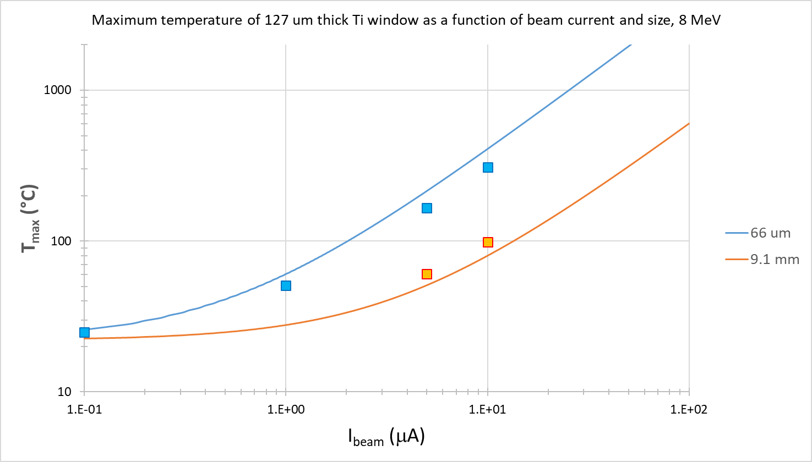
Figure 4: Peak temperature at the Ti window as a function of beam current for 8 MeV electron beam with a Gaussian distribution with nominal (9.1 mm) and smallest (0.066 mm) values of sigma. The solid curves are obtained from Eq. (1), the symbols are obtained from ANSYS.
Fast-closing UHV valve
An engineering control to protect the SRF QCM in the UITF from an inrush of air resulting from an accidental loss of beamline vacuum is the installation of a fast-valve. There is one gate valve on the market (http://www.vatvalve.com/en/business/valves/catalog/F/752_1_V) with a specified closing time of < 10 ms and it has been used at many accelerator facilities throughout the world, including CEBAF.
Detailed studies have been done at CERN to determine the speed of a pressure wave resulting from the loss of vacuum due to rupture of an aluminum window foil and to measure the closing time of the fast-valve [2, 3]. The main results can be summarized as follows:
- The propagation speed of the pressure front increases with the ratio of the square roots of hole surface and cross section of the tube
- The maximum speed of the pressure front was measured to be (879 +/- 12) m/s
- The closing time of the fast-valve was measured to be 8.5 ms after rupture of the aluminum window foil
- Despite closure of the valve, the pressure on the backside of the valve increased from ~1e-5 to ~1e-2 mbar. It is possible that a small fraction of air molecules may have significantly higher speed than the main pressure front and pass through the valve before it closes. However, tests indicated that non-gaseous particles have very little chance of passing through the valve before it closed.
It is proposed to install the fast-valve after the differential pumping (DP) stations downstream of the QCM (shown in Fig. 5). This location would make the installation easiest and reducing the risk of particulate contamination near the QCM. An additional benefit of this location is that a small pressure rise from some of the gas going through the valve before it closes could be damp by the DP stations before reaching the QCM.
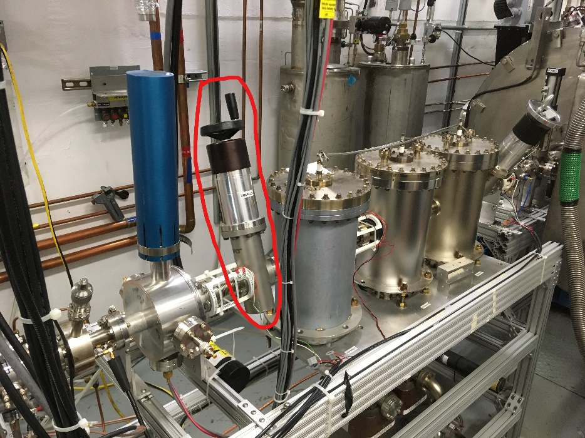
Figure 5: Proposed location for the installation of the fast-valve highlighted in red.
The distance between the fast-valve and the exit window is 12.4 m and the pressure gauge used to trigger the valve’s closure is at ~0.2 m from the exit window. In the worst case of complete rupture of the window, the travel time of the pressure front to the fast-valve location is 12.4/879 = 14 ms, longer than the fast-valve closing time.
As an additional measure to slow the pressure front, an orifice (Cu gasket with 16 mm diameter hole) will be placed at the connection between the tube section with 4.5” Conflat flanges and the tube section with 2.75” Conflat flanges.
The following additional measures will be in place to minimize the probability of accidental beamline venting:
- A polyethylene cap will be used to cover the window when irradiation experiments are not running, to prevent accidental hitting of the window foil.
- A pneumatic valve ~5 m from the window will be used to continuously isolate the irradiation beamline section from the rest of the UITF beamline and will be opened only for the irradiation experiments
- A beam current interlock from the beam current monitor cavity downstream of the QCM will be active to limit the maximum beam current to 100 nA.
OZONE PRODUCTION
The electron beam will travel through the air gap between the Ti window and the sample holders, resulting in the production of ozone. The distance between the Ti window and the stainless steel cover of the sample holder is set to be 1.70” (4.3 cm). The ozone concentration by weight can be calculated using the following equation [4]:
Ozone conc. = 1.24 × 10⁻⁶ P_{air} (W)/F (m³/min) (2)
where P_{air} is the beam power loss in air and F is the air exhaust rate, which is 11800 CFM in the UITF. The beam power loss in air can be calculated as:
P_{air} = LET*ρ*d*I_{beam} (3)
where LET is the total stopping power (also called “linear energy transfer”) for air, ρ = 1.2 kg/m³ is the density of air at 20 °C, 1 atm, d is the distance the beam travels in air and I_{beam} is the beam current. LET for 8 MeV electrons in air is 2.07 MeV cm²/g [5]. For d = 4.3 cm and I_{beam} = 100 nA, the power deposited by the beam in the air space is ~1 mW. The ozone concentration calculated with Eq. (2) is 0.004 ppb, well below the human threshold limit value (TLV) set by OSHA to be 100 ppb.
The ozone production rate can be calculated as:
Ozone prod. rate (kg/h) = 8.95 × 10⁻⁵ P_{air} (W) (4)
therefore the quantity of ozone produced per sample at the highest dose of 20 kGy would be ~54 μg.

REFERENCES
[1] A. Gurevich and G. Ciovati, Phys. Rev. B 87, 054502 (2013).
[2] M. Ady, M. Hermann, R. Kersevan, G. Vandoni and D. Ziemianski, “Leak propagation dynamics for the HIE-ISOLDE superconducting Linac”, in Proc. of IPAC2014, Dresden, Germany, 2014.
[3] M. Ady, “Measurement campaign of 21–25 July 2014 for evaluation of the HIE-ISOLDE inrush protection system”, CERN Technical Note TE-VSC-1414574, CERN, Switzerland (2014)
[4] M. R. Cleland and R. A. Galloway, Physics Procedia 66, pp. 586 – 594, (2015).
[5] M.J. Berge et al., Stopping-Power & Range Tables for Electrons, Protons, and Helium Ions, NIST Standard Reference Database 124, July 2017. https://www.nist.gov/pml/stopping-power-range-tables-electrons-protons-and-helium-ions

