**ISOTOPE PRODUCTION May 1-7 RUN**

May 17, 2017

***Introduction***

67Cu is a promising therapeutic isotope for a number of cancers including non-Hodgkin's lymphoma, Hodgkin's lymphoma, acute myelogenous leukemia, and acute lymphocytic leukemia. Jefferson Lab has fielded proposal to produce this isotope at LERF by means of photo-nuclear mechanism using a 50 kW electron beam and a gallium target.

That the CEBAF accelerator was at 4K provided an opportunity to conduct a test to produce 67Cu using a gallium target. The successful set up of the CEBAF Injector at 4K made the test possible. Beam line modifications were modest as mentioned below. New diagnostics (BPM and Harp) in front of the isotope target were calibrated against existing diagnostics in the beam line. (The existing diagnostics were downstream of the target which intercepted all of the beam)

***Goals of the Run***

The run had two goals

1. Produce ~ 0.5 mCurie of Cu-67 using 18.65 MeV, 50 μA (~1kW) electron beam irradiating 100 gms of gallium encased in a Boron Nitride crucible
2. Chemically separate Cu-67 from the gallium target at VCU

Two implied and essential conditions were to ensure personnel safety and machine safety (CEBAF injector where this test was done).

***Location of the run and modifications to the beam line***

Injector’s 4D line was the location of the experiment. The beam line modifications were:

1. Remove part of the beam line (~1 m) to install the experiment
2. Install a Be window
3. Install a Beam position Monitor (BPM) to monitor the beam position
4. Install a harp to measure the beam profile
5. Remove radiation sensitive camera near the dump
6. Relocate the Beam Loss Monitor (BLM) in the dump to slightly upstream of the experimental target to protect the beam line

***Experiment Setup***

Figure below is the experiment set up. A copper base holds the Boron Nitride (BN) crucible. Two copper plates (one on each side of the crucible and a plunger at the beam exit end of the crucible) hold the BN crucible in place by means of pneumatic controls. The design follows ALARA principles in that the pneumatics are engaged (to keep the BN crucible in good thermal contact with the cooling plates) and disengaged (for quick target retrieval) from a distance from the target set up.

At 50 μA, the Be window absorbs only ~6 W of beam power. However, in order to ensure the beam line integrity, the Be window was cooled by jet of instrumentation air. Additionally, a software alarm is set to warn of any loss of vacuum integrity due to Be window flange heating.

As mentioned earlier, the BLM in the dump was relocated to slightly upstream of the target in order to protect the beam line in case of excessive beam excursions.

The target was aligned and the alignment verified using beam hitting chromox films. (The tungsten radiator and the BN crucible were removed for this step). Once the target was known to be aligned, the chromox films were removed and the radiator and BN crucible were installed.

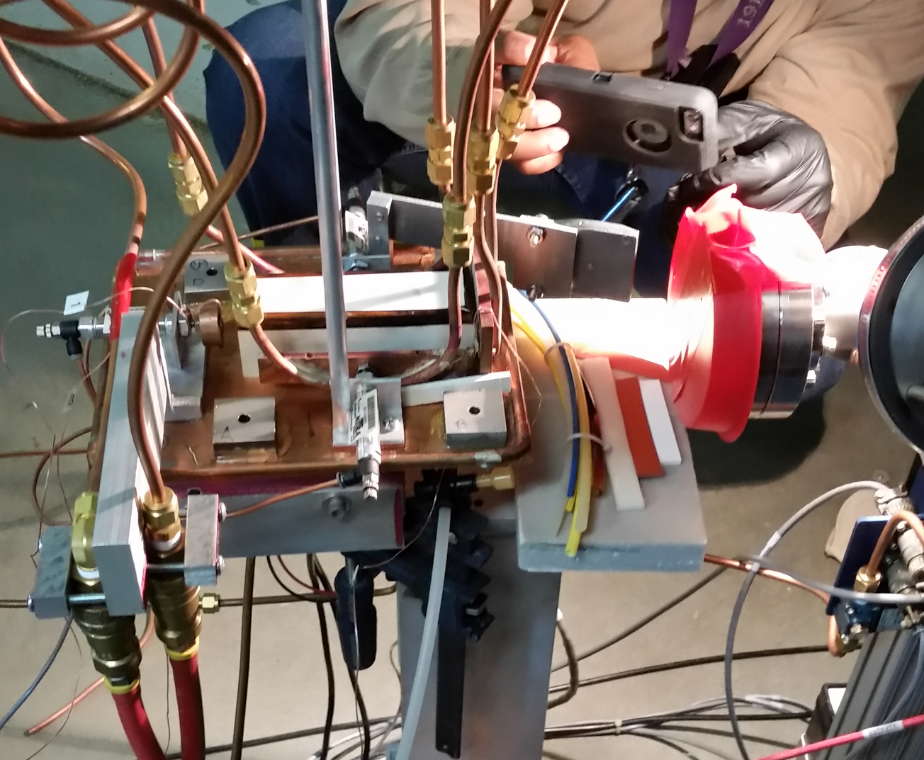

Boron Nitride crucible with 100 gms of gallium target

Tungsten Radiator (1 mm) attached to copper cooling plate

Copper Base

Copper Plates with Cooling Coils

(1 mm)

Electron Beam Direction

Beryllium Window

(0.4 mm)

***Planned and Executed Schedules***

***Planned***

1. Beam set up May 2 – 3
2. Installation May 3 – 4
3. Run May 5 – 7 (extended to May 8)
4. Sample Shipped/Delivered to VCU – May 9/10

***Executed***

1. Beam set up completed – May 3
2. Installation completed – May 4
3. Beginning/End of run – May 4/May 6
4. Sample Shipped/Delivered to VCU – May 8/10

***Results***

To reiterate, the goals were

1. Produce ~ 0.5 mCurie of 67Cu using 18.65 MeV, 50 μA (~1kW) electron beam irradiating 100 gms of gallium encased in a Boron Nitride crucible
2. Chemically separate 67Cu from the gallium target at VCU

Results were

1. Produced ~70 μCuries of 67Cu
2. No chemical separation could be done at VCU

The two implied and essential conditions to ensure personnel safety and machine safety were successful with the exception that two pieces of equipment in that area were damaged. These were replaced.

***Lessons Learned***

The retrospective on the experiment focused on the following categories

1. Planning
2. Review Process
3. Risk Assessment
4. Skills mix (technical, procedural, operational,..)
5. Safety
6. Documentation
7. Communications

***Planning***

This was opportunistic test and the lead time was short as was the window of opportunity. It is difficult to anticipate the arising of opportunity and plan.

* There was very little formal planning
* Informal planning occurred at 7:45 AM prior to the 8 AM Program Deputy meeting
* If the planning meetings occurred after the 8 AM PD meeting, there would have been more input to the experiment.
* Even with this short time to execute, proper procedures were followed: the DOE site office was made aware of the experiment and the experiment was cleared by Oak Ridge Office. A number of individuals contributed to obtaining the needed permissions.
* .Is it worth investigating and creating a library of potential experiments, planned and prioritized for opportunistic running?

***Review Process***

* There was a formal review
* The mix of reviewers was good. It included representatives from Physics Division, Operations, Engineering and Radcon.
* The recommendations from the reviewers were specific and helpful
* Suggestions of the review committee were followed
* There was an SCMB review
* Safety of CEBAF machine was thoroughly reviewed
* Experiment was reviewed less thoroughly than the safety of the machine
* No Experimental Readiness Review (ERR) occurred
* Threshold size of experiment for the ERR needs to be determined. One suggestion was any ATLis plan that goes beyond base equipment may warrant an ERR
* Another suggestion is to conduct a Technical Advisory Committee (TAC) type review
* A recommendation is to find the process in place at BNL for small experiments of this type.
* for opportunistic running?

***Risk Assessment***

* There was no formal risk assessment
* The risk assessment, even if informal, paid much attention to machine and personnel safety
* Experiment would have benefited from developing a risk matrix, consequences and mitigations
* Should the reviewers be charged with raising questions regarding risks?
* The experimenters might have responded well to reviewers but might not have been diligent in heeding input from outsiders

***Skills Mix***

* The right skills were brought into the experiment
* Operational Support was good
* Beam set up at 4K including calibration of newly installed diagnostic equipment with the existing equipment in the beam line went very well
* Experiment installation, alignment without and with beam had the right people to execute and was successful
* Temporary Operational Safety Procedure (TOPS) and Task Hazard Analysis (THA) were done by safety professional
* Radcon and Industrial hygiene personnel were included in the retrieval, packaging and shipment of the irradiated sample
* ATLis containing the test plan was being revised during the experiment. Suggestion is to have a person who is well acquainted with generating ATLis (such as an operator) participate in developing the test plan
* Having regular meetings after the 8 AM PD meeting would have brought in more expert help.

***Safety***

* RWP, TOSP and THA were reviewed prior to the experiment
* SCMB has reviewed the safety of the experiment
* No personnel were hurt
* Target retrieval was rehearsed
* The gallium in the BN crucible should have been grounded (BN is an electrical insulator)
* Some instrumentation near the target area sustained radiation damage. Dose rate calculation should be part of experiment planning
* Shipment should include appropriate labels
* The shipment should include the activity and dose rate document
* Dry run of un-irradiated gallium to VCU’s RSO would have helped prevent the spill at VCU
* Clear instructions to the VCU’s Radiation Safety Officer on opening the container should have been included in the package. Should include VCU’s RSO in future shipment process
* Should acquire a DOT Type A container for shipment
* Should assume that the person opening the package knows nothing about what's in it, and that they will assume they can open any openable container in the package unless there are instructions telling them otherwise.

***Documentation***

* There were check lists for installation and target retrieval process
* The documentation was mostly complete with the exception of formal risk analysis
* No Engineering drawings of the experiment were drawn
* ATLis entries were being updated the day of the experiment. This should have occurred earlier
* Responses from reviewers could use more time
* ATLis author needs to have better knowledge of operations
* Documentation should be such that a different group of experimenters can successfully stage the experiment
* A mailing list of people to notify all concerned with any change of plans would be useful

***Conclusion***

***Production part of the experiment***

While all the factors listed above, if adequately resolved, would have helped in conducting the experiment, a key factor led to the less than expected success of the experiment. This is the failure of the pneumatic mechanism due to radiation damage to its power supply. This led to the BN crucible not making a contact with the copper plates on the sides of the crucible and also on the front face where the beam entered the radiator. It is quite probable that the experiment could have continued if the thermometry which monitored the temperature of the tungsten radiator, BN crucible and the cooling water temperature was functioning. Losing the first two and not having confidence in the understanding of the readings of the third necessitated the termination of the experiment. Redundant monitoring systems, even in case of the failed pneumatic controls, would have allowed continuation of the experiment to its conclusion.

***Chemical Separation at VCB***

Regardless of the first part of the experiment, the chemical separation part of the experiment would have failed. The key contributor is the failure to include VCU’s RSO in establishing the packaging and shipment protocols.

Attachment 1: Isotope Run Readiness Review – Response

Attachment2: Additional response

# [Isotope Run Readiness Review](https://www.jlab.org/indico/event/212/)

Steve Suhring (chair), Matthew Bickley, Harry Fanning, Robert May, Ken Baggett, Greg Smith, Brian Freeman, Keith Welch

Friday, 14 April 2017 from **09:00** to **12:00** (US/Eastern)   
at **MCC Conference Room**

**https://www.jlab.org/indico/event/212/**

**Charge and Comments**

In support of a pending DOE proposal the proponents desire to expose a Ga target located on the 123 MeV spectrometer line in CEBAF. Beam operations for this exposure are relatively brief, on order of a day or two, but the conditions are quite off-normal. The special conditions include but are not limited to: SRF operation at 4 K, material handling of the exposed material, and shipping the exposed material off-site.

This short beam run will be executed as a Beam Test plan which is captured in the ATLis tool (*ATLis number here*). Nominal Beam Test plans use the AOD umbrella to define roles and responsibilities, conduct of operations and emergency response. This beam run is sufficiently off-normal to require a detailed review of ATLis and run plan.

The purpose of this review is to evaluate the plans for this test in terms of compliance with the Accelerator Safety Envelope (ASE), Final Safety Assessment Document (FSAD), Accelerator Operations Directives (AOD) and Environmental Assessment (EA).

The review committee is requested to review the integration of the various components based on the material prepared and presented. In addition to making comments and recommendations on this broad view, the committee should address the following charge questions:

* **Is the run plan sufficiently detailed for effective operations?**

*No run plan was presented.*

*It was made clear to the Isotope Test Team that a detailed plan would be required, and approval needed before the run could start.*

*New alarms must be created for some elements of the 4D beamline. Guidance for the alarms should be reviewed by operations before the start of the experiment.*

AI 1.1) Develop and submit the ATLis test plan using standard CEBAF protocol.

* ***An ATLis test plan, #17308 is in the system.***

AI 1.2) Develop a TOSP/OSP to be included as an attachment to the ATLis plan.

* ***TOSP # xxxx is in preparation***

AI 1.3) Provide a detailed run plan, either in the body of the ATLis or as an attachment.

* ***ATLis #17308 contains a detailed run plan including actions to be taken in case of any ambiguities during the run***

AI 1.4) Document specific roles in the run plan document: Principal Investigator, CASA APEL, OPS liaison.

* ***ATLis #17308 contains the roles and the responsibilities in the run plan. They are stated here for convenience***
  + ***Principal Investigator – George Kharashvili***
  + ***Co-Principal Investigators – Kevin Jordan, Pavel Degtiarenko, Hari Areti***
  + ***CASA APEL –Yves Roblin***
  + ***Ops Liaison – Michael McCaughan***
  + ***Installation, Interface to Control Software Group – Joe Gubeli***
  + ***4KSetup and Diagnostic Calibration – Joe Grames, Grigory Eremeev, Yves Roblin, Reza Kazimi, George Khrashvili, Hari Areti***

AI 1.5) Provide and implement a MPS plan to protect the beamline leading up to the Tungsten target.

* ***ATLis #17308 contains the plan and it is restated here for convenience. There are two instances from which the beamline needs protection***
  + ***The beam line past the spectrometer magnet must be protected from beam hitting any part of the beamline. The beam line is protected by an Machine Protection System (MPS) beam loss monitor (BLM) which is placed near the isotope target. Its placement is guided by the simulations performed by George Kharashvili. Since back scatter from the target can set off the BLM, the BLM is shielded by lead block. Prior to going to CW mode, the functioning of the BLM and its sensitivity will be set as follows***
    - ***Tune mode beam will be steered on purpose to hit the beam pipe.***
    - ***It will be verified that the BLM will register a signal.***
    - ***If there is no signal discernable over the background, the BLM sensitivity will be raised (Higher Voltage)***
    - ***This will be the setting of the BLM***

Approximate Location of BLM

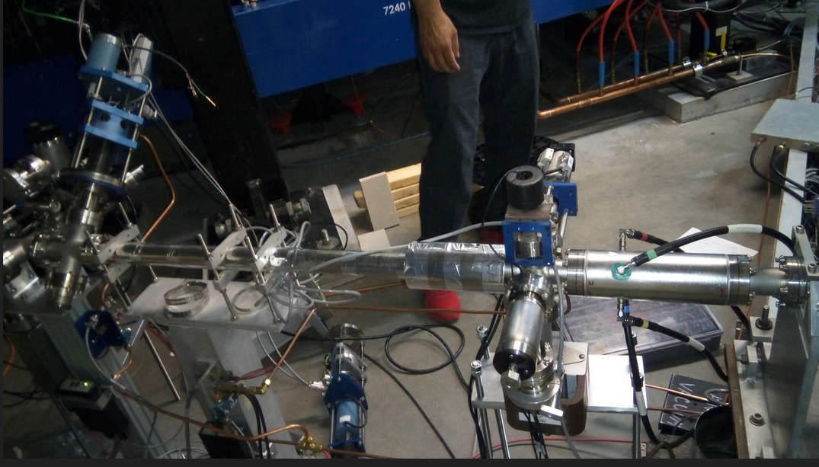

***Safety Systems Group will critique these steps and integrate the BLM into the MPS System***

* + ***The Beryllium window will intercept 7W of beam power. The increase in flange temperature may compromise beam line vacuum.*** 
    - ***Calculations indicate that an air flow of 2m/s will hold the flange temperature to 600C. This can be accomplished by blowing instrumentation air on the flange (Help from Steve Suhring)***
    - ***An alarm will be set to go off on vacuum excursions and the beam will be terminated***

AI 1.6) Verify that all of the operational elements are in place prior to start of the experiment (new screens available and usage communicated with operations, CED updated to reflect equipment, signals archived, etc.).

* ***Yes. Joe Gubeli is the lead. The Ops Liaison Mike Mccaughan has been briefed on the new elements in the beam line. We will work with him in preparing the screens for operations.***

AI1.7) Ensure up to date on-call support lists and principles are made aware of the run.

* ***Will do so by working with the PD and Paul Vasilauskis***

AI 1.8) Develop experiment specific alarms (temperature, flow, beam position, etc.) and provide appropriate response guidance to Operations

* ***ATLis #17308 contains this information and is reproduced here for convenience.***
  + ***4-D beamline protection is the highest priority. Followed by running the experiment safely.***
    - ***Alarm - Flange temperature monitored by vacuum excursion***
      * ***Action – Terminate beam operations, inform the PD, PI and Operability Manager***
    - ***Alarm - Radiator/Target temperature greater than ??***
      * ***Action – Terminate beam operations, inform the PD, PI and Operability Manager***

AI 1.9) Perform Hot Checkout prior to running.

* ***This will be done on Tuesday May 2 after the beamline installation is completed.***

AI 1.10) Determine appropriate lock configurations and test the locks before the installation of the target and target holder.

* ***Energy and position locks***
* **Is operation of SRF at 4 K sufficiently routine for Operations staff? If not are plans in place to train or supplement with experts during beam operations?**

*Operation at 4K has been demonstrated and no additional training for Operations is anticipated. Supporting ATLis documentation links are provided at the end of this report.*

*Expert EESRF support may be needed as zones are initially brought up to RF ON****.***

* **Is the material handling plan appropriate and adhere to ALARA principals?**

*Yes. Model calculations show that the activation should decay quickly and will be contained in a small area of the injector (4D dump). Expectations for the full target assembly are 100mrem/h at 30 cm after 24 hours. Target only, 2.4mrem/h after 24 hours.*

*If radiation levels were underestimated, the area around the will be roped off per normal Radcon procedures.*

*A spill plan was discussed with a recommendation to pre-stage appropriate absorbent materials. Clean up materials are to be identified and evaluated in coordination with Jennifer Williams at EHS&Q.*

*The gallium will be handled using a long handled clamp to provide distance (ALARA).*

*Packing and shipping requirements are well understood and will be handled by Shipping and Receiving with Radcon and ESH support.*

*VCU to handle final disposal of material.*

*The copper base plate will be stored in the tunnel in a designated RADCON area and wait for radiation levels to decay to a safe state.*

AI 3.1) Develop a spill plan and prepare needed materials and procedures.

***ATLis #17308 contains this information and is reproduced here for convenience.***

* ***If for any reason, the Boron Nitride capsule with target materil allows gallium to leak out, gallium will be contained within the copper base plate since the total amount of gallium is less than 100 gms (<20 cc)***
* ***A camera system on the target will show the breach. At this time, the experiment will be halted. The PI, PD, Operability Manager and Jennifer Williams will be notified. Any cleanup operations will be directed by Jennifer Williams***
* ***Once the radcon allows access to the target area, the entire target system will be removed from the beam line and stored in the tunnel. That area will be roped off with standard radiation posting***
* **Is the material handling plan appropriate and adhere to JLab environmental requirements?**

*The plan, as discussed in the review, is appropriate, but at the time of the review the supporting documentation was not available.*

*Radcon participants consider the shipping of the irradiated sample to be part of the routine responsibilities of their group. This instance poses no new hazards or handling problems.*

*Post-review, the following email correspondence was provided by B. Rainey:*

An email “from Jim Elmore confirms that DOE will not require additional NEPA evaluation for the Gallium experiment; unless some aspect of the experiment changes dramatically.”

AI 4.1) Develop and document the material handling plan.

***ATLis #17308 contains this information and is reproduced here for convenience.***

* ***After installation of the target system in the beamline and prior to beam operations, there will be a rehearsal of target retrieval. Here are the steps to follow.***
  + ***Prior to the experiment, designate an area in the tunnel to store the target system with appropriate boundaries established and signage.***
  + ***Gather the tools or have them ready in the MCC control room. These tools are:***
    - ***Long handled retrieval tool***
    - ***Padded container to hold the Boron Nitride capsule***
    - ***Shielded box to place the padded Boron Nitride capsule***
  + ***Procedure:***
    - ***Once radiation survey allows access, enter the target area with the tools***
    - ***Disengage the pneumatic restraints on the target***
    - ***Retrieve the target and place it in the padded container***
    - ***Place the container at a distance from the area where people are working***
    - ***Retrieve the entire target system***
    - ***Place it in the designated storage area***
    - ***Place the target container in a shielded box***
    - ***Hand the shielded box to radcon and ES&H for shipping to VCU***

**5.a. Are special emergency response guidelines needed for this beam run? If so are the plans to train Operation staff on these new guidelines adequate?**

**5.b. Does the presence of the activated target require a change in existing emergency response procedures? If yes, are the changes adequate and plans to train appropriate staff in place?**

**5.c. Are there special emergency response procedures and training required for possible mishandling of the activated target? If yes, are the procedures adequate and plans to train appropriate staff in place?**

*No changes to the standard emergency response are needed.*

*In the event of a safety emergency, standard JLab emergency response protocol will be followed and is sufficient for this experiment. No additional training is required.*

*The failure of a component necessary for the experiment should not be considered an emergency, but should be viewed as machine downtime and dealt with using standard JLab practices.*

*If there is a catastrophic failure and loss of the target material, the Radcon group will determine if access for cleanup (and other work) can be done within ALARA guidelines. A special meeting of the Jefferson Lab Radiation Review Panel (JRRP) may need to be convened to review the RWP and projected exposure. None of this would be done under a time constraint.*

*Discussion regarding these and other operational issues seemed to point to the need for a general “plan” that does not appear to be formalized in any document. The ATLis Test Plan and RWP were discussed as appropriate places to include these items. See AI 1.1)*

*A TOSP/OSP to describe the specific plans and procedures for lines of responsibility, material handling, responses to any foreseeable off-normal events, call-in lists, etc., is recommended. The OSP development process provides for a useful “checklist” to help ensure that all necessary issues are addressed. See AI 1.2)*

AI 5.1) Develop and submit an RWP for this test. The RWP should be attached to the ATLis.

* ***An RWP will be attached to the ATLis***

1. **Are the roles and responsibilities of the JLab staff, Accelerator, Engineering and EHS&Q divisions, clearly defined for this beam run?**

*Broadly speaking, the answer to this question is Yes, with a few caveats:*

*One of the isotope test participants needs to serve as a single point of contact (aka run coordinator) for ops as well as for the test participants to reach 24/7 during the test.*

*The collaboration needs to include/schedule the survey & alignment group to align the beamline diagnostics & the target itself, and to dowel/index the target so its position on the beamline can be accurately set and reproduced.*

AI 6.1) Engage the services of the Survey and Alignment group to positively and reproducibly position the target cell. A beam based ‘alignment’ could be performed after the physical placement by S&A, but should not be the primary means of positioning the target cell.

* ***Joe Gubeli has enlisted the help of the Survey and Alignment Group. The plan for final alignment with beam is described in ATLis #17308 as part of the set up preocedure***

1. **Is a detailed plan in place to restore CEBAF to standard configuration post beam run adequate?**

*There is no detailed plan, and the committee was not confident that restoration could be accomplished without that plan. A document that lists each change is recommended and should include the following: a list of devices modified, channel names or addresses changed, shielding added or moved, CED modifications, ancillary changes (e.g. BLM move), so that undoing and/or redoing the work is easily accomplished.*

AI 7.1) Provide a detailed plan for restoration of CEBAF to standard configuration.

***ATLis #17308 contains this information and is reproduced here for convenience.***

* ***The following are the list of elements changed in the 4-D beamline***
  + ***The beam line itself has changed. There is an approximately meter long gap in the beamline to accommodate the isotope target assembly***
    - ***The exit flange just prior to the target has 15 mil Beryllium window***
    - ***There is a new BPM ( IPM4D00E) in the beamline to monitor the position of the beam on target***
    - ***There is harps (IHA4D00E) to measure the beam profile on the target***
    - ***There are two cameras, one looking at the target, one looking at LCW temperature gauges monitoring the target temperature***
    - ***The BLM (ILM4D00) in the dump is moved to just upstream of the target to protect the beamline***
    - ***Present BPM (IPM4D00) downstream of the intended target stays but its readout box was removed and stored in order to protect it from radiation***
    - ***There is a Bi/Fe blanket protecting a camera downstream of the target near the entrance to the dump***

***Restoration Steps:***

* ***The electronics to the BPM (IPM4D00) are restored***
* ***The Bi/Fe is removed and stored in the tunnel until radcon releases the blanket for removal***
* ***The BLM is restored to its place in the dump.***
* ***The Beryllium window is removed and the beamline reconnected***
* ***Control system names used/reused for this experiment are released***

AI X.X) The Isotope Run Team must determine the beam energy and energy spread requirements that optimizes yield/risk. For example, EBeam + 3σdP/P < 18.59 MeV.

* ***The energy and its spread are not critical parameters for this run. The numbers given in the proposal for Ga-67 production are wrong***

AI X.X) Perform beam energy and energy spread measurements prior to inserting the target to determine if energy and energy spread specifications are met.

* ***With the knowledge that the 4D spectrometer magnet’s field is known only to the extent of bounding the beam’s kinetic energy to ±1%, the nominal kinetic energy is 18.65MeV. At 1% above this, more Cu-67 will be produced and the total activity of the sample will be a bit higher but not so much as to pose a risk. At 1% below the nominal energy, the Cu-67 production falls by a factor of 2. This is deemed tolerable for chemical separation.***

**General Comments for Consideration with Action Items**

AI C1) The new Harp is thought to be a non-encoded. Make sure this important diagnostic is checked and ready and that the Harp Analyzer tool is functional.

* ***Have to check this***

AI C2) Check integrity of the copper test stand base for leaks.

* ***Leak tested with water***

AI C3) Consider moving the target clamping to below the target holding plate and having the actuators push the cell via a levers.

* ***The most likely actuator to fail will be the one downstream of the target capsule. This will not damage the experiment.***

AI C4) Check Gallium temperature and vapor pressure numbers expected during beam operations.

***Vapor pressure of Gallium at various temperatures up to 1000 0C.***

***T (°K) T(°C) p(Torr)***

***300.0 26.85 1.51e-38***

***500.0 226.9 5.57e-20***

***800.0 526.9 1.46e-9***

***1300 1027 6.53e-3***

AI C5) Mock-ups and dry-runs for target removal and shipping (including external contact participation) should be considered.

* ***Rehearsal for retrieval of the irradiated target is planned for May 2, 2017. Radcon has the VCU’s RSO contact information. This will be done after installation, prior to alignment***

AI C6) Ensure VCU ready to handle the geometry of the new Hexagonal Boron Nitride container.

* ***VCU collaborators have been notified of the Boron Nitride container’s details and have expressed no issues***

AI C7) In order to return to beam operations, determine the anticipated actions needed if a PSS segment drops to Restricted Access and a resweep is needed. (The location of the Spectrometer/test apparatus is in close proximity to the sweep pattern for the West ARC.)

* ***Radcon will assess the radiation at the target area***
* ***A stand with Bi/Fe blankets is in the tunnel. This will be moved to shield the target to mitigate the radiation exposure to personnel during sweep prior to full power (1kW) operation of the experiment***
* ***The Bi/Fe stand will be moved out for retrieving the target***
* ***The Bi/Fe target can be returned to protect personnel from irradiated beamline should radcon deems it necessary***

AI C8) The Tungsten is a ~3% radiator. The primary bream energy is more or less equal to the critical energy for  Ga. High energy electrons can cause an electromagnetic cascade in the Ga (Ga target represents ~ 5 RL). Rough calculations indicate forward peaked dose from electromagnetic cascade in Ga could well be in excess of megarad per hour (ignoring self-shielding of target and target cell). This may be above the damage threshold for the plunger seals and hBN target cell for the length of the run. This needs further assessment.

* ***Given that the target system is level, failing or failed seals will leak air but the target will stay in place. Failed seals on the plungers will have no holding power and will not interfere with target removal.***
* ***Boron Nitride is expected to be a radiation hard material.***

The high-dose and high-temperature monitors of reactor irradiation based on insulators [Nuclear Energy and Technology](http://www.sciencedirect.com/science/journal/24523038), [Volume 1, Issue 2](http://www.sciencedirect.com/science/journal/24523038/1/2), October 2015

***“Radiation-induced changes of the structure and properties have been investigated for oxide and nitride materials, and the use of high-temperature insulators as temperature/dose monitors for in-reactor irradiation of materials test assemblies has been validated.”***

***“1. Results on radiation-induced changes of structure and properties of high-temperature insulators (Al2 O3, BN) have been analyzed. It has been shown that these materials are promising for use as monitors of in-reactor conditions for irradiation “***

AI C9) Monte Carlo calculations could help answer questions about survivability and the need to relocate or shield sensitive nearby beamline components. Perform calculations and distribute to Review Team and Isotope Team for information and application.

* ***The radiation sensitive electronics near the beam line are two electronics boxes for the cameras installed for this experiment and the downconverter electronics module for IPM4D00. The camera electronics will be shielded using Bi/Fe blankets. The BPM electronics will be removed and stored far from the target area.***
* ***The other instrument a BLM in the dump area (ILM4D00) will be relocated to just upstream of the target to protect the beamline from beam excursions. This BLM will be shielded from backscattered radiation from the target system using one 4” thickness of lead brick.***

C10) As pointed out during the review, it’s crucial that the incident electron energy (including tails) be less than 18.59 MeV at the face of the W radiator, in order to stay below the threshold for the 69Ga(γ,2n)67Ga reaction. According to Table 2 on page 17 of the proposal, there’s an enormous yield (~1.5x104 higher than for 71Ga(γ,α)67Cu), and a long (3.3 d) half-life associated with that reaction. The dose rate will be much higher than estimated, and fall off much more slowly than anticipated, if the 18.59 MeV Eγ threshold is exceeded at the radiator. Although an average of 0.1 MeV is lost in the Be window, there’s a spread in that energy loss as well as in the incident beam energy. As a result, in order to assure the Ga dose rate will follow expectations the incident energy of 18.59 MeV should correspond to the energy before the Be window, not after it.

* ***The numbers given in the proposal for Ga-67 production are wrong. Unlike Cu-67, Ga-67 production rate does not have a steep increase with energy.***

AI C10.1) The Isotope Run Team must determine the beam energy and energy spread requirements that optimizes yield/risk. For example, EBeam + 3σdP/P < 18.59 MeV.

* ***With the knowledge that the 4D spectrometer magnet’s field is known only to the extent of bounding the beam’s kinetic energy to ±1%, the nominal kinetic energy is 18.65MeV. At 1% above this, more Cu-67 will be produced and the total activity of the sample will be a bit higher but not so much as to pose a risk. At 1% below the nominal energy, the Cu-67 production falls by a factor of 2. This is deemed tolerable for chemical separation.***

AI C10.2) Perform beam energy and energy spread measurements prior to inserting the target to determine if energy and energy spread specifications are met.

* ***Will measure beam energy and spread as part of the beam setup***

**Related ATLis tasks, for reference:**

**DATE ATLis**

05/23/14 14251 - [Mott @ 4K](http://opsweb.acc.jlab.org/CSUEApps/atlis/task/14251)

12/02/16 16454 - [4K Test of 0L02 and 3](http://devweb.acc.jlab.org/CSUEApps/atlis/task/16454)

01/10/17 16363 - [4K Test of 0L02 and 3](http://opsweb.acc.jlab.org/CSUEApps/atlis/task/16363)

3/22/17 17270 - [4K Test of 0L02 and 3](http://devweb.acc.jlab.org/CSUEApps/atlis/task/17270)

3/22/17 17271 - [18.5 MeV @ 4K](http://devweb.acc.jlab.org/CSUEApps/atlis/task/17271)

4/3/17 17275 - [4D Line Installation](http://devweb.acc.jlab.org/CSUEApps/atlis/task/17275)

4/10/17 17299 - [4D Line Install](http://devweb.acc.jlab.org/CSUEApps/atlis/task/17299)

4/10/17-5/9/17 17308 - [Irradiation of Gallium Target for Isotope Production](http://opsweb.acc.jlab.org/CSUEApps/atlis/task/17308)

Comments from the members of the ‘Green Team’ (Freyberger, S.Smith, Suhring) to the Isotope Run Team Leader (H.Areti):

 _______________

The submitted ATLis, test plan, and associated documentation needs more explanation and greater technical detail in the following areas.  All of these items should be completed by 1:00pm, Tuesday, May 2.  
  
1) Crucible Survival:   We view this to be the most crucial deficiency that needs to be addressed

- Estimate the integrated radiation dose the crucible will receive.  If possible separate estimates of neutron and gamma/x-ray dose should be provided.

***1 dpa (displacements per atom) corresponds to about 10^21 n/cm^2 for graphite in reactors. Damage for graphite starts at ~0.01 dpa. hBN is similar to graphite but is expected to be better.***

***A 50 uA, 72 hours irradiation is 0.6*10^13*50*72*3600 /0.09 electrons/cm^2 entering hBN (3x3 mm,) which is ~ 10^21 e/cm^2. Neutron flux will be smaller. This is only at the location of the beam entering the hBN, the fluxes everywhere else will be much lower.***

***Conservatively, damage due to electrons is at least ~100 times smaller than neutrons, so we are at the edge and might start seeing effects of the damage at the beam entry location. But not around the body of the crucible. Neutron fluxes everywhere will be much much smaller.***

- Develop and present the case for survival of the crucible given the estimated dose.

***It is possible that the crucible*** ***can become fragile during or after the exposure, specifically at the place where beam enters the tungsten radiator. We do not have a quantitative answer.***

- What is the safety factor?

***Unknown***

-Is there any additional literature pertaining to hBN survivability under similar conditions?

***The radiation hardness of h-BN is not easily found in the literature. Neutrons would be the leading agents for radiation damage, The estimate above gives some confidence that the crucible can survive the radiation. It is crucial that the crucible handling be done at its rear part where the neutron fluxes will be smaller.***

- Once understood, identify appropriate parameters to keep breaching from occurring and identify any visual or diagnostic predictors of such.

***Given the lack of knowledge of h-BN’s radiation hardness, the best we can do is to address the actions to take in case of breach of the crucible integrity.***

***There is a camera looking at the target. If the failure of the crucible is obvious, the experiment ends. Radcon assistance will be needed (David Hamlette and Jennifer Williams have participated in a meeting –April 28, 2017 at 1 PM to go over the actions to take). Brifely, no entry to the target area until radcon permits. The target assembly will be removed and stored away with all the required isolation measures by a Rad II trained person (Pavel Degtiarenko), if Rad II is warranted.***

***It is also possible that the crucible can break during retrieval at the end of the run. The risk is higher if the crucible is handled where the beam enters the target. With that in mind , the handling will be restricted to the beam exit end of the crucible. Pavel Degtiarenko has volunteered to retrieve the crucible, He will use the long handled to vertically lift the crucible ensuring the coper base is under the crucible. The crucible will only be lifted to the height needed to place it in poly box.***

***If the crucible breaks during this operations material will still be contained in the base. The target assembly will be removed as per the step above of the crucible breached during the irradiation***

***The retrieval of the crucible will be rehearsed in the presence or David Hamlette and Jennifer Williams on Monday, May 1, around 1 PM in the LERF building.***

2) Define Operational parameters and expected responses

- Provide alarm points and Ops responses for Radiator/Target temperature, beamline vacuum, and LCW temperature.

***h-BN and Tungsten Radiator to alarm at 500 0C .***

***LCW – 10 0C over the incoming water temperature***

***Beamline vacuum – No idea (Mike McCaughan?)***

- Complete integration of diagnostics into the Controls system, identify appropriate ranges, and provide guidance to Ops for out of range conditions.

***Mike McCaughan of Ops is helping integrating all the dignostics into the Control system.***

3) Finish work procedures:

 - a procedure needs to be developed and approved for target alignment

***The target holder crucible will be fiducialized by the Alignment Group under Joe Gubeli’s guidance.***

***The next step is to align the crucible’s position with beam.***

***1, The crucible will be removed from the target assembly along with thetungsten radiator***

***2. Chromax films with graduation will be placed on the target assembly,, one film at the front (beam entrance) one at the expected exit of the crucible. Viewer limited beam will be used to ensure that the beam spots on the films are seen at the expected places. The procedure may require controlled accesses.***

***I do not know who approves this procedure.***

4) Any BLM HV changes post-calibration movement must  be approved by the SSG group leader and  Director of Accelerator Operations

***The movement of the BLM from its present place in the dump to slightly upstream of the target has been coordinated with SSG’s staff. SSG will guide the BLM settings. Once that happens, Ops Director’s approval will be solicited.***  
  
5) - Identify a single point of contact for the "Run Coordinator" for the entire run.

***Hari Areti –* 757 269-7187 (Office), 757-255-4516 (Home) 747-338-0023 (Mobile) will be the contact all through the experiment.**

- We also recommend briefing, in person, affected personnel well prior to start of run.  The team has received feedback that this could prevent delays due to Communications problems.

***This is ongoing. We have communicated the hazard scenarios to David Hamlette and Jennifer Williams. They will observe the rehearsal of inserting and retrieving the target. Ops Liaison Mike McCaughan has been invaluable with interface with Ops, developing the screen. We will keep all relevant personnel well informed of day-to-day and the experiment long activities***

- Work with the MCC Operations Leader (Paul Vasilauskis) in providing guidance via the PD Standing Orders.

***Yes. Will keep meeting with Paul and the PD regularly.***

6) Evaluate the coupling between position and energy locks with only one position monitor (IPM4D00E)

- We strongly recommend that only an Energy lock be used  
- Define the inputs and outputs of the Energy lock and other locks (if planned)

***Mike McCughan is implementing PID locks.***

***Additionally, at the beginning of each shift, the request to the Ops staff would be measure the beam size and adjust it to the nominal sigma of 2.5 mm***

7)  Add steps in the procedure to establish the wire SUM BPM (IPM4D00E) as a current monitor

- Cross calibrate with known current monitor (IBC0L02)

***Will add this to the beam setup procedure.***

- Determine the appropriate BPM gain for production running and place the BPM in fixed gain mode.

***Will add this to the beam setup procedure***

- Establish an alarm(chime) if the BPM wire sum drifts 10% below the 50 uA equivalent during steady state CW running.

***Will add this to the beam setup procedure***

8) Update documentation to reflect all changes

***Will do so***