Small Project Quarterly Report Template
DOE Office of Nuclear Physics (NP)
Facilities and Project Management Division

Proposal Name: Isotope Production at the Jefferson Lab LERF Facility
Report Date: July 26, 2019
Principal Investigator: Andrew Hutton
Work-scope Highlights:
Work at Jefferson Lab to prepare the LERF for irradiation of gallium targets continues.
Radiator and target support system designed and hardware installed; awaiting electrical connections.
The installation of the tele-manipulator on an existing hot cell is now complete.

Brief summary of activity issues, concerns, successes:
Slight delay in the LERF installation, mostly driven by limited access to the LERF vault due to LCLS testing.
Considerable progress has been made in preparing for transfer of non-irradiated targets to VCU, the first test will occur in July 2019.
The operation of the manipulator inside the hot cell has been tested. Some slight adjustments are currently being made in readiness of receiving targets for radiochemical processing and separation.

Milestones
M5 1KW target design and fabrication complete
Forecast date: March 15, 2019, actual date: 6/29/2019

M6 LERF Beamline Installation and target line complete for 1 kW
Forecast date: 6/19/19, expected date: 7/31/19
The LERF beamline is installed and the target line is complete. Beam was sent down the LERF beamline and a few items were identified that need to be fixed. Beam has not yet been transported through the target line, so we are not calling this activity complete. The target support structure is installed and awaiting electrical connections. The shielding hutch is designed and partially installed.

M8 JLab Authorization for Low Power Beam Tests Granted
Forecast date: 6/19/19, actual date: 7/31/19
Authorization will be requested when the target support structure and shielding is complete.
JLab Budget

Summary of total expenditures:

 | Item/Task | Baseline  Total Cost | Costed  &  Committed | Estimate  To Complete | Estimated  Total Cost
ID #
 |  | (AY$) | (AY$) | (AY$) | (AY$)
1 | Beam transport installation | $66,600 | $66,067.5 | $532.5 | $66,600
2 | 50 kW target design | $197,100 | $150,966.5 | $46,133.5 | 197,100
3 | Operations | $104,300 | $12670 | $91,630 | $104,300
Totals: |  | $368,000 | $229,704 | $138,296 | $368,000

Summary of expenditures by fiscal year (FY):

 | FY 2018
a) Funds allocated | $368,000
b) Actual costs to date | $229,704
c) Uncosted commitments | $0
d) Uncommitted funds (d=a-b-c) | $138,296

Details on, or further, issues/concerns
The resuscitation of the LERF accelerator has made great strides. All of the accelerating components have been checkout with beam. There were a few minor difficulties with the beamline equipment, but tune beam was successfully brought into the old FEL dump line. The new target line is fully installed, pumped down with all electrical connections made.
The radiation requirements were evaluated to minimize gamma or neutron damage to components in the LERF vault. This resulted in a shielding requirement of 13” of steel plus 8” of water. Existing SEG blocks were used for most of the shielding with spaces filled with steel plates. The design was the subject of two design reviews to ensure compliance with all standards (including earthquake).
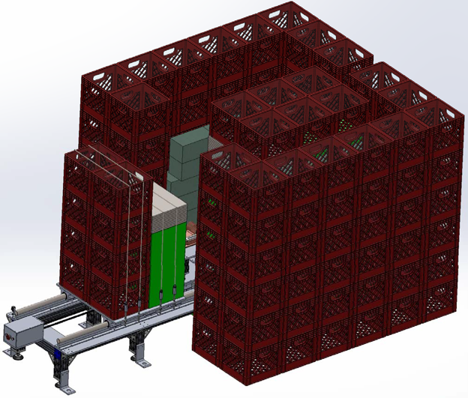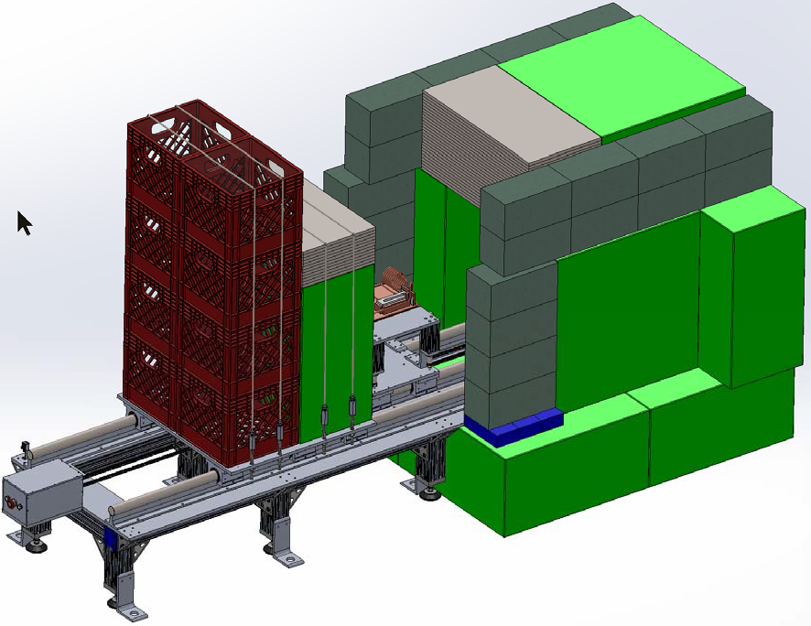
Figures 1a and 1b: Design of the shielding hutch
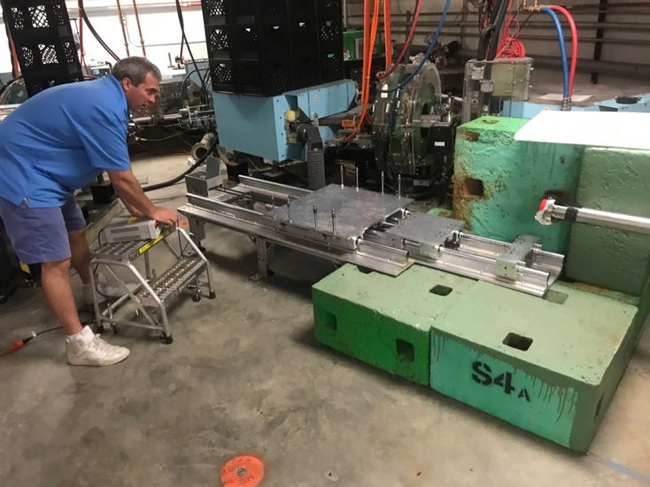
The support structure for the target assembly and radiator has also been designed, parts procured, and assembled. Here is a photo of the installation. The structure consists of two Thompson rails with three sliding sections. The tungsten radiator is mounted at the front; the intention is that this will usually remain in place and will only be retracted after it has cooled down significantly. The target assembly is mounted on the central section, and a shielding block is strapped to the rear section. The rear sections are actuated together via a motor (seen here being activated by Joe Gubeli, the engineer who designed the installation). When fully inserted, the target assembly is pressed against the radiator by a spring and the shielding block completes the shielding. When fully retracted, the target assembly is accessible for removal of the crucible.
Figure 2: Support structure for the radiator,
target assembly and rear shielding
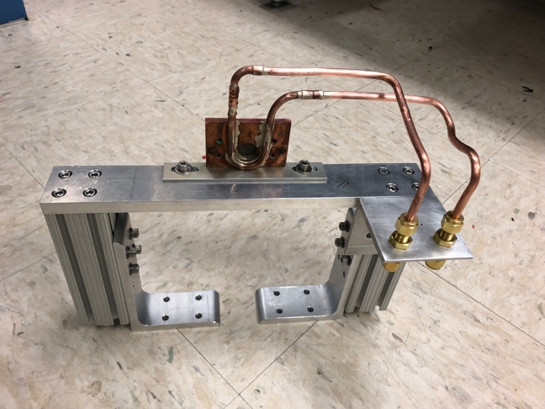
The radiator, a 1.5 mm thick tungsten disc is fixed to a support structure with a separate cooling loop. The structure itself mounts on the front section of the support structure.

Figure 3: The radiator and support structure.

The target assembly consists of three items: the liquid gallium target; the boron nitride crucible, and the support raft. In the last report, we described the crucible design with a hole drilled from the back and closed by a threaded carbon plug so it also acts as electrical ground. Flat shoulders make the seal, and the plug has hexagonal head to allow the remote manipulator to unscrew it. The first boron nitride crucible of this design has now been built (see photo), and we are ready to test it. A key component is the integration with the remote handling device at VCU that will be used to remove the crucible from the pig, unscrew the plug, and pour out the gallium. With the imminent arrival of the remote manipulator at VCU (see below), we are now in a position to test all of these steps.
The gallium will be a liquid during the irradiations due to the electron beam heating, and afterwards due to the radioactive decay of the daughter products. However, initially it will naturally be a solid (melting temperature 29.76°C). Gallium expands by about 3% when it freezes, so we need to take that into account. It seems impractical to try and ensure that the temperature never drops below 30°C, so we will ensure that there is sufficient space to allow for the expansion. Otherwise, we will have the burst water-pipe phenomenon that we all know too well. The graphite plug will be machined to provide “flats” that allow the plug to be unscrewed in the hot cell.

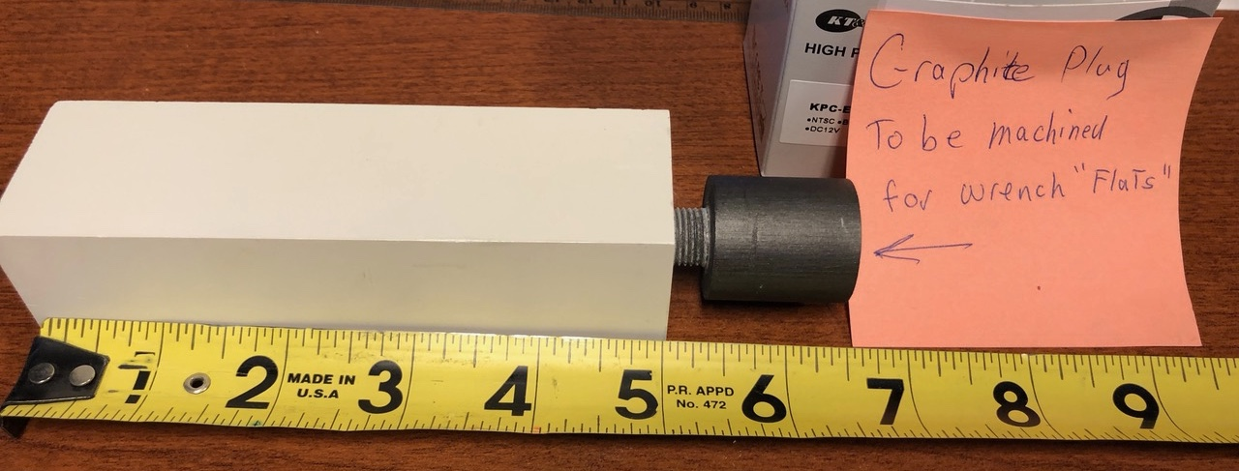
Figure 4: Boron nitride crucible

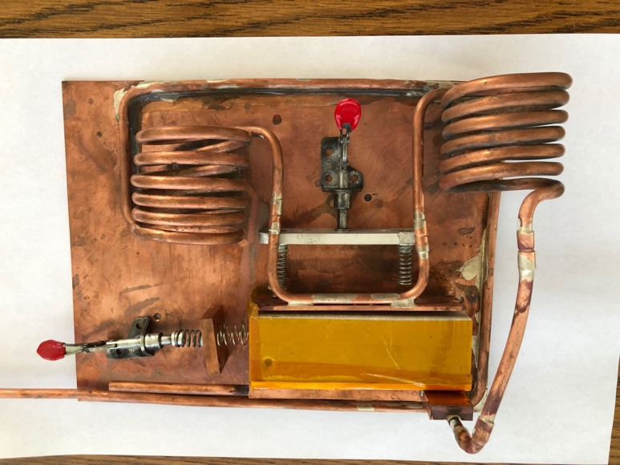
Finally, the raft that supports the crucible and also provides the cooling has been modified from the test version. It is known that this will provide sufficient cooling to support initial irradiation with 1 kW beam. The design may have to be modified for later tests at higher power. The copper tubing bringing water to the cooling plates is coiled to allow the cooling plates to retract without having to disconnect the water. The process requires undoing the two clips (red handles in Figure 5) and removing the crucible with long-handled tongs.
Figure 5: Target raft

We have procured two “pigs” for transporting the crucible to VCU as well as a Class A shipping container. These are now in house and we are finalizing preparations for the test transfer to VCU.

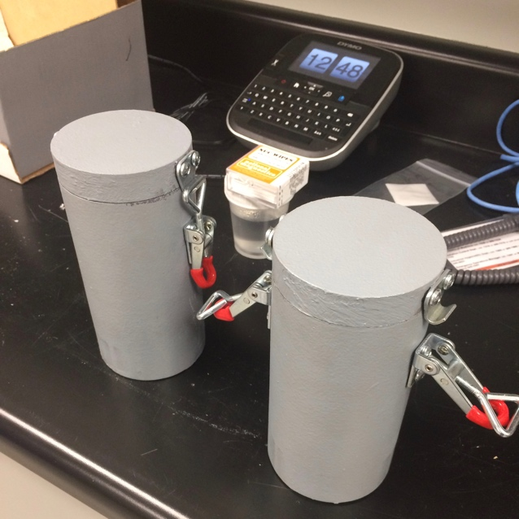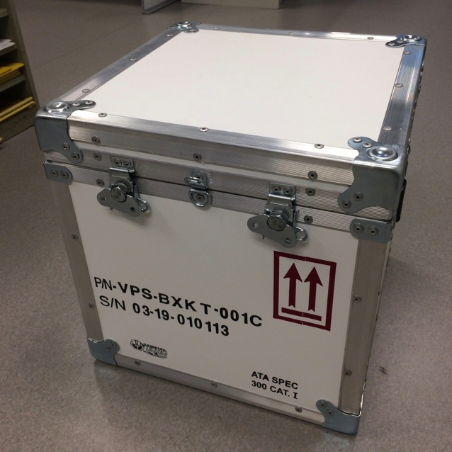
Figure 6a and 6b: Lead “pigs” and Class A shipping container

We had hoped to have everything ready for the test transfer in this quarter, but we felt that getting everything right was more important. We have claimed 50% complete for this activity, given the progress that has been made.

Virginia Commonwealth University

Progress at VCU has focused on the remote manipulator. This was procured and finally delivered after some delay. The initial fit-up showed some problems which were fixed by the manufacturer. It is now fully functional.

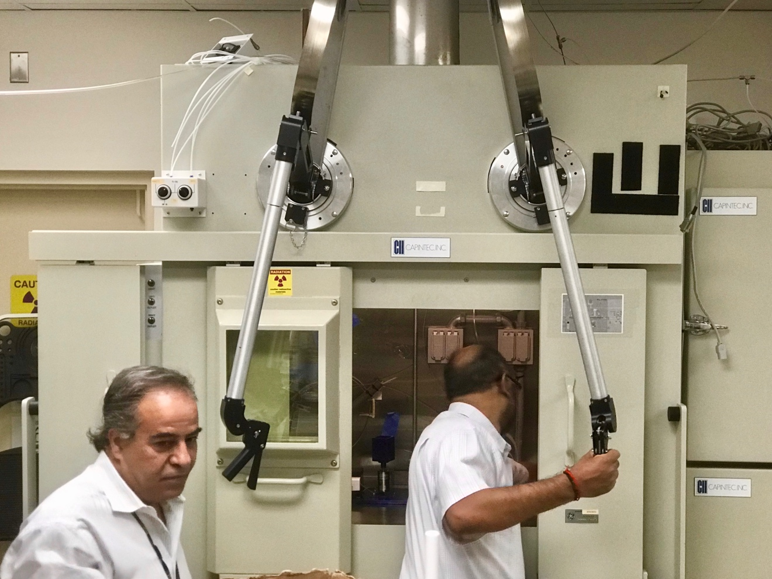
Figure 7: Remote handling installed and operational in the VCU hot cell
VCU has recently hired Mark Murphy to be responsible for the radioisotope separation process. Mark is a cyclotron engineer and radiochemist who has extensive experience in the production of PET isotopes, having worked at the Universities of Hong Kong and Kansas, where he was responsible for the operation of cyclotron and production of clinical-grade PET radiotracers based on F-18, N-13 and C-11.

New Mexico Tech
In support of the 1 kW experiment, NMT students have worked with Dr. George Kharashvili to install and train on the use of FLUKA for simulating isotope production in realistic targets. These simulations produced estimates of 67Cu production from the 1-kW natural gallium target, as well as estimates of the photo-production and neutron-capture production of other isotopes during a 1 kW experiment. These estimates are also being used to address the radiation safety, regulatory and shipping issues of the post-irradiation target. Figure 7 illustrates the some of the central results of these simulations. In the 3rd quarter NMT students have also:

- scheduled and trained for a July trip to JLAB in support of the 1 kW experiment,
- completed the JLab training online
- moved a two-ton lead shield from a warehouse to the Physics department’s gamma spectroscopy lab (for the Ge detector)
- scheduled rigging of lead shield to permanent location
- successfully installed FLUKA software
- ran activation and dosimetry simulations with FLUKA and compared results (they compared favorably, when scaled by mass, power and irradiation time) with prior simulations run by Dr. George Kharashvili. These results are also consistent with the results of the Photon Activation Analysis handbook of Dr. Christian Segebade.

Figure 8: Shown is the decline in equivalent dose rate for a natural, 64 g gallium target irradiated for 24 hours with the bremsstrahlung beam of a 1 kW, 40 MeV electron beam.

