Small Project Quarterly Report Template
DOE Office of Nuclear Physics (NP)
Facilities and Project Management Division

Proposal Name: Isotope Production at the Jefferson Lab LERF Facility

Report Date: January 25, 2019

Principal Investigator: Andrew Hutton

Work-scope Highlights:
Work at Jefferson Lab to prepare the LERF for irradiation of gallium targets is well under way. Milestones M1, M2 and M4 have been completed on time.
Two students have been selected at NMT (milestone M3).
Brief summary of activity issues, concerns, successes:
The installation of equipment in the LERF is well advanced, but has had to contend with the simultaneous installation of two LCLS II cryomodules in the LERF vault (now complete, cool-down expected in January 2019) as well as competition for resources with CEBAF operation and upgrades. Nevertheless, installation is still on track.
An internal milestone to carry out a trial transfer of an unirradiated gallium target from Jefferson Lab to VCU will probably not be met (best transport container has not yet been selected). We expect to meet this internal milestone in FY19Q2.

Milestones
Milestone M1: Project Activities and Schedule Defined
Milestones and Gantt Chart developed
Due 10/1/2018, delivered 9/26/18
Milestone M2: Detailed Budget Established
Due 10/31/2018, delivered when?
Milestone M3: NMT student selected
Selection of a student at NMT to perform thesis work associated with the project
Due 10/31/2018, delivered early October 2018
Instead of one student, two students were selected, (one PhD and one Masters). They will be supported 50% by the Isotope Project, 50% by NMT funds.
Milestone M4: Complete LERF Installation Planning, Optics Deck Approved
This milestone rolled up three internal milestones: Prepare optics deck; Plan LERF installation between cryomodule and dump; and Plan target beamline installation
Due 11/23/18, delivered 12/3/18
Two optics decks were developed by Chris Tennant and published as internal Jefferson Lab Tech Notes. TN-18-050 (9/26/2018) defined the beamline between the cryomodule and the dump; TN-18-054 (12/3/2018) defined the target beamline. Installation of the beamline between the cryomodule and the dump started on 11/5/2018.
Budget

Summary of total expenditures:
The work-scope is generally broken down into a number of items, activities and/or tasks. Please complete the table below.
- The first column, “ID#”, is the item/activity/task identification number. It can be the WBS number if you have a formal schedule, or any identification number that works for you.
- The second column is a brief description or title of the item/activity/task. Note: For clarity purposes, please be consistent throughout all reports with numbering and names of items/tasks.
- The third column is the “baseline” total cost associated with the item/task, including contingency. In this case, “baseline” cost means that assumed in the original proposal.
- The fourth column, “Costed & Committed”, shows the total of costs and commitments through the end of this reporting period associated with the item/activity/task.
- The fifth column, "Estimate to Complete", shows the estimated funds that are necessary to complete the related item/activity/task, including contingency.
- The last column, "Estimated Total Cost", is the sum of “Costed & Committed” and “Estimate to Complete”.

 | Item/Task | Baseline  Total Cost | Costed  &  Committed | Estimate  To Complete | Estimated  Total Cost
ID #
 |  | (AY$) | (AY$) | (AY$) | (AY$)
Totals:

Summary of expenditures by fiscal year (FY):
Funds allocated are the funds that you have received from NP through the end of the reporting period. “Actual costs to date” are already disbursed funds, or items for which you were billed. “Uncosted commitments” are committed funds that you have not yet been billed for. What is left over are your available funds (including contingency). This table is similar to the table above, but presents the budget in terms of time as opposed to activity. Both give valuable information to help track the progress in the effort.

 | FY 20XX | FY 20XX | FY 20XX
a) Funds allocated
b) Actual costs to date
c) Uncosted commitments
d) Uncommitted funds
(d=a-b-c)

Details on, or further, issues/concerns
Jefferson Lab
The layout of the vault is shown in Figure 1.
The cryogenic transfer line for the LCLS II cryomodules interfered with the original triplet which was relocated upstream. An additional triplet was installed downstream of the transfer line, giving considerable flexibility in the beam envelopes. The final layout of the beamline between the cryomodule and the dump is shown in Figure 2.
Figure 1: Rendering of the LERF vault with the LCLS-II cryomodules (orange) in place, parallel to the linac axis, along with the cryogenic transfer line (inset)

Figure 2: Plan view of the 1F region showing the placement of the two additional triplets. The LCLS-II transfer line is also shown for reference. (Beam direction is from left to right)

The triplets have now been installed with their vacuum chambers; the interconnecting vacuum chambers are ready to be installed (see photos). For the new triplet, cables have been run and are ready to be connected. The BPMs have been connected and checked out. The beam profile monitors need new YAG screens to be able to visualize the lower intensity beams we will use for the Isotope Project. These are being procured.

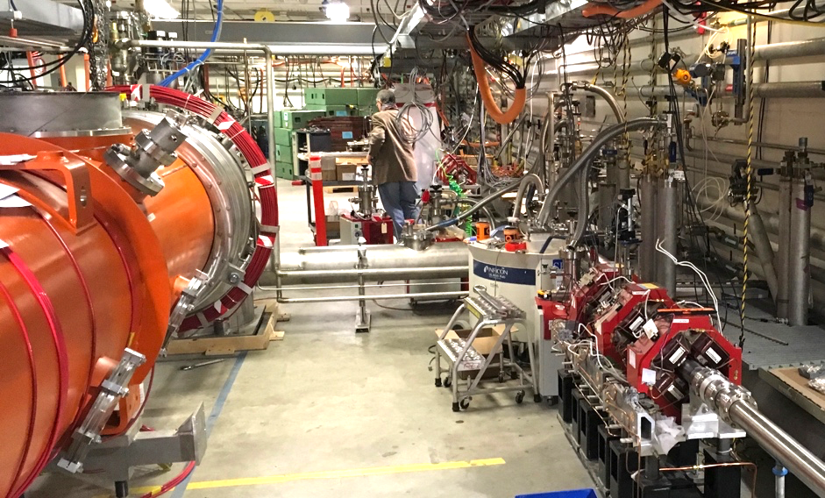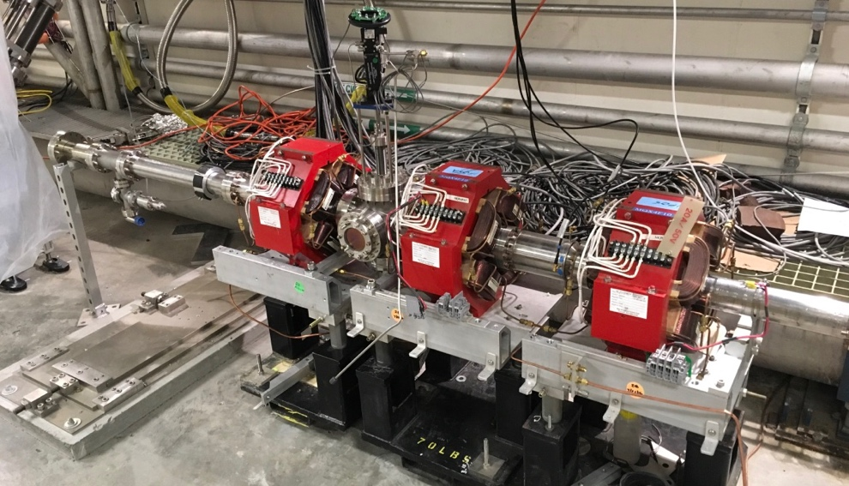
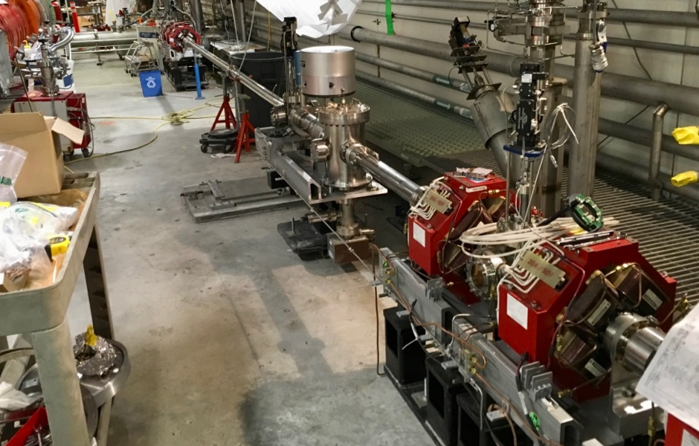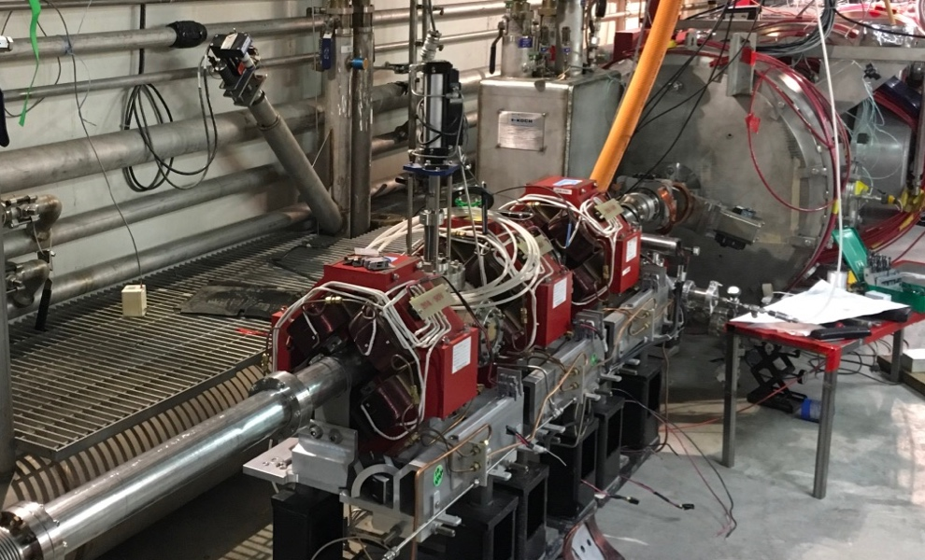

The layout of the target line is shown in Figure 3.
Figure 3: Close up view of the extraction chicane, the first three quadrupoles in the 2F region, the dipole that directs beam to the isotope beamline (beam direction is from right to left). The isotope line consists of a single quadrupole with a BPM/correct pair upstream and a beam viewer downstream.

The dipole replaces a quadrupole that was installed but never used. The dipole itself was part of the original IR Demo FEL and had been kept in storage. It was refurbished for the Isotope Project. The dipole was originally equipped with a Y-shaped vacuum chamber, which has been reutilized. The dipole therefore acts as a switch enabling beam to be sent to the isotope target or to carry on around the 180º bend where additional experiments could eventually be installed. This could include a high-power beamline for Ac225 production.

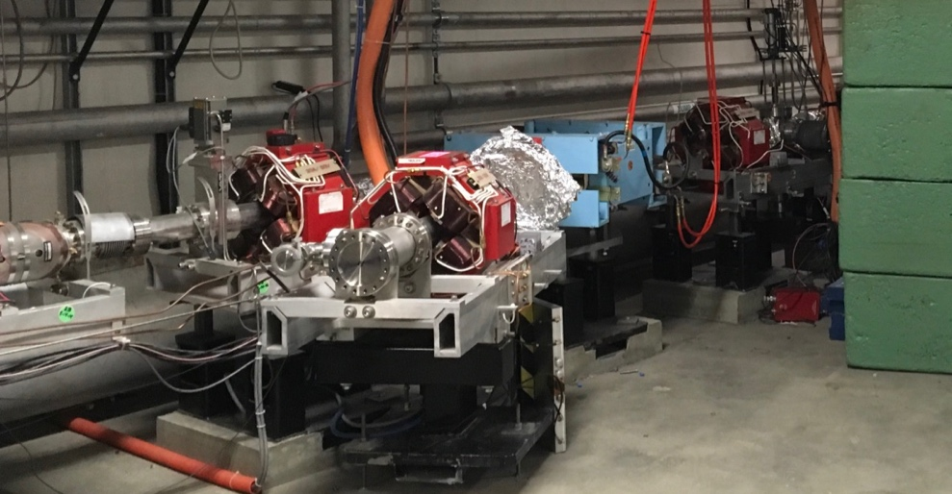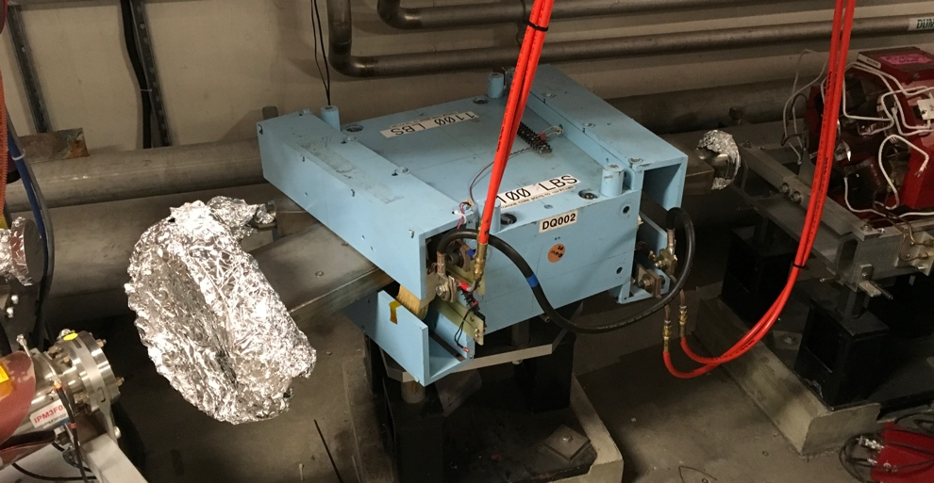

The dipole and the new quadrupole are already installed as can be seen from the photos. A power supply has been identified for the dipole allowing beam energies up to 40 MeV. The vacuum system, power cables and diagnostics will be installed as manpower becomes available.

The initial target for 1 kW tests will be an improved version of the target already used in CEBAF (Figure 4).
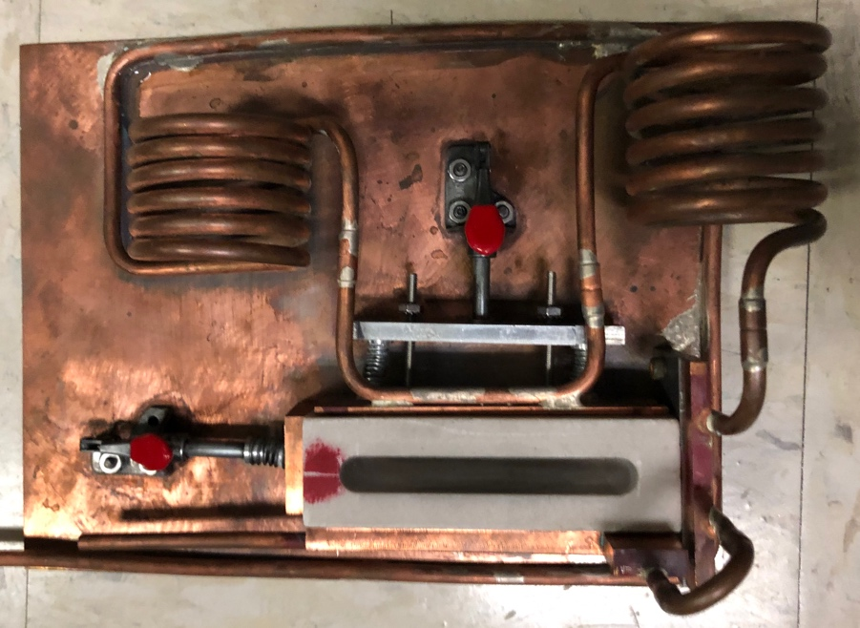
Radiator
Boron Nitride container for the liquid Gallium (lid not shown)
Spring-loaded clamps to ensure good contact between the Boron Nitride container and the cooling plates

Coiled water lines permanently connected

Figure 4 Initial liquid Gallium target holder – 1 kW power handling
Radiation shielding calculations for targets up to 5 kW at 40 MeV (125 μA) and 1 kW at 18.5 MeV (54 μA) have been carried out and an initial shielding layout has been determined. It will use some of the SEG blocks from the existing dump which was designed for 10 mA, a current which cannot be reached without recirculation. It will also require neutron shielding, for which we will use 20 cm of water in cubitainers. Simulations show that the dose in the upstairs equipment gallery is <0.02 mrem/h with a beam power of 5 kW.
The shielding concept is shown in Figures 5 and 6. The target will be attached to the rear shielding blocks which are mounted on a rail system allowing the target to be pulled back from the shielding hutch. The cooling water will be attached rigidly to the rear shielding block and will not require disconnecting from the target cooling mechanism.
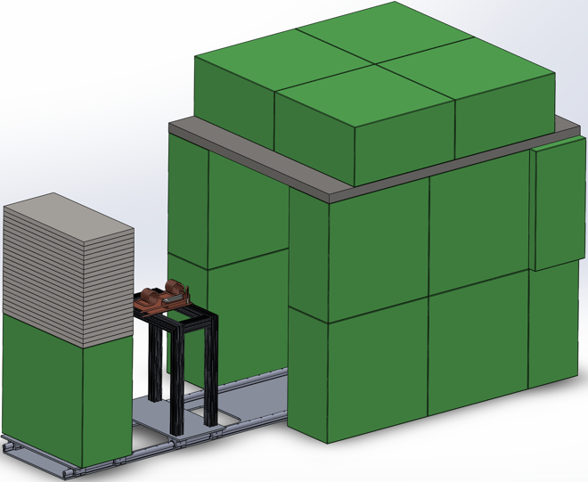
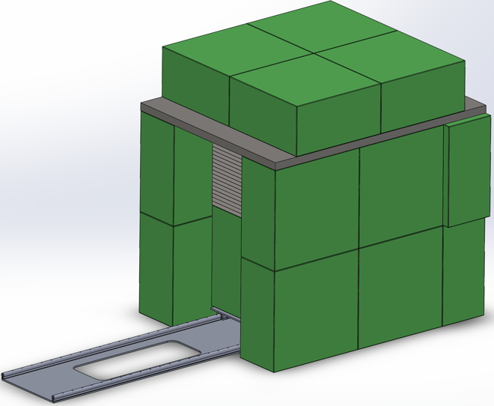

Figure 6 shows the rear shielding and target retracted to allow removal of the target
Figure 5 shows the radiation shielding in the closed position ready for irradiation.

The radiator will be mounted on a separate trolley allowing the radiator to be removed separately. This is not expected to be a frequent event and would be preceded by a delay sufficient to allow the radiation to decay to acceptable levels.
The area where the isotope target will be placed has been emptied and is ready for installation of the shielding and the target handling.

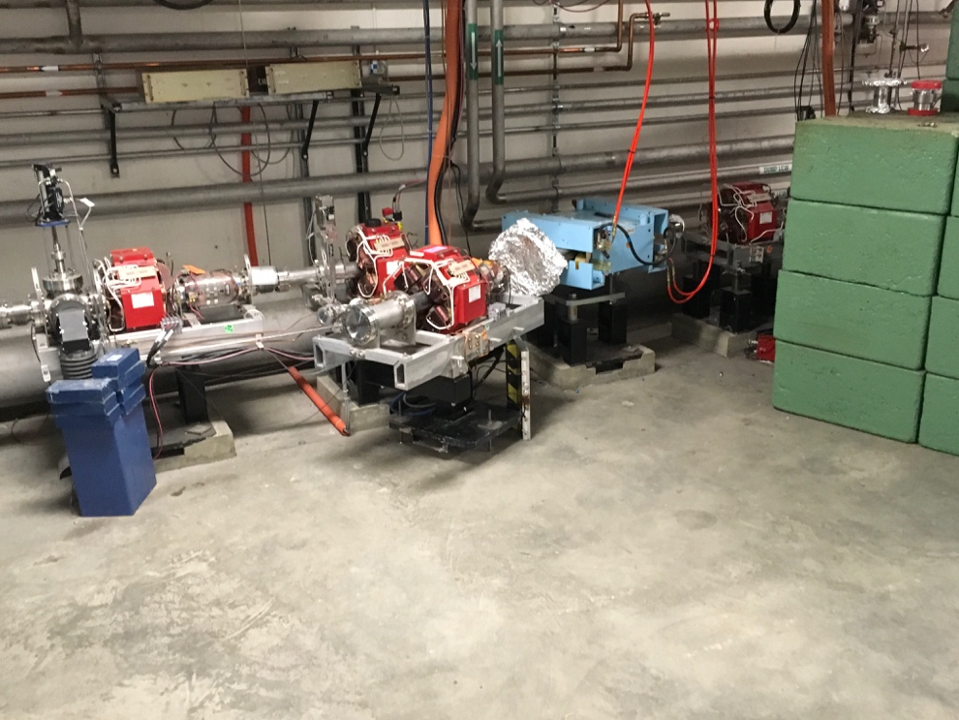

Budget, technical, management, schedule or workforce issues that you would like to discuss with NP. No more than 5 pages.

