Isotope Production at the Jefferson Lab LERF Facility

Feasibility Study Final Report

Thomas Jefferson National Accelerator Facility
Virginia Commonwealth University
South Dakota School of Mines and Technology

January 20, 2016

Prepared by:
A. Hutton, P. Degtiarenko, J. Gubeli, G. Kharashvili, G. Myneni, G. Neil, K. Jordan, JLab
J. Zweit, S. Gobalakrishnan, VCU
D. Wells, SDSMT
Contents
1.0 Executive Summary 3
2.0 Introduction 4
2.1 Background 4
2.2 LERF Capability 4
2.3 Isotope Market 7
2.4 Expertise of the Investigators 8
2.5 References 9
3.0 Isotope Physics and Conversion Rates 10
3.1 References 12
4.0 Isotope Separation and Purification 13
4.1 Separation, Purification 13
4.2 Radiochemical separation of ⁶⁷Cu 13
4.3 Radiochemical Analysis 16
4.4 References 16
5.0 Radioisotope Target Design 17
6.0 Production Economics, Costs and Cost Justification 20
7.0 Summary and Conclusion 22
7.1 References 23
Appendix A: Preliminary Study – ²²⁵Ac production 24
Appendix B: Thomas Jefferson National Accelerator Facility (JLab) 26
Appendix C: Virginia Commonwealth University (VCU) 28
C.1 Description of facilities and capabilities 28
C.1.1 Hospital, Clinical Teaching and Research 28
C.1.2 Facilities and Resources 29
C.1.3 Other Equipment at the Center for Molecular Imaging 30
Appendix D: South Dakota School of Mines and Technology 31

1.0 Executive Summary
This document discusses the effort needed to develop an isotope production capability at the Low-energy Electron Recirculating Facility (LERF) at JLab without major investment in construction. Beam power is a critical parameter in isotope production at electron linacs. LERF is an energy and current tuneable accelerator capable of delivering an average beam power >100 KW. After the initial study we have chosen ⁶⁷Cu as an isotope of interest. “This isotope of copper, owing to interesting decay properties, is potentially useful for radio immunotherapy, but due to limited availability, researches that actually use this isotope are few, compared to other Cu isotopes.” (http://www.ncbi.nlm.nih.gov/pmc/articles/PMC4033511/) ⁶⁷Cu may be produced cost-effectively using relativistic electron beams on a target/beam dump containing liquid gallium, (natural, not isotopically enriched but 99.9999% chemically pure), downstream of a tungsten radiator. An advantage of this approach is the high-power capability of the target material; since gallium does not boil nor tungsten melt at any reasonably achievable temperature, the target can be directly exposed to the electron beamline during irradiation, simplifying the design. We have a conceptual design of the target system which requires minimal handling at LERF and have identified the steps necessary to qualify and optimize this design. We intend to use water as a secondary cooling medium to indirectly cool the gallium. At the end of an irradiation run the liquid gallium can be transported to a chemical separation facility. Production rates of the desired isotope, 24 hours after irradiation with 40 MeV electron beam for four hours at 50 kW, are estimated to be ~31 mCi. The projected total cost of production and separation is $3.1K/mCi based on 10 runs per year, including onetime costs. Producing ⁶⁷Cu this way minimizes contamination of the product material with unwanted active and inactive Cu isotopes. Such contamination has been a significant factor in prior attempts at ⁶⁷Cu production.
The three collaborating institutions that prepared this report bring complementary skills to the effort: JLab provides expertise in accelerator technology including target design, thermal and radiation shielding, and in model calculations, simulations and optimization for the selection of the isotope production parameters; SDSMT provides expertise in photo-nuclear reactions and radio-isotope production; and MCI-VCU provides expertise in purification, isolation and determination of specific activity. We propose to perform a demonstration of the feasibility of this capability that would include: beamline configuration, target engineering and fabrication, a production run of ⁶⁷Cu, and separation of the material into a form which could be utilized by the medical and research community. The demonstration effort could be accomplished in less than a year and would be expected to answer any open questions regarding feasibility and practicality of this approach. Appendices B, C and D discuss the capabilities of the collaborators in this effort.

2.0 Introduction
2.1 Background
High power (~100 kW) electron accelerators are well suited for the production of some important isotopes for medical and industrial applications. Two of the methods to produce isotopes at electron accelerators are: i) directly irradiate the isotope target with the electron beam and ii) generate bremsstrahlung photons which in turn irradiate the target. (There are additional methods, such as fast-neutron secondary reactions and slow neutron capture, which electron accelerators are well-positioned to support.)
Direct irradiation with electrons deposits a great deal of energy in the target and photon conversion takes place in the isotope target. A large fraction of the electron energy goes into energy loss mechanisms that do not contribute to the production of photons. The second method, using a radiator generates photons in a material that is physically isolated from the isotope target and makes heat management simpler. Additionally, the isotope target can be much thinner (smaller in volume) resulting in higher specific activity.
High energy bremsstrahlung photons are produced when electrons from the accelerator encounter a target. For sufficiently high Z targets, a large fraction of the electron energy is converted into bremsstrahlung photons. While the photo-nuclear peak cross-sections are generally lower than proton induced reactions, photo-nuclear resonant cross sections have large widths. This feature, in conjunction with the large flux of photons that can be produced at high power electron accelerators, enables substantial yields of desired isotopes by photo-production because the yields are proportional to the integral of the flux and the cross section. In addition, the high penetrating power of photons enables much thicker targets than can be used with proton beams, which further boosts photo-nuclear yields, and alleviates some of the heating and corrosion issues encountered when using high power density proton beams. In the sections below we discuss the capability of the LERF facility, and review the research and medical needs for isotopes of interest. Section 3 continues with estimates of ⁶⁷Cu isotope production rates in our beam. We discuss the methodology for separation of the isotope from the target material in Section 4. Section 5 presents a conceptual design of the target. In Section 6 we review the economics for production of ⁶⁷Cu by our proposed method.
2.2 LERF Capability
For the production of radio-nuclides at appreciably high activity yields, the average current of the photon-producing electron beam should be as high as achievable to maximize the photon flux. The Low-energy Electron Recirculating Facility (LERF) at JLab is a 170 MeV superconducting radio-frequency electron accelerator, tuneable in both energy and current, which can be easily optimized in beam current and energy for photo-production of radioisotopes. While LERF is capable of very high beam powers in energy recovery mode we will be sending the electron beam to a fixed target, which limits the total beam power to less than 100 kW. Figure 2.1 is a schematic representation of the facility for producing isotopes and Figure 2.2 shows the facility at JLab.
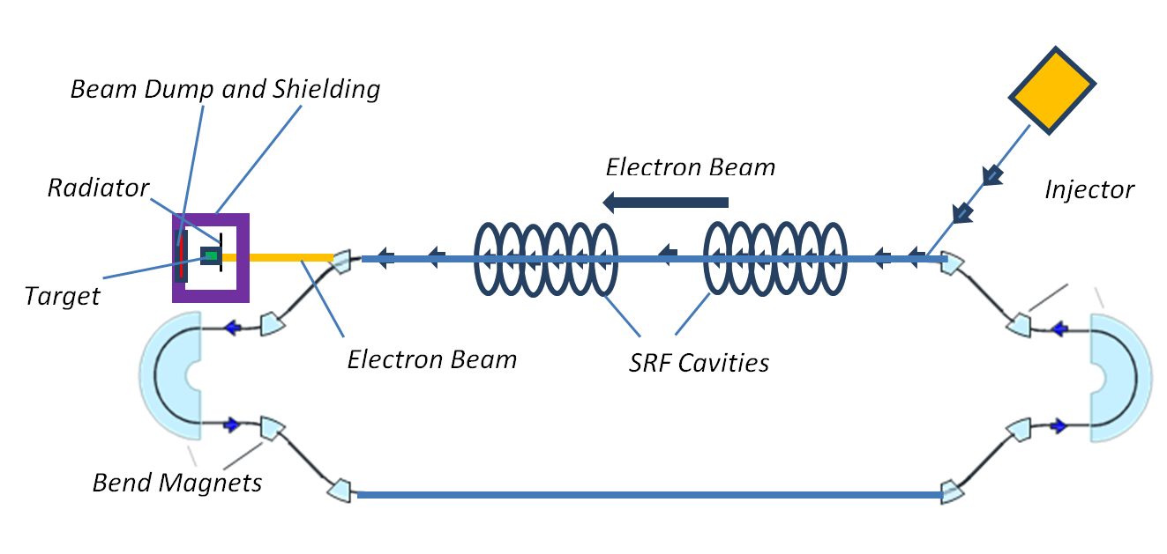
Figure 2.1: Schematic layout of the isotope production at LERF
The LERF injector can provide 6 mA of current. The 5 kW klystrons and the present 100 kW beam dump sets the limit on energy and current though LERF is capable of producing nearly 200 kW of beam power. Figure 2.3 shows the maximum electron beam current capability at different energies. The klystrons and the beam dump could be upgraded for higher power operations in the future though we believe the existing capability provides a practical level of isotope production per run.

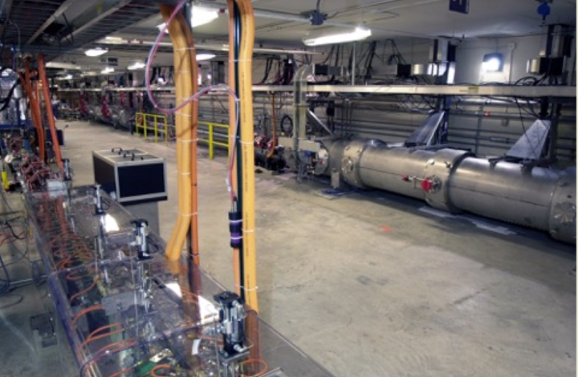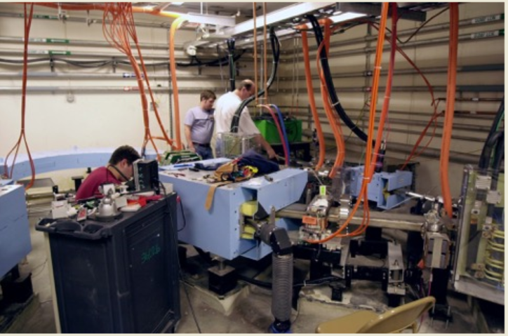
- b)
Figure 2.2: a) LERF accelerating section b) Location of the Bremsstrahlung and Isotope Targets
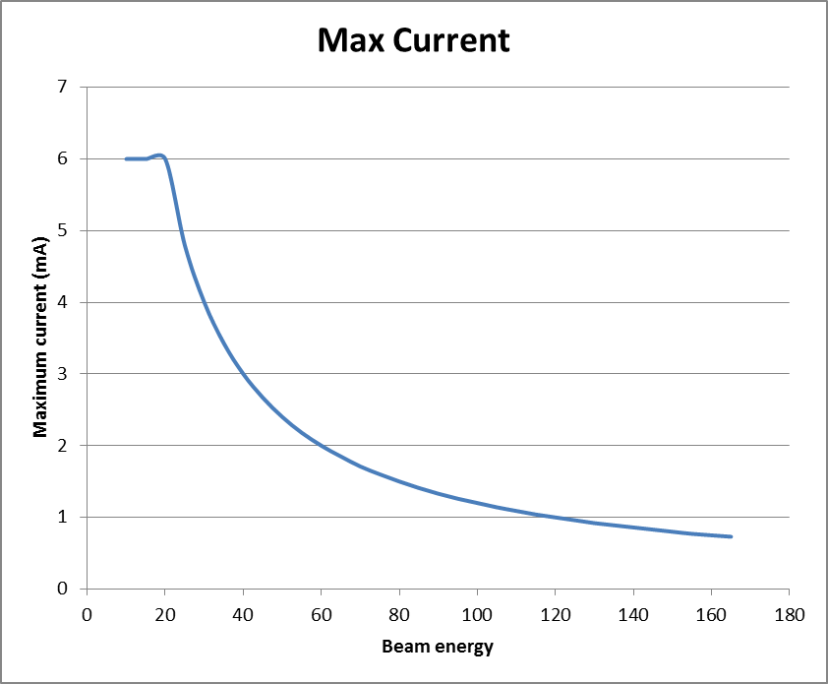
Figure 2.3: LERF Electron beam fixed target current limit as a function of the beam energy
We examined those radionuclides that are favourable for photo-production and have been identified by NSAC, DOE, or NIH as of interest [1, 2, 3, 4, 5]. Nuclides that are of particular interest are those produced in reactions, e.g. (γ, p), or (γ, α). The production of carrier-free species is more straightforward with such reactions because the daughter is chemically different. (γ, n) reactions, where the radioactive chain enables carrier free separation, e.g. ²²⁶Ra (γ,n)²²⁵Ac are of interest as well.
The generic beamline at LERF will consist of the usual magnets and beam diagnostics elements. For isotope production, the beamline will include a target system that does not presently exist. Reasonable yields of isotopes (~10s of μCi/g.hr or ~mCi/g.hr) require kWs of beam power. Our analysis has indicated specific isotopes which could be optimally produced in a facility such as LERF. This document focuses on ⁶⁷Cu. ⁶⁷Cu is an attractive isotope for both therapy and imaging because it combines both beta and gamma emissions. It can be used to synthesize various compounds including small molecules and macromolecules. We propose producing ⁶⁷Cu in gallium via the ⁷¹Ga(γ,α)⁶⁷Cu reaction.
The bulk of the capital cost of the LERF facility was provided from contracts with Office of Naval Research (ONR) and grants from the Commonwealth of Virginia. The system is in operational condition in energy recovery mode, having been brought to this state of readiness in preparation for a spring 2016 PAC-approved experimental search for dark matter called DarkLight. The operating cost of LERF is well documented through its previous use in CRADAs and WFO activities as $2,807 per hour burdened cost for FY16. This is the full cost recovery for operating LERF for isotope production. We estimate that it will take 4 hours to set the machine up for proper irradiation for each run at optimum energy and average current for isotope production. After that point the production rates of the desired isotope will be as projected in Section 3: ~31mCi of ⁶⁷Cu 24 hours after a 4 hour irradiation at 50kW beam power.
In addition to machine setup time there will be effort involved to put the target in position and to remove it, and pack and document it for shipping for separation.
2.3 Isotope Market
The demand and shortfall in supply of radioisotopes for nuclear medicine, for national security applications, and for many other applications in research and industry is enormously important because of its critical impact on each of these endeavours. It is extremely important to note that a shortage of radioisotopes is the fundamental limiting factor in many biomedical research programs that endeavour to exploit advances in molecular biology for targeted treatment with radioisotopes, as noted by both the National Academy of Sciences and the national Nuclear Science Advisory Committee [2, 6]. Applications of isotopes in research and medicine is a multi-billion dollar industry that serves nearly 20 million Americans each year in nuclear medical procedures, and serves an essential function in the nation’s nuclear security and nuclear research. Despite this, for many isotopes the nation’s supply of research radioisotopes is overly reliant on too few facilities and too few processes to provide adequate quantity and reliability of the supply [7, 1, 2, 3, 4, 5]. Moreover, the training of students and development of ‘human capital’ in nuclear sciences relevant to isotope production and nuclear medicine is lagging well behind the nation’s need [2].
These numerous reports document extensively the national need for research radioisotopes, especially for beta/gamma emitters such as ⁶⁷Cu that enable synchronous imaging and therapy, and alpha-emitters such as ²²⁵Ac that enable research on cellular-level, targeted molecular treatment of a variety of diseases. Despite these needs, no robust sources for these research radioisotopes and many others exist today in the United States. Nuclear medicine and bio-medical research are perhaps the most critically-sensitive users of radioisotopes because of the large number of patients involved and the short half-lives of most medical isotopes. Nuclear medicine in the U.S. continues to be an important part of non-invasive disease diagnosis and treatment. Despite the enormous positive impact that nuclear medicine has had on improving patient care, major gains are not only possible, but thought to be highly probable if adequate radioisotope supplies are available. In response to a congressional request, the National Academy of Sciences (NAS) issued a major report and recommendations on “Advancing Nuclear Medicine through Innovation” [2] where they point out that the age of “personalized medicine” is emerging where new advances in molecular biology and pharmaceutical sciences can be wed to nuclear techniques and radio-nuclides to specifically target unique individual medical profiles. The creation of new isotopes for medical research would enable further advances in these biomedical sciences.
We propose to partially address the pressing national need for research radioisotopes, especially ⁶⁷Cu, by investigating photo-production using photo-nuclear reactions induced by bremsstrahlung photons from a high-power electron linac. Initially, we propose to investigate the production of useful quantities of ⁶⁷Cu using the (γ,α) reaction, and then we will undertake investigations of radioisotope production using other photonuclear reactions such as (γ,fission) and electro-excitation (virtual photo-reactions).
Historically, (γ,x) reactions have not been exploited for isotope production because of the difficulty of achieving useful specific activity (SA), although the technique is well-known to be capable of production of large quantities of total activity, and to be practical for many other applications [8]. However, all photo-nuclear reactions with charged-particle exit-channel products enable, in principle, relatively simple post-irradiation separations and subsequent high specific-activity products because of the fact that the reaction products are chemically different than the original target material.
In addition, there are important advantages to adding electron accelerators to the U.S. portfolio of isotope production facilities. Electron beam accelerators are substantially simpler to operate, much cheaper to construct, and carry far less of a regulatory, safety and environmental burden than do nuclear reactors. Development of isotope production capability using electron accelerators would open a straightforward path to ensuring better access to isotopes throughout the U.S. and a more reliable domestic supply of short-lived isotopes that are amenable to production using this technique.

2.4 Expertise of the Investigators
Dr. Andrew Hutton is the Associate Director for Accelerators at JLab. He has contributed to accelerator science and technology at CERN and SLAC and holds a number of patents for innovations in the field. Dr. Pavel Degtiarenko is a senior radiation physicist working at JLab’s Radiation Control Department. He specializes in model calculations and evaluation of the radiation environment at JLab, including effects of high power electron beam interactions with materials and structures. He holds several U.S. patents, three of which deal with new methods of cooling high power particle accelerator targets. Dr. George Kharashvili is a radiation physicist in JLab's Radiation Control Department. His research interests include applications of accelerators in research and technology, interaction of radiation with matter, and radiation metrology. Mr. Kevin Jordan is a senior engineer at JLab. A number of his many patents include patents in Boron Nitride nanotube technology. He has also authored a paper titled BNNT-Mediated Irreversible Electroporation: Its Potential on Cancer Cells.
Prof. Jamal Zweit is Professor of Radiology and affiliate Professor of Biochemistry and Molecular Biology, Radiation Oncology and Molecular Pathology at VCU. Dr. Zweit is the founding director of CMI, the Center for Molecular Imaging at VCU. He is internationally recognized for his expertise in Multi-modality molecular imaging, radiopharmaceuticals, Radiation & Medical Physics and Nanotechnology, in cancer biology and therapy. He has over 25 years of experience in radioisotope production, radiopharmaceuticals for imaging and therapy, radio-metal-based PET imaging and targeted therapy. Prof. Sundaresan Gobalakrishnan is the Head of Multi-modality Imaging Laboratory and Scientist Manager of CMI. His research focus is on the in vivo evaluation and validation of multi-modal imaging approaches, including studies of targeted hybrid probes.
Prof. Douglas Wells was the head of Idaho Accelerator Center at Idaho prior to becoming the Dean of Graduate Education at South Dakota School of Mines and Technology. His expertise is in nuclear physics, especially photo-nuclear reactions (over 30 years) and applications of photo-nuclear physics, particularly the applications of photon activation analysis, isotope production, homeland security and nuclear non-proliferation. He has considerable expertise in radiation protection (health physics), and formerly a certified health physicist.

2.5 References
[1] Forecast of the Future Demand for Medical Isotopes, DOE, 1999.
[2] Advancing Nuclear Medicine Through Innovation, National Academy of Sciences, 2007.
[3] M.J. Rivard et al., The U.S. National Isotope Program: Current Status and Strategy for Future Success, J. Applied Radiation and Isotopes, 63, 157-178, 2005.
[4] J. Pantaleo, The Nation’s Needs for Isotopes: Present and Future, Presentation to the Joint NCI-DOE Workshop on Isotope Needs, August 3-7, 2008.
[5] T.J.R. Harris, J.D. Kalen, J. Hall, Report of the Meeting Held to Discuss Existing and Future Radionuclide Requirements for the National Cancer Institute, April 30, 2008, SAIC report to the National Cancer Institute, 2008.
[6] NSAC, Meeting Isotope Needs and Capturing Opportunities for the Future, The 2015 Long Range Plan for the DOE-NP Isotope Program, NSAC Isotopes Subcommittee, July 20, 2015.
[7] U.S. Radio-isotope Supply: a Position Statement, America Nuclear Society, 2004.
[8] C. Segebade, H.- P. Weise and G. J. Lutz, Photon Activation Analysis
[9] Artor Niccoli Asabella, Giuseppe Lucio Cascini, Corinna Altini, Domenico Paparella, Antonio Notaristefano, and Giuseppe Rubini, The Copper Radioisotopes: A Systematic Review with Special Interest to 64Cu, http://www.ncbi.nlm.nih.gov/pmc/articles/PMC4033511/

3.0 Isotope Physics and Conversion Rates
As a test case for isotope production using electron accelerators, we propose producing ⁶⁷Cu from gallium via the ⁷¹Ga(γ, α)⁶⁷Cu reaction. Gallium has a melting point of 29.8°C and a boiling point of 2204°C. This makes it possible for a gallium target to absorb significant electron beam power without that beam power destroying, or evaporating the target.
The proposed irradiation setup consists of an electron beam incident on a 1 - 1.5 mm (28 - 43% radiation length) thick tungsten radiator followed by a thick (2-3 radiation lengths) liquid natural gallium target. We have investigated using ⁷¹Ga but the significant cost (~$1M/kG) for the isotopically pure material renders the approach impractical.
The cross section of the ⁷¹Ga(γ, α)⁶⁷Cu reaction is significant above 15.1 MeV, which is the sum of the binding energy of alpha particle in ⁷¹Ga Q_{α}=5.3 MeV and its Coulomb Barrier B_{α}=7.8MeV [1]. Figure 3.1 presents the evaluated cross section of this reaction [2].
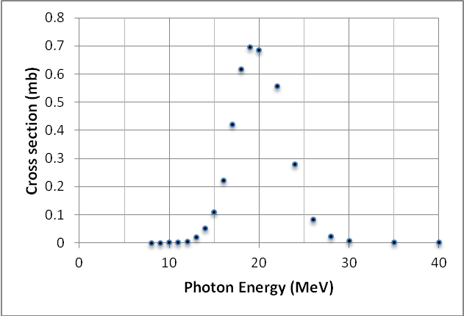
Figure 3.1. Cross section of ⁷¹Ga(γ, α)⁶⁷Cu [2]
We used FLUKA [3] to calculate ⁶⁷Cu yields in gallium. Results are generally in good agreement with TENDL-2014 data. However, there are discrepancies between both FLUKA and TENDL-2014 and the much lower cross sections reported by Antonov et al. [1] and Segebade et al.[4]. These discrepancies must be resolved experimentally to validate the cost estimates presented in what follows.
We have settled on 50 KW beam power for reasons of target heating and heat removal. Calculated yields of ⁶⁷Cu for 40 MeV and 100 MeV electron beams at this power in thick ⁷¹Ga and 20 MeV, 40 MeV, and 100 MeV in natural gallium (⁶⁹Ga – 60.1%, ⁷¹Ga – 39.9%) targets are presented in Table 3.1. Total induced radioactivity in the targets is also considered. Table 3.2 lists half-lives and activities of all notable radionuclides 1 day after a 1 hour-long irradiation by 50 kW beam. Calculations were for 10 radiation length targets.
Target | ⁶⁷Cu Production (mCi/h/50kW)  E_{e} = 20 MeV | ⁶⁷Cu Production (mCi/h/50kW)  E_{e} = 40 MeV | ⁶⁷Cu Production (mCi/h/50kW)  E_{e} = 100 MeV
⁷¹Ga | 10 | 43 | 53
Natural Ga | 4 | 17 | 22
Table 3.1. Yields of ⁶⁷Cu per 50 kW beam in thick ⁷¹Ga and natural gallium targets calculated using FLUKA
 |  | ⁷¹Ga |  | Natural gallium
Nuclide | T_{1/2} (h) | A (mCi) 1 day after 1 hour irradiation E_{e}=40 MeV | A (mCi) 1 day after 1 hour irradiation E_{e}=100 MeV | A (mCi) 1 day after 1hour irradiation E_{e}=20 MeV | A (mCi)  1 day after  1 hour irradiation E_{e}=40MeV | A (mCi)  1 day after  1 hour irradiation E_{e}=100 MeV
⁷²Ga | 14.1 | 61 | 81 | 16 | 55 | 72
⁶⁷Cu | 61.8 | 33 | 41 | 2.7 | 13 | 17
⁶⁹Zn | 0.9 | 17 | 41 | 0.1 | 7 | 17
^{69m}Zn | 13.8 | 16 | 38 | 0.1 | 7 | 16
⁶⁷Ga | 78.2 | < 0.05 | 31 | 2.3 | 407 | 559
⁶⁴Cu | 12.7 | < 0.05 | 21 | < 0.05 | 106 | 165
⁶⁶Ga | 9.5 | < 0.05 | 5 | < 0.001 | 1 | 23
Total |  | 127 | 258 | 21 | 596 | 869
Table 3.2. Activities of notable radionuclides 1 day after a 1 hour-long irradiation of thick ⁷¹Ga and natural gallium targets by 20 MeV, 40 MeV, and 100 MeV, 50 kW beams calculated using FLUKA. Note the low production of ⁶⁴Cu at 20 MeV
We narrowed the choice of energy to 40 MeV at 50kW of beam power. A run at 20 MeV and 2.5 mA average current, produces much less undesirable spurious radioactivity in the target but the yield of ⁶⁷Cu is much lower. We chose 99.9999% chemically pure gallium for reasons of its low initial copper content at a reasonable cost. Table 3.3 lists the impurities in gallium at different chemical purity levels [5].
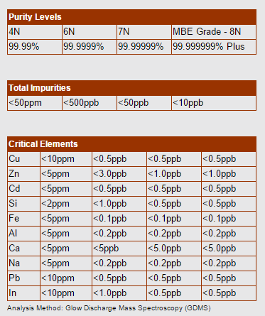
Table 3.3 Impurities in Ga at different enrichment levels

3.1 References
[1] A.D. Antonov et al. Sov. J. Nucl. Phys. 53 (1) 1991
[2] A.J. Koning et al. ”TENDL-2014: TALYS-based evaluated nuclear data library”, ftp://ftp.nrg.eu/pub/www/talys/tendl2014/tendl2014.html
[3] A. Ferrari, et al., "FLUKA: a multi-particle transport code" CERN-2005-10, INFN/TC_05/11, SLAC-R-773 2005
[4] C. Segebade, H.-P. Weise, G.J. Luts, “Photon Activation Analysis”; De Gruyter 1988.
http://www.axt.com/site/index.php?q=node/39

4.0 Isotope Separation and Purification

4.1 Separation, Purification
The photo-production process generally converts a very small amount of target material to the radio-isotope, as little as nano-grams of radio-isotope per gram of target. The chemical separation methods must therefore account for separating nine orders of magnitude difference in mass and corresponding dilution, while protecting without loss or contamination, the very small amount of radio-isotopic product. The challenges are significant to achieve contaminations low enough to provide radio-isotope high specific activities in the Curies/milligram range.
Following target irradiations at LERF, radioactive targets will be delivered to the radiochemistry laboratory at VCU for processing. Target processing will be carried out inside a lead shielded hot cell fitted with remote manipulators. By remote manipulation, the irradiated target material will be removed from the target holder and will be measured in a dose calibrator inside the hot cell to determine the total radioactivity in the target. This total activity will contain not only the desired radioisotope, but also other co-produced radioisotopes. Next, the target material will be dissolved in the appropriate solvent and a small fraction (μCi) of the solution will be taken and processed for initial Gamma spectroscopy analysis. This will determine the identity of the isotopes induced in the target by their respective gamma ray emissions. Following radiochemical separation, gamma spectroscopy analysis will be repeated on the purified radioisotope product as well as the other separated isotopes to determine the efficiency of the purification method and quantify the radioactivity of all produced radio isotopes.

4.2 Radiochemical separation of ⁶⁷Cu
The photonuclear production of ⁶⁷Cu from ⁶⁸Zn (γ,p) ⁶⁷Cu reaction, using >99% enriched ⁶⁸Zn metal, has been demonstrated by a number of groups. Although useful quantities have been produced through this route, the specific activity of ⁶⁷Cu is compromised by the production of stable Copper isotopes resulting from imperfect enrichment of the ⁶⁸Zn target and from metal impurities.
Therefore, in this project we propose a new route for the photonuclear production of ⁶⁷Cu from natural gallium by the ⁷¹Ga(γ, α) reaction. Producing ⁶⁷Cu this way is expected to minimize contamination of the product material with unwanted active and inactive isotopes. Such contamination has been a significant failure mode in prior attempts at production.
Photon irradiation of natural gallium target (60% ⁶⁹Ga / 40% ⁷¹Ga) leads to the production of ⁶⁷Cu by the ⁷¹Ga(γ, α) reaction as well as production of stable ⁶⁵Cu by the ⁶⁹Ga(γ, α). If an enriched ⁷¹Ga target could be used, the production of stable copper isotopes (⁶³Cu and ⁶⁵Cu), would be greatly minimized leading to significant increase in the specific activity of produced ⁶⁷Cu.
The irradiation of gallium also leads to the production of Zinc (Zn) isotopes through (γ, xp) reactions. As a result the radiochemical separation of ⁶⁷Cu must ensure not only separation from the Ga target, but also from other Zn impurities, and other trace metals (e.g.: Fe, Co, etc.) that could be induced in the container housing the liquid Ga target.
The radionuclide separation approach planned is a modified version of previously published methods [1,2] used to separate ⁶⁴Cu/⁶⁷Cu from radioactive waste generated during the proton-induced production of ⁶⁷Ga from Zinc target. We will employ a combination of solvent extraction and ion exchange chromatography to separate ⁶⁷Cu from the liquid Ga target material and from other trace metals co-produced during the irradiation. The initial step will involve removal of the bulk Ga using isopropyl ether (IPE) solvent extraction in which Ga will be retained in the organic phase and ⁶⁷Cu/Cu will remain in the aqueous phase. A second IPE extraction of the aqueous phase further removes residual Ga. The aqueous phase containing ⁶⁷Cu/Cu will be evaporated to near dryness and re-dissolved in dilute HCl. The ⁶⁷Cu/Cu activity will be extracted into dithizone phase; this organic agent has high selective affinity for Cu and not Ga, Fe or Zn. The ⁶⁷Cu/Cu will be back extracted into an aqueous phase prior to ion exchange purification using CG-71 amberchrome column impregnated with dithizone. This chromatography step purifies the final product from traces of Ga, Fe and Zn. The scheme of its workflow is outlined below in Figure 4.1.

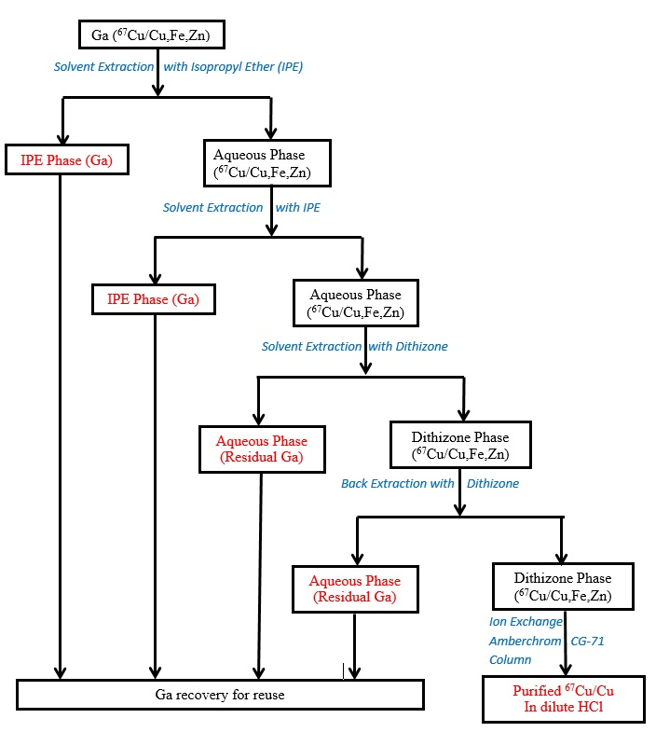
Figure 4.1. Schematic workflow showing the steps and processes involved in the separation of ⁶⁷Cu/Cu from irradiated gallium target

4.3 Radiochemical Analysis
Gamma-ray and Alpha-ray spectroscopy: High purity Germanium based Gamma spectroscopy (Ortec, USA) will be used to analyze the samples for radionuclide purity and to accurately measure absolute yields (<5 µCi) using detector efficiency calibrated for a range of gamma rays from 20 keV to 2 MeV. The measured activity will be extrapolated to the total volume of the purified isotopes and verified by dose calibrator measurements (mCi level).
Inductively Coupled Plasma Mass Spectrometry (ICP-MS): ICP-MS will be used to quantitatively measure stable isotopes of both the desired elemental isotope as well as other stable isotopes. These measurements will yield data on the amount of the trace isotopes produced as well as on trace chemical impurities.
Specific Activity measurements and determination: From the gamma spectroscopy and ICP-MS analysis, the specific activity of the purified isotope will be determined from these measurements.

4.4 References
[1] Kim JH, Park H, and Chun KS. (2010) Effective separation method of ⁶⁴Cu from ⁶⁷Ga waste product with a solvent extraction and chromatography. Applied Radiation and Isotopes; 68: 1623–1626.
[2] Cong Liu, (2015) Technique for radiolabeling tracers with ⁶⁴cu for positron emission particle tracking (PEPT) experiments. Thesis presented in fulfilment of the requirements for the degree of Master of Science (Eng) at the University of Cape Town, South Africa.

5.0 Radioisotope Target Design
The target system must: i) handle 50kW of beam power; ii) require minimal amount of handling at LERF and iii) have low copper content. Additionally, the amount of gallium has to be optimized for specific activity. Table 5.1 lists the target shapes and sizes we have investigated. For heat handling capabilities, integrated design and low copper content, the preference is for a tungsten container which can hold 210 g. of gallium. This choice yields not only the highest specific activity among the preliminary designs considered so far but also results in cleaner radiochemical separation and higher chemical purity.
Shape |  | Volume | Mass of gallium | Activity after 4 hr. irradiation | Activity one day after irradiation
 |  | cc | gm | mCi/50KW | mCi
cylinder |  | 35.34 | 208.88 | 40 | 31
cylinder |  | 70.69 | 417.75 | 48 | 37
Truncated Cone |  | 222.09 | 1312.54 | 52 | 40
Truncated Cone |  | 136.14 | 804.56 | 48 | 37
Truncated Cone |  | 695.73 | 4111.78 | 60 | 46
Table 5.1 Target shapes and sizes and Activity
The target system for radio isotope production is shown in Figure 5.1. The electron beam will be defocused onto the front face of the target system (left side in Figure 5.1). The centers of each of the four inlet/outlet sections act as radiators with a total thickness of about 1.5 mm of Tungsten, including the entrance window of the target. Between the radiators and the gallium target container is a small air gap. The target container has thin tungsten windows. The ends of the fins on the target container are in contact with circulating cooling water, (horizontal pipes), moving fast enough to avoid boiling.
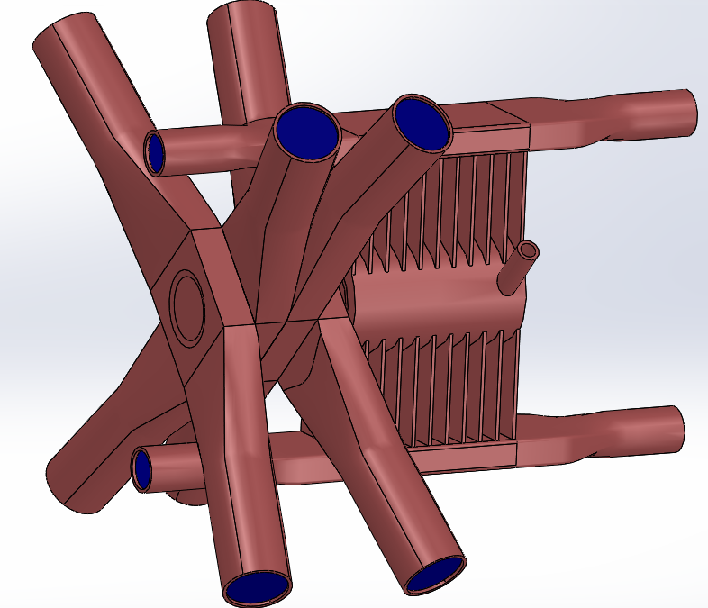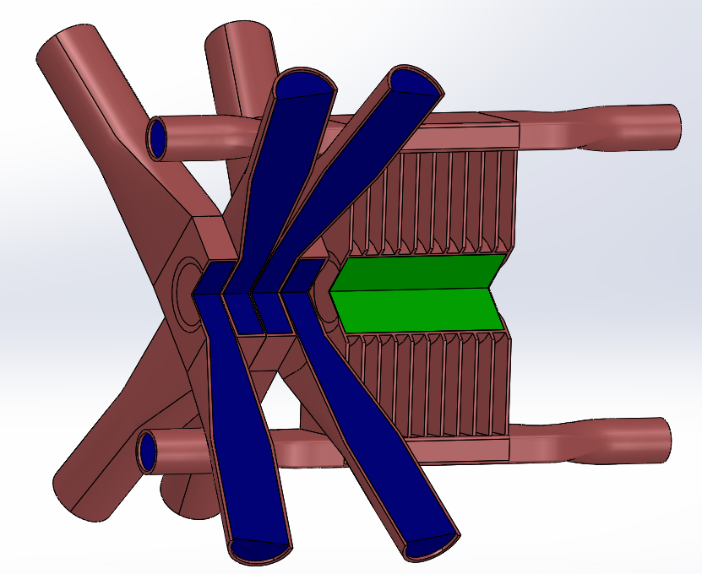Figure 5.1. Target system (Brown is Tungsten, Green is Gallium, Blue is Water)
The gallium target container will have a small volume of inert gas to allow for the thermal expansion. The fill/drain valves will be fitted with remotely controlled electric/pneumatic ball valves. A design goal for the target system is that the irradiated gallium can be retrieved remotely.
Figure 5.2 shows the results of a simple thermal analysis which does not take into account convective or radiative cooling. Notice the large temperature reduction due to increased fin thickness. With additional modeling, we are confident that our final target system will be able to handle 50kW of beam power without boiling the gallium target.
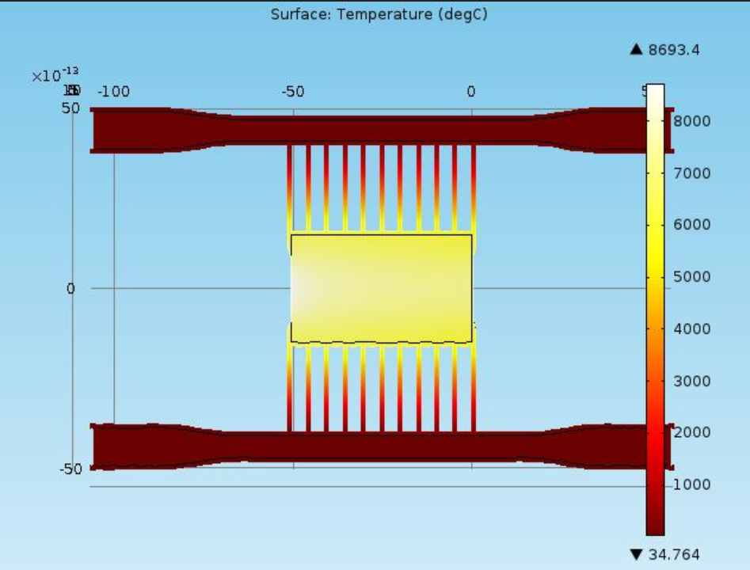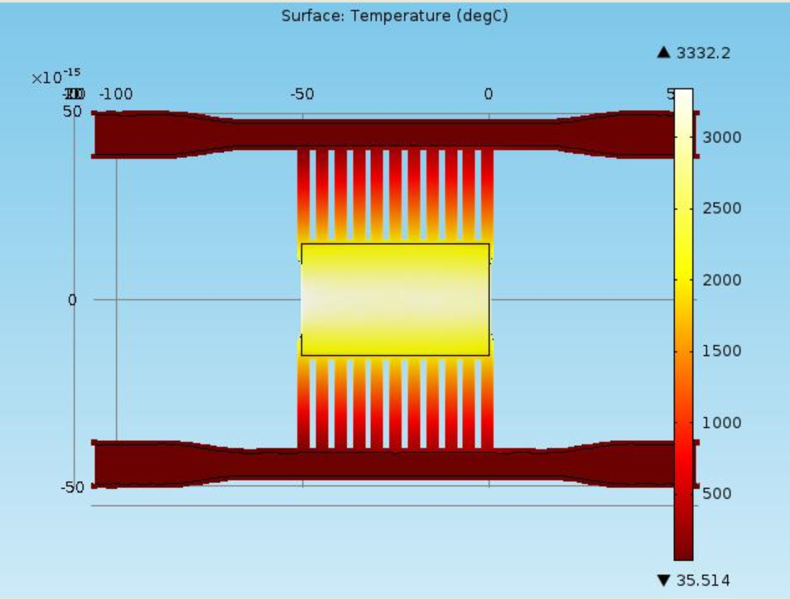
Figure 5.2. Thermal profile of the target container at 50 kW beam power
(left – 1mm fins, right 3.5mm fins)
The LERF has an isolated water cooling system located in the accelerator vault that has sufficient cooling capacity; it is rated for the full recirculated beam power of 100kW. This “Dump Water Skid” has its own recirculation pump, monitoring system, resin bed, and a parallel plate heat exchanger to the normal LCW system.
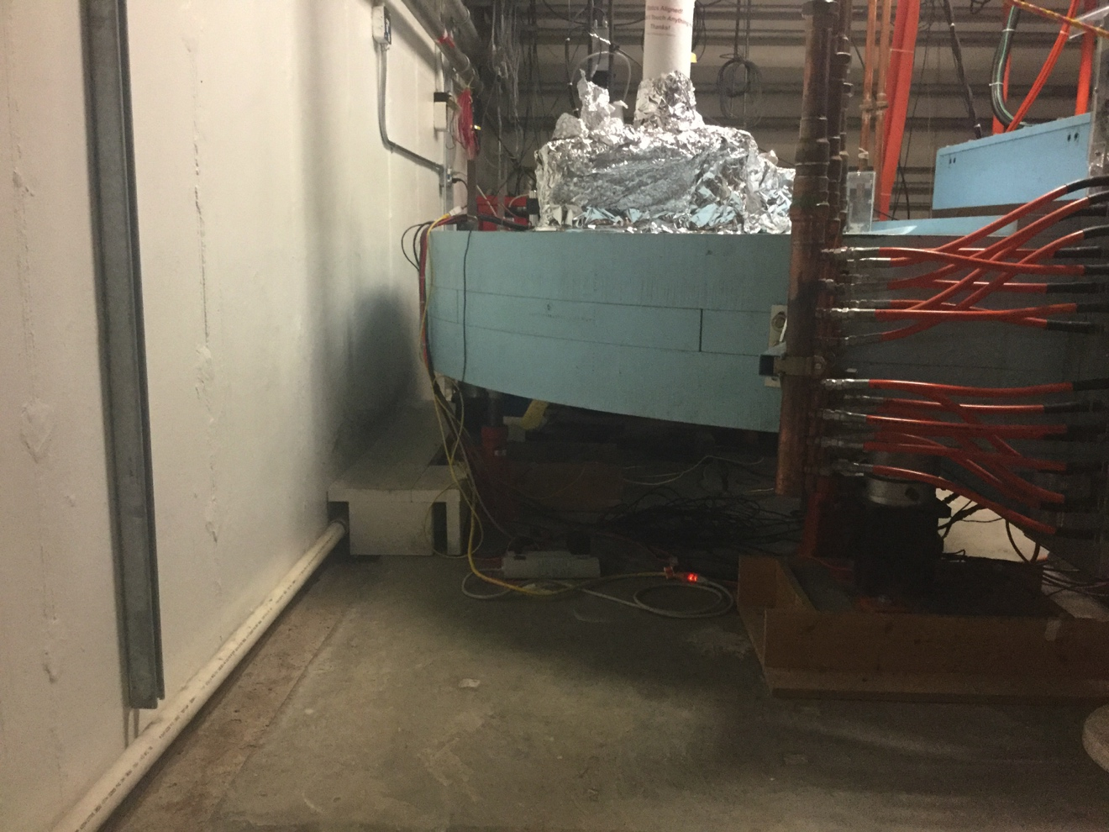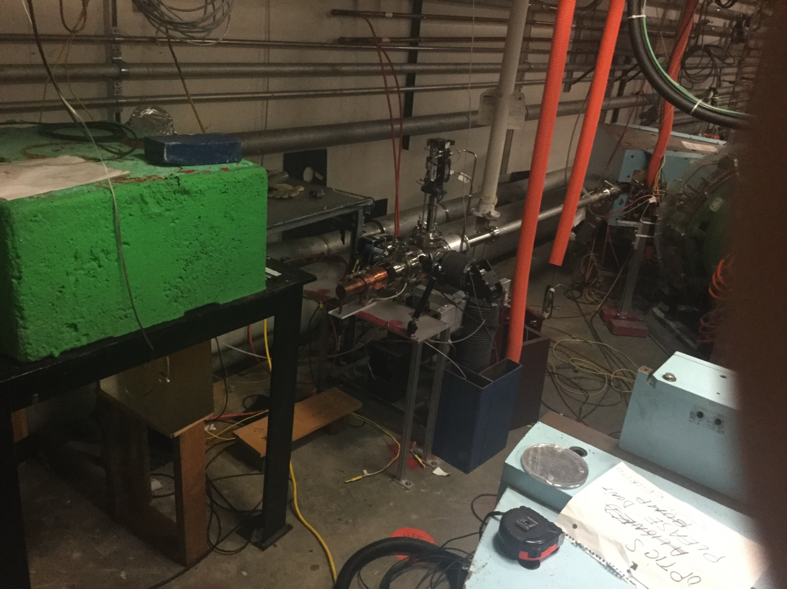
Figure 5.3 Standby location of the “pig” (under the blue dipole) and the irradiation area (green shielding block)
The area under the blue dipole (Figure 5.3) will be shielded. Inside the shielding will be a transport system (rails/trolley) to retrieve the gallium target container after irradiation. The blue dipole is ~5m away from the irradiation area (green shielding block in Figure 5.3). Once the irradiation is complete, remote electro-mechanical actuators will remove the cooling lines and lower the target container into a shielded enclosure (“pig”). When the target container is ready to be retrieved, the “pig” travels from the blue dipole to the location under the target. Once the target assembly is secured into the “pig” and the cover is installed, the assembly will travel back to the station under the blue dipole. The “pig” assembly is now moved to a removable dolly and then towed out of the vault and into the elevator. This will enable the retrieval of the target container with minimum radiation exposure to personnel. The target container will be shipped to VCU.

6.0 Production Economics, Costs and Cost Justification
The previous sections have shown it is possible to produce ⁶⁷Cu from a liquid gallium target using a high average power 50kW electron beam from the JLab LERF machine. A target system made of tungsten integrates the radiator and the liquid gallium target and produces an efficient photon conversion of the gallium to ⁶⁷Cu. Heat deposited in the target will be removed using a closed water-cooling loop. The Ga-Cu liquid will be transferred to a shipping container and sent to VCU for chemical separation.
Economics of the process are shown in Table 6.1, for 10 production runs per year (does not include amortized fixed onetime costs). The costs are based on FY15 DOE-approved rates for JLab and standard VCU rates. A fully burdened cost of ⁶⁷Cu averaged over 10 runs is $3.1K/mCi. (If onetime costs are amortized over 5 years, the cost per mCi will be substantially lower).
Onetime Costs ($405.196K)
Once acquired, these items will be used for a few years. Two onetime costs, DOT type B transportation container and the 99.9999% chemically pure gallium target material, are not included here. They are included in the Test Costs section.
Operating Costs – Irradiation ($306.142K):
Minimum time at LERF is a shift of 8 hrs. duration: 4 hrs. are allocated to the setup of the accelerator and 4 hrs. for irradiation.
Operating Costs – Separation ($113.545K):
These are costs for chemical separation, purification, and determination of specific activity
Test Costs to resolve issues ($123.311K):
Three items described in section 7 will be resolved by a set of test runs. The transportation container and the target which can be reused are listed here.
The cost estimate assumes that the tests will occur in FY16. Onetime and operating costs will span FY16 and FY17 with costs loaded with FY17 values.
The fully loaded cost recovery includes all of the items listed above, for 10 runs to obtain 310 mCi of ⁶⁷Cu, (one day after irradiation), is $948.187K.

Onetime Costs
Item | Loaded $K | Institution
Remote Manipulator | 207.665 | VCU
2 Target systems made of Tungsten | 177.275 | JLab
Remote Target Controller – Senior Engineer | 20.256 | JLab
Total | 405.196
Operating Costs for 10 runs
Item | Loaded $K | Institution
Irradiation |  | JLab
LERF Operation –10 shifts (each shift is 8 hrs.) | 224.560 | JLab
Install, remove, ship target - Technician III -23 weeks | 71.991 | JLab
Install/remove shielding between runs - Technician III - 1.6 weeks | 5.032 | JLab
Shipping Charges | 4.559 | JLab
Separation
Glassware | 8.110 | VCU
Chemicals | 5.793 | VCU
Chromatography Columns | 10.428 | VCU
Hot Cell Supply Lines and Valves | 15.062 | VCU
Radiochemist | 33.368 | VCU
Analytical Chemist | 26.880 | VCU
Faculty Salaries | 13.903 | VCU
Total | 419.686
Test Costs to Resolve Issues
Item | Loaded $K | Institution
LERF Operation – 8 hr. Shift – 1shift | 22.456 | JLab
DOT Type B Transportation Container | 12.690 | JLab
Target – 99.9999% Chemically Pure Gallium | 1.194 | JLab
Senior Scientist – Radcon – 1 week | 6.366 | JLab
Scientist II – Radcon – 1 week | 4.257 | JLab
Senior Engineer – Accelerator Ops – 1 week | 5.093 | JLab
Technician III – 1 week | 2.954 | JLab
Lab Supplies | 13.660 | VCU
Scientist – 1 week | 22.767 | VCU
Chemist – 1 week | 22.767 | VCU
Technician – 1 week | 9.107 | VCU
Total | 123.311
Table 6.1 ⁶⁷Cu Production Costs

7.0 Summary and Conclusion
We have determined that production of ⁶⁷Cu is technically feasible at the JLab LERF. Gallium as the production target allows us to use 40 MeV electron beam at high beam power (50kW). This results in high production rates of the desired isotope without producing large fractions of undesirable ⁶⁴Cu isotope. This is achievable in a relatively short beam running time of 4 hours while operating at only 40% of LERF power capability. We have a conceptual design of a beam target system which is capable of dissipating the heat generated in the target system by the beam power.
We have estimated the cost of production on the basis of 10 production runs per year with each run producing ~31 mCi of ⁶⁷Cu per run at a cost of $3.1K/mCi. Detailed costs and justification were presented in Section 6 above.
These results are attractive to carry the effort forward to commercialization. We propose to resolve three issues prior to the start of production:
- Our estimates of productions rates (and therefore costs/mCi) have been made using the best available data on cross sections. A test is essential to verify the estimated production rates and cross-sections.
- We must verify the technique to chemically separate 10s of nanograms of ⁶⁷Cu from a few hundred grams of gallium while reducing or removing other common copper isotopes.
- It may be possible to further remove copper from the purchased gallium. It would be useful to pre-purify one sample of gallium at VCU, irradiate this sample and compare the ⁶⁷Cu activity with untreated sample.
These issues can be resolved by a low power (1-5kW) tests at a cost of $134.6K. We propose carrying this effort forward with a set of test runs to qualify our process and validate the economics.
There are other isotopes that may be produced in a cost effective manner using electron beams. For example, ²²⁵Ac can be produced from a radium target. ²²⁵Ac will be indirectly produced by ²²⁶Ra (γ,n) ²²⁵Ra, followed by beta decay of ²²⁵Ra to ²²⁵Ac. While radium is an expensive material, it could be recycled after chemically removing the actinium and subsequently reused. An experimental validation of this approach would be useful. The feasibility of producing clinically useful quantities of ²²⁵Ac has been demonstrated [1, 2]. Another target of interest that could be used as a parent for the ²²⁵Ac production is ²³⁰Th (Appendix A).

7.1 References
[1] Morgenstern, A, (2009) Production and Pre-Clinical Testing of Ac-225/Bi-213 and U-230/Th-226, 6th Alpha-Immunotherapy Symposium, Toronto, June 2009.
[2]http://apps.snm.org/docs/CME/PresenterItems/EventID_85/PresenterItemTypeID_1/14.%20Alfred%20Morgenstern%20-%20330.pdf

Appendix A: Preliminary Study – ²²⁵Ac production
LERF is a very configurable accelerator both in energy and current which makes it a suitable machine for Photoproduction of many isotopes. One of the isotopes of interest is ²²⁵Ac which may be produced via either ²²⁶Ra(γ,n)²²⁵Ra or ²³⁰Th(γ,n)^{229Th} at energies lower than threshold of two-neutron production (E<~12 MeV). This is attractive because of low production of accompanying radioactivity, in both reactions. Our investigation of this isotope was cursory for two reasons: first, we wanted to focus on ⁶⁷Cu and second, we were unable to locate a source of target material.
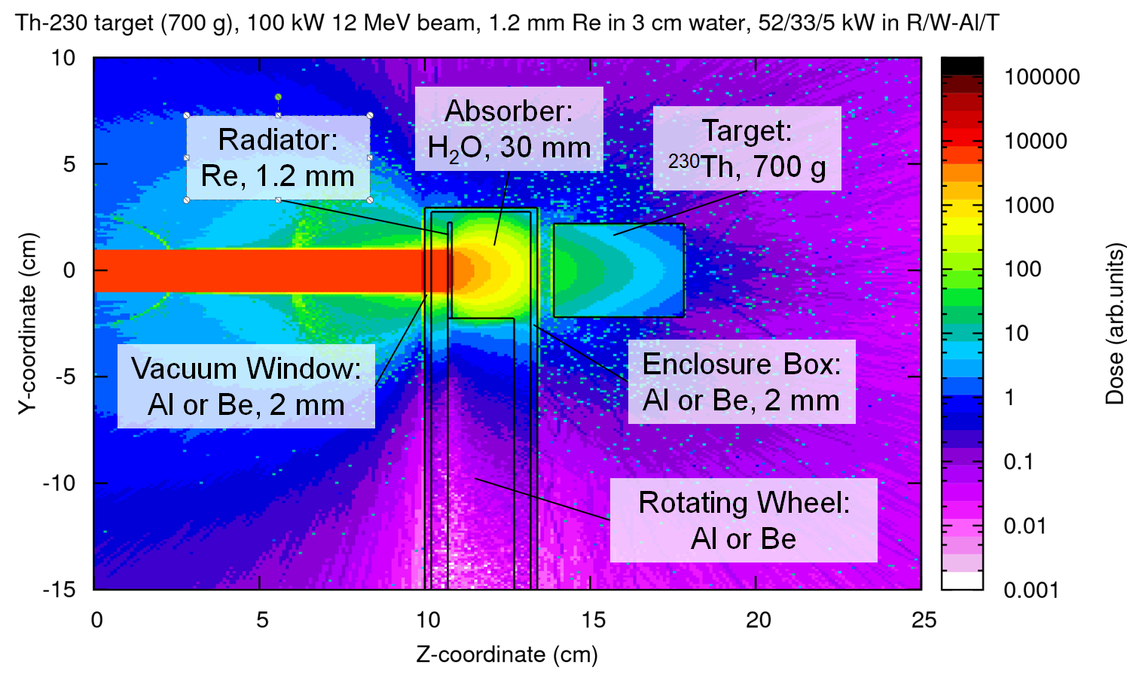
Figure A.1 – Conceptual set up for ²²⁵Ac production
We will briefly describe a likely path for ²²⁵Ac production using a beam power of 100 kW. One of the investigators (P.D) has a patent (US Pat.#8,334,523 B1) “Moving Core Beam Energy Absorber and Converter”. The concept is as follows: a ~1 mm thick radiator in shape of a flat ring mounted on the internal rotating wheel, which is suspended in the flow of coolant (water). The radiator will be placed close to the beam entrance. The coolant will be of sufficient thickness to prevent most of the electrons from reaching the target, thus limiting the power on the target (Figure A.1). ²³⁰Th is attractive due to the large ²³⁰Th(γ,n)²²⁹Th cross-section, and low intrinsic radioactivity. According to FLUKA calculations, it would take about 500 hours of electron beam irradiation at 12 MeV, 100 kW, to produce approximately 1 mCi of ²²⁹Th in the target. After that the target becomes the sustained source of ²²⁵Ra (²²⁹Th half-life is 7880 years). It takes about 18 days to regenerate 1 mCi of ²²⁵Ac from 1 mCi of ²²⁹Th in equilibrium with ²²⁵Ra. The separation of ²²⁵Ac would follow fairly well established techniques. If the separation technique preserves both Thorium and Radium in the target, then such target may become a long-term operational factory producing 1 mCi of ²²⁵Ac every 2-3 weeks.

Appendix B: Thomas Jefferson National Accelerator Facility (JLab)
JLab has pioneered superconducting radiofrequency (SRF) technology for the lab’s CEBAF electron linear accelerator (linac) and has built up extensive experience of over a quarter century in the design, fabrication and operation of SRF electron linacs. It also pioneered high-power SRF energy-recovery linac (ERL) technology for the lab’s high-average-power free-electron laser (FEL) [1].
LERF offers advantages for production of isotopes. As an electron linac, it is a reasonably simple device to operate and maintain and can be run by a small group of trained technicians, Beam energy and current are ‘tunable’ allowing optimization of beam parameters for specific isotopes. For this proposal, we will limit our beam energy and current to 40 MeV and 1.25 mA respectively.
Figure B.1 shows LERF’s main components. It begins with an injector, which provides the electron beam bunches, typically from a laser-driven photocathode. This beam is then accelerated by one or more SRF cavities. Typical accelerating gradients are 10–15 MV/m. The cavities are submerged in a helium bath within a cryomodule. The beam is steered and focused with magnets and beamline components until it is delivered to the target apparatus.
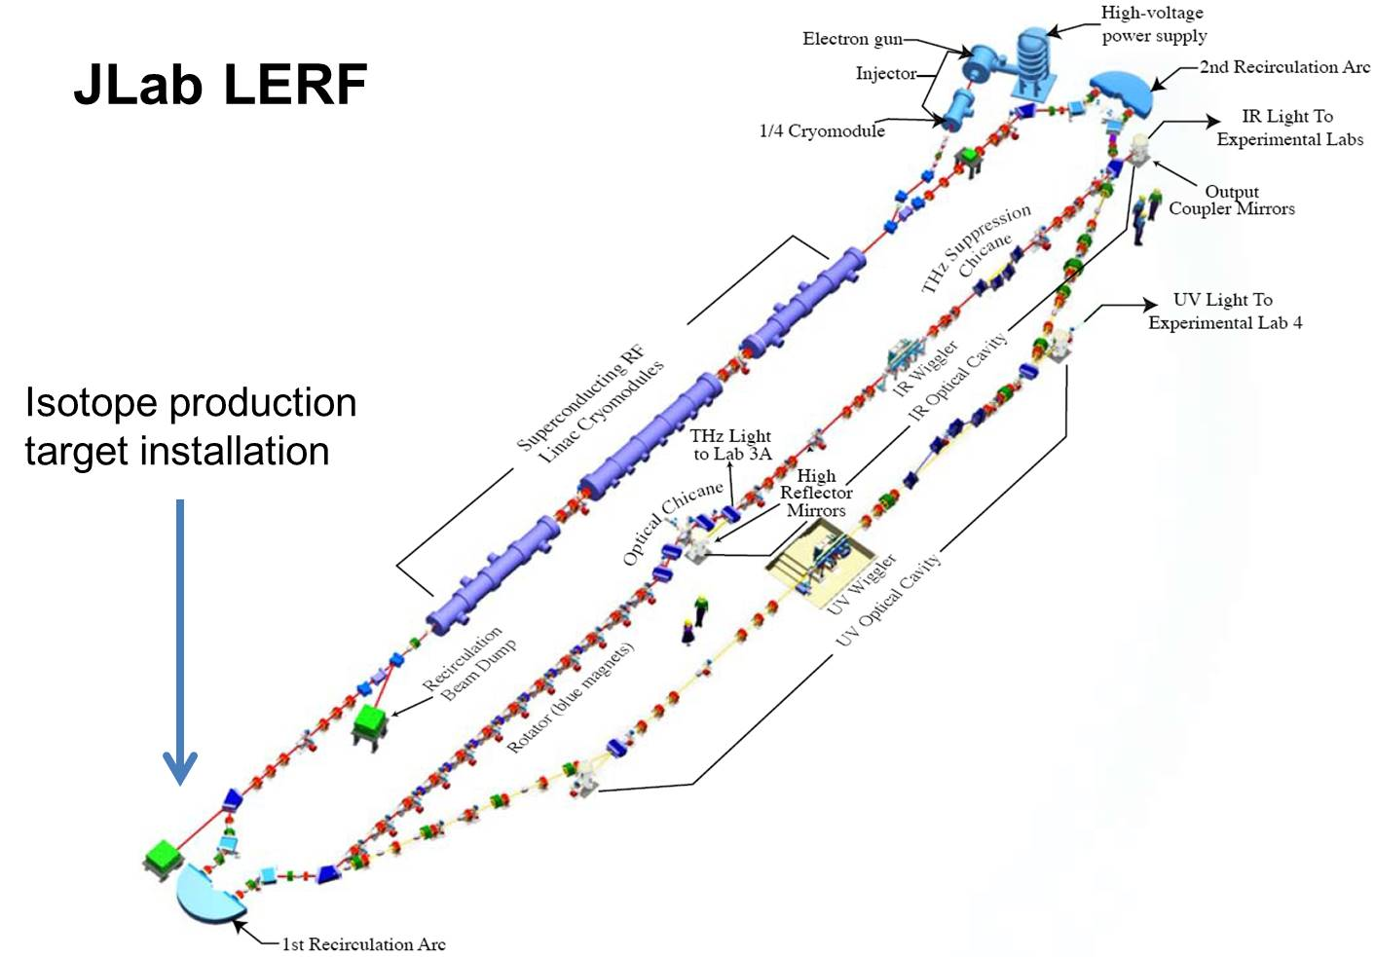
Figure B.1. LERF at JLab. Dimensions are 65 m × 6 m. For isotope production, the beam will go to the straight-ahead beam dump at the location indicated. Such an installation will not interfere with other uses of the machine such as installation of the DarkLight NSF experimental search for dark matter.
The heart of the LERF is the linac used for both acceleration and energy recovery of the electron beam. For energy recovery to be efficient the cavities need to a) have a high accelerating gradient to give maximum acceleration per unit length of linac, and b) have low inherent losses in the accelerating structure. This naturally leads to the use of SRF over normal conducting copper structures, as both the maximum accelerating gradient and the cavity losses are lower. There is of course the added cost of the associated cryogenic systems that are required, but many studies suggest that during operating lifetime of similar facilities the accumulated cost is significantly less. An SRF system working in CW mode is often the optimum solution for high average power electron beam production.
In the initial isotope production effort proposed here we will not use the energy recovery capability. Rather, we will utilize a straight-ahead beam dump in the location indicated in Figure B.1. This location is convenient for shielding and has the added advantage of non-interference with other projected uses of the machine. The dump area will require additional new shielding (available on site) to deal with the 50 kW of beam incident at 40 MeV producing neutrons (the existing energy recovery dump is designed for 100 kW of beam but at energies less than 10 MeV or so no neutrons are produced). If our initial efforts at utilizing photonuclear reactions to make isotopes are successful, we will explore the extension of this approach to techniques using energy recovery as well.
JLab will utilize services of the Accelerator Operations Group to run the accelerator for the isotope production (this is the same group that runs CEBAF). All accelerator operations will be directed from the CEBAF Machine Control Center. Handling of the radioactive materials will be managed by the JLab Radiation Control Group, which will review and monitor all manipulations of the radioactive target. They will also bear responsibility for packaging and shipping of the target material to VCU for chemical separation. A summary of the VCU facilities and capabilities is in Appendix C.

Appendix C: Virginia Commonwealth University (VCU)

C.1 Description of facilities and capabilities
VCU, located in downtown Richmond, Virginia has an excellent intellectual environment that is ideally suitable for this proposal. It is a major, urban public research university with national and international rankings in sponsored research. The VCU Medical Center campus occupies approximately six square blocks in downtown Richmond. VCU is a state-supported, Carnegie Extensive research institution and, as such, has a number of resources and research-based centers to support research endeavors. Building on a heritage of established strengths in clinical and translational research, VCU has established the Center for Clinical and Translational Research (CCTR) to provide the necessary longitudinal and cross-disciplinary networking, culture, and infrastructure for identifying promising discoveries made in the laboratory, and developing trials and studies for humans. VCU has subscriptions to numerous journals in electronic and hard copy versions and also has a very good collection of books in its libraries.

C.1.1 Hospital, Clinical Teaching and Research
The Medical College of Virginia Hospital of the VCU Health System, the Fairfax Inova Hospital, and the McGuire Veterans Administration Hospital together with their associated outpatient clinics provide the clinical teaching sites for medical students. In alignment with the teaching sites, the General Clinical Research Center and the Massey Cancer Center, provide facilities for clinical research studies.
VCU is the home of Massey Cancer Center (MCC), one of only 65 NCI designated cancer centers, striving to bring their discoveries from the laboratories to the bedside as quickly and safely as possible. MCC is central Virginia's most important resource for cancer research, clinical trials, and treatment, with an annual census of more than 1,400 patients. In addition to its research activities, VCU Massey Cancer Center provides comprehensive, nationally recognized clinical oncology care, including a full range of medical and support services. More than 175 full, associate, and affiliate members from 28 academic departments, five schools and one college, come together at VCU Massey Cancer Center to conduct basic, translational, clinical and population sciences research to discover better ways to prevent, diagnose, and treat cancer. Research programs include developmental therapeutics, radiation biology and ontology, cancer cell biology, immune mechanisms, and cancer control. Moreover, the School of Medicine has a large vibrant group of investigators. This intellectual environment informs and inspires, and will contribute greatly to probability of success.
The Center for Molecular Imaging (CMI) is one of the VCU School of Medicine’s Research Centers. CMI was established in 2008 to foster and facilitate multidisciplinary molecular imaging and nanotechnology research using advanced non-invasive imaging technologies. The emphasis is on multi-modality imaging approaches to study biology, biochemistry and pharmacology in vivo. Through these efforts, CMI provides a hub for translational research with basic and clinical scientists at VCU and beyond. The VCU Massey Cancer Center (MCC) is one of the centers that have imaging support provided by the CMI. Through a focus on investigator-initiated therapeutic trials and the development of a clinical research affiliations network, the Center is extending its clinical trial offerings to patients across Virginia, helping to bring new drug discoveries to the state’s residents. Along with a dedicated wet laboratory and chemistry space, the CMI investigators have direct access, from within its radiochemistry laboratory, to a 16 MeV Proton GE PETtrace self-shielded Cyclotron (GE Healthcare) operated through partnership with IBA Molecular Inc, USA. The CMI investigators of this proposal have access to a preclinical work area with hot cells, radiochemical and chemical hoods, as well as mini-cells and associated work areas, all adjacent to the preclinical nuclear imaging facility located conveniently adjacent to the cyclotron and the radiochemistry laboratory in the Gateway Building. In addition, all investigators have access to the other shared resources and facilities maintained and professionally staffed by VCU.

C.1.2 Facilities and Resources
- Radio-Chemistry, Nano Chemistry, Cell Culture and Molecular Biology Laboratories: The CMI has three laboratories (362, & 430 sq.ft.) for molecular, cellular biology and biochemical studies in the Sanger Building and two laboratories (483 & 480 sq.ft.) for radiochemistry in Sanger and Gateway buildings. There are two imaging suites one is located in the Gateway building with state-of-the-art PET/SPECT/CT and optical fluorescence imaging equipment and another in the Sanger Hall Building with a 7 Tesla/30 cm horizontal bore Magnetic Resonance Imaging system, Multispectral Optoacoustic Tomography (MSOT) and a R4 microPET. Adjacent to the nano-chemistry laboratories in Sanger is an equipment room (255 sq.ft.) and a cell culture and fluorescent microscope room (139 sq.ft.). There is a walk-in 4C° room (200 sq.ft.), ice-maker, autoclave, photocopier, and a dark room with an automated X-ray film developer down the hall from the laboratory. The radiochemistry laboratory in Gateway building (480 sq.ft.) has seven hot-cells, three auto synthesizers and three HPLC systems in addition to the basic equipment for SPECT (and PET) radiochemistry.
- Cyclotron Facility: CMI has access to a 16 MeV Proton PET Trace Cyclotron operated through partnership with IBA Molecular. Targetry for the production of O-15, N-13, C-11, F-18, Zr-89, as well as solid targets for the production of I-124, Mn-52, and other inorganic PET radionuclides, are available on this machine.
- Radiochemistry Laboratory: The radiochemistry laboratory has seven hot-cells, four auto synthesizers; three HPLC systems and HPGe gamma spectroscopy system in addition to basic equipment for SPECT and PET radiochemistry such as radio TLC etc. There is also a gas chromatography system that will be used for organic solvent analysis. (Figure C.1)
- Preclinical small animal imaging facilities: The imaging suites of the Center for Molecular Imaging (CMI) are located in two adjacent buildings the Medical College of Virginia campus of Virginia Commonwealth University. The imaging equipment available with CMI can support multimodality molecular imaging of small rodents such as mice and rats.
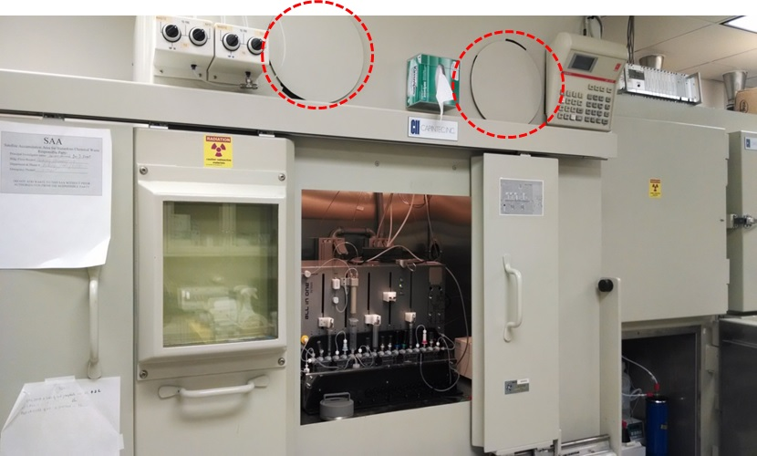
Figure C.1: The hot cell that will be used for isotope separation. The remote manipulator will be fitted through the access ports at the top

C.1.3 Other Equipment at the Center for Molecular Imaging
The laboratories house an automated Forma CryoPlus 1 liquid nitrogen freezer, one -80°C freezer, two upright -20°C freezers, five 4°C refrigerators, and an Eppendorf thermocycler, two large centrifuges with temperature control, four micro centrifuges, one with temperature control, electrophoresis systems for running DNA/RNA and protein gels. A gel documentation system is available as a shared resource adjacent to the laboratories. An Olympus fluorescent microscope with `Nuance system’ for multi-spectral imaging (Cri Inc, USA) and a Beckman Coulter multimode plate reader are also available within the PI’s laboratories. A phase-contrast microscope is also available for cell culture. The laboratory also has Mettler analytical and standard balances, a 37°C shaking incubator, one water purifiers, a sonicator, 2 BioRad western transfer apparatus, pH meters, microwave oven, a UV/Visible spectrophotometer, fluorescence spectrophotometer, and a variety of water baths, orbital shakers, vortex mixers, stir plates, pipettors, and vacuum pumps. The cell culture and microscope rooms house A2/B3 Biosafety cabinet, two CO₂ water-jacketed incubators, a refrigerator for cell culture reagents.

Appendix D: South Dakota School of Mines and Technology
SDSM&T’s relevant expertise and facilities lie in nuclear physics (especially photonuclear physics), and chemical and metallurgical engineering.
Nuclear Physics: SDSM&T 6 nuclear and particle physics faculty, of which 2 specialize in nuclear physics. Among the relevant nuclear facilities for radio-isotope production, purification and measurement are three facilities supported by SDSM&T in partnership with the nearby Sanford Underground Research Facility (http://sanfordlab.org/science) and several partnering universities. These include:
- CASPAR (Compact Accelerator System for Performing Astrophysical Research): a low-energy particle accelerator housed a mile below the surface that will allow researchers to mimic nuclear fusion reactions in stars. It is called a compact system because it is a very small accelerator.
- The MAJORANA DEMONSTRATOR: A complex of ultra-pure and ultra-low-background germanium detectors & shielding at the Sanford Underground Laboratory a mile below the surface in what we call a “Demonstrator Module.” The first half of the detectors will be fabricated from natural germanium, which is 7.44% ⁷⁶Ge. Shielding materials, including ultra-pure copper, are purified and manufactured at SURF to enable extreme purity and, therefore, extremely low background spectroscopy.
- The Berkeley Low Background Counting Facility, recently re-located to a location a mile beneath the surface at Sanford Underground Research Facility, will enable extremely precise and low-rate radioactivity levels in materials from photo-production experiments. This low-background facility is supported and complemented by surface HPGe gamma spectroscopy measurement capability.
SDSM&T has extensive capabilities in Chemical Engineering and Materials and Metallurgical Engineering.

