Isotope Production Run Plan

Revision Number: 1

Technical Custodian: Stephen Benson, Chris Tennant

Estimated Time to Perform: 2 Days

Document filename: Isotope Beamline Run plan

Procedure Overview
Once the target beamline is commissioned and shown to be able to run 1 kW of beam power to the isotope target at 25 MeV, we can do an extended run with a gallium target to produce isotopes.
Hazards
- Radiation activation of the target.
- Pinch hazards of the target removal system.
Prerequisites
- The Isotope Beamline commissioning plan must be carried out successfully.
- Target system installed and operational with a tungsten radiator, gallium target, and graphite plug.
- ERR must have occurred and all action items must have been addressed.
- Beam authorization for 1 kw of CW beam at 25 MeV must be given by the head of acceleration operations.
- Before operation, all cavities should be tuned to be close to the proper frequency using an RF cart.
Tune beam tests

Recover setup to 1X dump
  - Restore the settings from the 1X commissioning run and cycle all magnets.
  - Turn on tune beam and adjust the drive laser and cavity 3 phase and laser power to get 8.6 pC charge and the correct spots on ITV0F04 and ITV0F06 as recorded from the commissioning run.
  - Verify that the beam is centered in the injector cryounit, the 0F, 1F, and 2F quadrupoles, and the ITV0F01 viewer.
  - Verify that the zone 2 cavities are properly crested using the 1X01 viewer.
  - Use the zone 2 gradients to set the beam energy to reproduce the IPM1X01 and ITV1X01 positions from the commissioning run.

Verify CW operation
  - Verify that the beam loss is negligible on all BLMs when their voltages are set to at least -1000 V. If necessary, use the laser buncher gang phase or the 0F quads to reduce losses.
  - Unmask all BLMs, withdraw all viewers and ramp up the duty cycle until CW beam is achieved with 40 microamps of beam as indicated on the injector current cavity. Mark the time and log the vacuum levels.
  - Monitor the vacuum levels near the 1X beamline. Verify that they do not rise more than a factor of two.
  - Allsave this configuration “Isotope production at 25 MeV – mm-dd-yyyy”.

Perform Isotop Irradiation
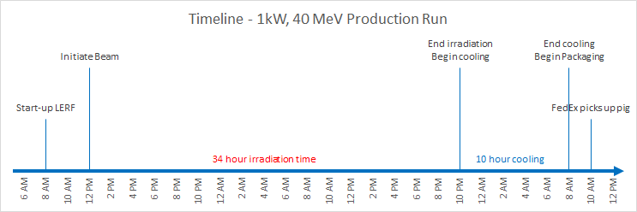

  - While monitoring the vacuum levels and beam current, continue to run CW beam to the target. Reset RF , BLM, and magnet faults as they occur. If they cannot be reset, go back to tune beam and verify the phases.
  - When 34 hours has elapsed, shut the beam down and Allsave the machine parameters. Log the time that the was shut off.
  - Perform a weekend shutdown but do not drop the vault to restricted access. All personnel entering the vault must be accompanied by Radcon personnel.
  - When 10 hours has elapsed after the beam shut-off, have Radcon go in and measure the radiation levels around the target.
  - After having received permission from Radcon, withdraw the target and quickly transfer the crucible to the lead pig.
  - Close up the shielding and post the area if necessary.
  - Move the lead pig up to User Lab 3 , conduct a gamma spectrogram, and pack up the crucible for shipment to VCU.
  - Have FedEx ship the crucible to VCU.

Backout procedure
  - Restore the settings from the last allsave that reached the 1X dump.
  - Perform a weekend shut-down procedure.

Task complete.

