SNS-PPU Cryomodule Shipping Preparation Strategy

Contents
Introduction 1
Current Shipping System Design 1
Shipping Specifications 2
Shipping System Design Verification Testing 3
Simulated Cryomodule 3
Road Tests with Simulated CM 3
Testing with a Production CM 4
Testing Goals 4
Instrumentation 4
Changes to PPU Shipping System 4
Tractor/Trailer: 4
CM Installation on Shipping Frame 5
Instrumentation Housing 5
Proposed New Shipping System 5
Summary 5

Introduction
Seven SNS-PPU cryomodules (CM) will be fabrication at JLab and transported ~500 miles via road to ORNL. The shipping system is based on that which was used to transport 20 cryomodules in the early 2000s as part of the original SNS project. The CMs are installed on a tray (inner frame) which uses helical wire rope springs to attenuate shocks and vibration. The entire assembly is transported by a single drop trailer fitted with air-ride suspension

Current Shipping System Design
The shipping frame consists of two trays, the Inner Frame and the Outer Frame (Figure 1). The CM is sits on saddles which are attached to the Inner Frame. It is held on to the frame by means of ratchetting straps. Rubber strips of thickness 1” ensure full contact between the saddles and the vacuum vessel, while avoiding metal to metal contact. The inner frame is attached to the outer frame by twelve helical wire rope isolator springs (Aeroflex CB1500-12-C2). The springs are installed at a 45 degree angle to allow for a wider range of attenuating orientations. The full assembly is installed on a single-drop trailer using heavy duty ratchetting straps. The CM and springs were then covered with tarp during the road trips.

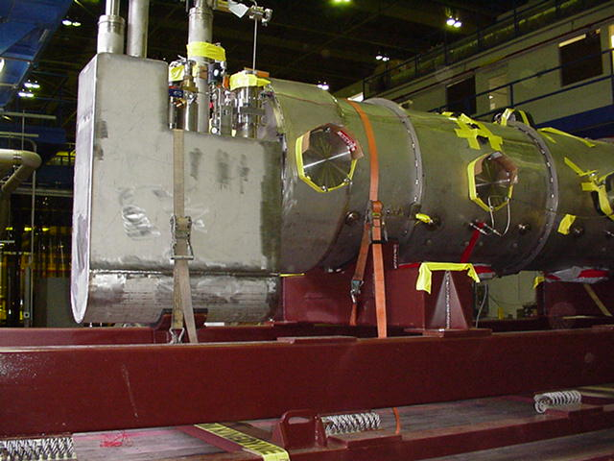
Figure 1: A high-beta SNS CM installed in the shipping frame

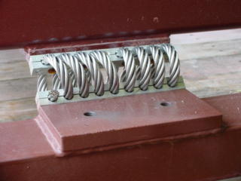
Figure 2: Wire Rope Isolator spring installed on the SNS shipping frame

Shipping Specifications
The CMs are designed with a conservative set of allowable shock loads (Table 1). The shipping process is the only time the CMs will likely see comparable loads. Table 2 shows the predicted shock damping from this spring configuration. The “Input Shock” is that which is predicted on the Outer Frame, while the “Predicted Response” is what would be felt by the CM on the Inner Frame. The input shocks are of length 20ms. The values are far lower than the specs shown in Table 1.

In addition to shock loads, the CM needs to be shielded from vibrations at its components’ resonant frequencies. A set of simple modal analyses will be used to determine any resonant frequencies close to those liable to be excited by the road travel. The most dangerous condition is having the spring system excited by the natural frequency of the air-ride suspension (1.5 – 2.0 Hz). The spring frequencies are shown in Table 3.

Allowable Shocks on CM
Lateral (X) | +/- 1.5g
Vertical (Y) | +/- 4.0g
Beamline (Z) | +/- 5.0g
Table 1

Shock Attenuation
Direction | Input Shock | Predicted Response
Lateral | 1.0g | 0.42g
Vertical | 2.5g | 0.85g
Beamline | 1.0g | 0.25g
Table 2

Spring Resonant Frequencies
Lateral (X) | 8.0 Hz
Vertical (Y) | 6.5 Hz
Beamline (Z) | 4.0 Hz
Table 3

Shipping System Design Verification Testing
Though the majority of the PPU CMs retains the original SNS design, a few of the modifications will require changes in the shipping frame. The Supply and Return End are supported by a small saddle attached to a dedicated cross-member on the Inner Frame (see Figure 1). In the PPU version, the cans are smaller and positioned lower in relation to the vacuum vessel. These cross-members will need to be modified in order to account for the change. As this alters the shipping configuration, a new set of design verification tests are recommended.

Simulated Cryomodule
The performance of the shipping frame can be simulated using a representative structure. It is important that the total mass of the structure and the center of gravity is comparable to the actual CM. There are several methods by which this may be achieved. A non-exhaustive list is below, in order of increasing complexity:

- Weights may be added to each of the main support cross-members (on which the saddles are attached). A total of 12,000 lbs would need to be divided between the two supports. Though this method would simulate the weight of the CM, it would be difficult to also simulate the correct center of gravity
- An I-beam of the correct weight can be positioned between the two main saddles. The beam would be raised an amount from the saddles to provide the correct vertical center of gravity, while the center of gravity in the horizontal plane could be obtained by adding additional weights. This setup could be used for road testing.
- A large pipe equal in diameter to the vacuum vessel may be filled with concrete to a level that matches the weight of a CM. This would then fit on the existing saddles and use the same restraint mechanisms as an actual shipment. Additional weights or compartments for the concrete fill may be used to obtain the correct vertical center of gravity. This setup could be used for road testing
- A small pipe representing the cavity string may be positioned in a concentric manner within a larger pipe that is the size of the vacuum vessel. The smaller pipe would be filled with concrete to simulate the weight of the cavity string and other internal CM components. This would be the most representative structure to simulate a CM, though it would also be the most complicated and expensive. Road testing with this setup could make use of instrumentation on both the outside of the simulated vacuum vessel and inside on the weighted pipe.

Measurements of the spring deflections may be obtained from any of the simulated CMs. The Inner Frame should be stiff enough to ensure that all of the springs are in compression. Large deflections in the Inner Frame caused by the loaded weight would result in some springs being loaded in tension, which would negate their ability to attenuate shocks. A possible consequence to finding that the Inner Frame is deflecting too much would be to:

- Reposition the springs
- Select new springs
- Stiffen the Inner Frame

Road Tests with Simulated CM
It is recommended that the modified shipping frame be road tested with, at the least, a simulated CM. The shipping frame and trailer would then travel a short distance (e.g. JLab to Richmond) on roads representative of those to be taken for the actual shipments. This trip can provide a basic idea of the shipping frame’s isolation capability. Shock sensors would be used to determine the levels of attenuation being provided by the isolator springs. Vibration sensors would record the resonant frequency peaks of the spring and air-ride systems. Following the short test, a longer test run to ORNL could be implemented to identify any regions of concern for the shipments. An engineer would follow all of the shipments to record road conditions and specific events.

Testing with a Production CM

Testing Goals
The prototype PPU CM from ORNL or the first production CM from JLab may be used for a road test from JLab to ORNL. The test would be preceded by a shorter test run to Richmond to ensure that instrumentation is working correctly. Using an actual CM for a road test is contingent on successful test runs using the simulated loads which show that shocks and vibrations are within acceptable levels. The following would be checked before and after the test run:

- Movement of the cavity string and the gate valves relative to the vacuum vessel and space frame
- No degradation of the insulating vacuum and beamline vacuum
- No leaks in the cryogenic lines
- The CM was not subjected to shocks beyond the design loads

Instrumentation
The shock attenuation capability of the shipping frame will be measured using the SAVER9X shock recorder. Synchronized piezoelectric accelerometers will be installed on the Inner and Outer Frames, and the vacuum vessel. The device’s GPS capabilities may be used to determine any problematic regions on the route from JLab to ORNL. This would be the main instrument traveling with all production shipments

Vibration and motion of the cavity string and gate valve may be measured using the Mide Slam Stick-X units. These may be installed on cavity flanges through the tuner access ports. Additional units may be installed on sensitive components such as the FPCs, close to the ceramic windows. Data from the SSXs may be correlated to any changes in the cavity string position found after alignment checks following a shipment.

The GPS location of the truck and data from the beamline vacuum gauge will be transmitted live to JLab and ORNL during each shipment. The transmitters will be powered by battery packs installed on the trailer.

Changes to PPU Shipping System
Several improvements and modifications are planned for the shipping frame beyond those required to accommodate the new CM design.

Tractor/Trailer:
Information will be taken from industry regarding the correct trailer to be used for the shipments. Ideally, this trailer would be leased for the duration of the project. A single-drop trailer was used in the past; this configuration has the advantage of a lower center of gravity which reduces lateral motion during a trip. The tarp used on the original SNS project will no longer be used, in favor of using a trailer with a sliding curtain side.

CM Installation on Shipping Frame
SNS CMs were installed on the shipping frame using low-capacity ratcheting straps. The shipping frame saddle design will be reevaluated to determine whether a more permanent installation system can be devised. At the least, the straps would be replaced by ones with a higher load capacity.

Instrumentation Housing
A dedicated housing will be welded on to the Outer Frame of the shipping frame to hold the batteries and other instruments required for each trip.

Proposed New Shipping System
Due to the design changes in the PPU CM end cans and FPCs (a sensitive component in terms of shipping), the safest shipping option may be to reengineer the shipping frame or design one from scratch. The new design would take into account the result from modal and stress analysis of the PPU CM design. As a reference point, the SNS shipping frame require approximately 100 hours of engineering time to develop. Some of the possible improvements include:

- A new system to restrain the CM on the shipping frame
- A new spring configuration to lower shocks
- A stiffer Inner Frame

Summary
The Shipping Frame designed for the original SNS project may be modified to transport SNS-PPU CMs from JLab to ORNL. Due to design changes in the PPU CMs, it is recommended that several road tests are carried out with both a simulated CM and an actual CM to verify the shipping frame design. The most conservative route would be to redesign the shipping frame with input from modal and stress analysis of the new CM design.

