fa
Operational Safety Procedure Form
(See ES&H Manual Chapter 3310 Appendix T1 Operational Safety Procedure (OSP) and Temporary OSP Procedure for instructions.)

Title: | LCLS II Cryomodule Testing in the Low Energy Recirculator Facility
Location: |  | LERF Bldg 18 |  |  |  |  | Type: |  OSP  □TOSP
Risk Classification  (per Task Hazard Analysis attached)  (See ESH&Q Manual Chapter 3210 Appendix T3 Risk Code Assignment.) |  |  |  | Highest Risk Code Before Mitigation |  |  |  | 4
 |  |  |  | Highest Risk Code after  Mitigation (N, 1, or 2): |  |  |  | 1
Owning Organization: |  |  | SRFOPS |  | Date:
Document Owner(s): |  |  | Michael Drury

DEFINE THE SCOPE OF WORK
- Purpose of the Procedure – Describe in detail the reason for the procedure (what is being done and why).
The purpose of this procedure is to facilitate the safe operation of the Low Energy Recirculator Facility (LERF) during the testing and operation of an LCLS II cryomodule string consisting of two LCLS II cryomodules and the associated cryogenic and RF infrastructure.
- Scope – include all operations, people, and/or areas that the procedure will affect.
This OSP addresses the activities associated with the testing and operation of a two LCLS II cryomodule installation. The two cryomodules will be connected together using an interconnect unit. High Power RF will be delivered to the individual cavities from an array of 16 1.3 GHz Solid State Amplifiers (SSA’s).
RF Testing will range from individual cavity tests to simultaneous operation of all cavities in both cryomodules. There will be a mix of local (LERF Control Room and MCC) operation and remote access operation. All LCLS II cavity operations will take place in a BEAM OFF state.
Individual tests of cryomodules or other equipment, which require operating parameters outside the scope of this OSP and existing hazard analyses, will be dealt with on an individual basis by separate TOSP’s.
- Description of the Facility – include building, floor plans and layout of the experiment or operation.
The LERF accelerator is located in the basement of the LERF (Building 18) in an area known as the LERF vault. The vault is a below grade, concrete enclosure that provides radiological isolation for the accelerator control room, support equipment areas, and laser laboratories above.
The LERF accelerator originally consisted of:
- an injector
- an energy-recovery linac containing 3 ¼ cryomodules
- two beam lines
- two permanent magnetic based wigglers – one on each beam line (one producing laser light in the infrared (IR) range and the other producing laser light in the ultraviolet (UV) range)
- a broadband terahertz (THz) port

The original energy recovery linac and beamline has been dismantled leaving only the quarter cryomodule and one C20 style cryomodule in the first two zones of the original LERF linac.

The two LCLS II cryomodules are to be installed in the aisle in parallel with the LERF linac from zones FL02 to FL03. See Figure 1
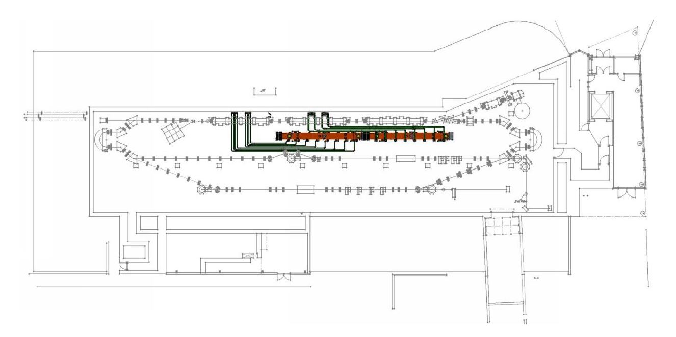
Figure 1: CM Locations

A set of 16 SSA’s along with racks containing llrf, resonance control, interlock and magnet controls have been installed in the gallery aisle on the 2nd floor in Zones 3 and 4. Waveguide from the SSA’s run down to the vault through existing penetrations.

There are two Access points to the LERF Vault:
Personnel entrance through a labyrinth and a roll up door used for cryomodule delivery. During LCLS II testing, concrete blocks are installed outside the equipment door for shielding purposes. See Figure 2
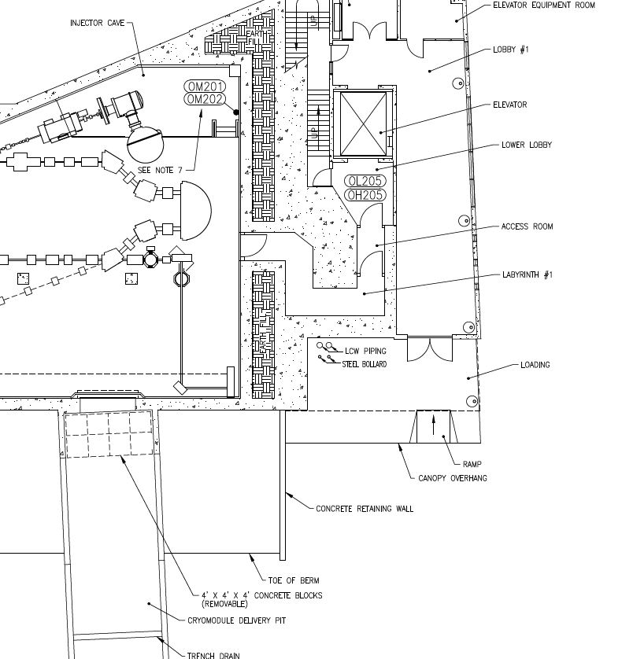
Figure 2: LERF Enclosure Access

Utilities:
- CHL 1 supplies liquid and gaseous helium to cool cryomodule helium vessels and shields. These cryogens will maintain the helium vessel at 2-4K and the shield at ~ 45K.
- Warm nitrogen supply is available in the LERF enclosure.
- High power RF will be coupled into the LCLS II cryomodules from one or all of the sixteen 1.3 GHz SSA’s located on the 2nd floor in the LERF Gallery.

ANALYZE THE HAZARDS and IMPLEMENT CONTROLS
- Hazards identified on written Task Hazard Analysis
- Electric Shock
- Cold Cryomodule ODH Hazards
- ODH Hazard from warm Nitrogen line
- 480 V Electrical Hazards associated with 1.3 GHz SSA electrical panels
  - Arc Flash from Disconnect
- Non–Ionizing Radiation from waveguide leakage
- Prompt Ionizing Radiation associated

- Authority and Responsibility:
  - Who has authority to implement/terminate
Director of Accelerator Operations - The Director of Accelerator Operations provides LERF operations oversight, including participating in program development and scheduling, and authorizing beam and lasing operations. Director of Accelerator Operations responsibilities include the following:
- Authorize resumption of beam operations as appropriate following critical events such as Safety Envelope violations, Operations Envelope and Operational Restrictions violations, Personnel Safety System malfunctions, and bean-strike events.
- Machine Protection System malfunctions, and beam-strike events.
- Appoint LERF Run Coordinators
- See LERF Operations Directives, Section 1.3.1 for full description of responsibilities.

LERF Hall Leader – The LERF Hall Leader coordinates with a variety of internal stakeholders, outside entities to ensure that the LERF facility best accommodates potential users, and the operating program is well defined and supported with appropriate resources. LERF Hall Leader responsibilities include the following:
- Serve as the designated spokesperson for the facility.
- Set high-level programmatic goals and priorities in consultation with JLab Management and present those goals and priorities to the LERF Scheduling Committee.
- Serve as a member of the LERF Scheduling Committee.
- Work directly with the Jefferson Lab Director to approve potential outside-funded experiments and then the LERF Experiment Scheduling Committee to find the best fit for available beam time.
- See LERF Operations Directives, Section 1.3.2 for full description of responsibilities.

LERF Operations Coordinator
The LERF Operations Coordinator organizes execution of the scheduled LERF program and addresses associated operational issues. This role requires a high level of familiarity with all aspects of the LERF program, including technical details of LERF accelerator operations and planned experiments. LERF
Operations Coordinator responsibilities include the following:
- Serve as a member of the LERF Scheduling Committee.
- Attend the CEBAF 08:00 Daily Summary Meeting and the LERF 0830 Daily Summary Meeting.
- During LERF shutdown periods, organize and run the 0830 Daily Summary Meeting as needed to continue progress toward the next period of scheduled running and update the LERF Short Term Schedule (whiteboard) as appropriate.
- Approve submitted ATLis tasks and Beam Test Plans.
- Maintain records for each experiment in an electronic database, including safety documentation such as the COO, ESAD, and LOSP as applicable.
- See LERF Operations Directives, Section 1.3.5 for full description of responsibilities.

Test Coordinator – The Test Coordinator for LCLS II cryomodule testing is assigned by the Department Head for SRFOPS with the concurrence of the Director of Accelerator Operations, the LERF Hall Leader and the LCLS II Cryomodule Production Manager. The Test Coordinator has overall responsibility for testing the LCLS II cryomodules that are installed in the LERF. The Test Coordinator is responsible for planning and scheduling tests, ensuring that operations are carried out in a safe manner, directing the activities of Test Operators on each shift, and insuring that the facility is properly staffed. The Test Coordinator must be cognizant of the status of the facility and the status of the cryomodules under test for the duration of testing. The TC will approve any remote access operations and insure that the Test Operators are aware. The TC must have a thorough understanding of the configuration and operation of the relevant systems required for the execution of the planned experiments. Test Coordinator responsibilities also includes the following:
- Publish a testing and staffing schedule ensuring that all stakeholders are aware in advance.
- Attend 07:45 Program Deputy Meeting and 08:00 CEBAF Daily Summary meeting.
- Insure that Test Operators receive appropriate training including required Safety training.
- Maintain the LERF Short Term Schedule with respect to LCLS II testing.
- Meet with Operations Coordinator as necessary
- Maintain communications with various stakeholders.
- The Test Coordinator has the responsibility and authority to terminate any test sequence or activity described in this OSP or the associated THA. The Test Coordinator is the principle point-of-contact for any off-normal event.

- The Test Coordinator must read and become familiar with this OSP, any attached documentation listed in Section 18 of this OSP and the LERF Operations Directives (LOD).

  - Who is responsible for key tasks
RF Test Operators:
Requires approval from the Test Coordinator before working shifts in the LERF. They assist the Test Coordinator in the execution of tests by operating the RF systems associated with the LCLS II cryomodules. They must have a thorough understanding of the configuration and operation of the PSS and MPS systems, as well as the configuration of the RF systems required for the execution of the planned tests. They should also have a good general understanding of the interactions of the cryogenic systems with the specific RF tests and the safe boundary conditions for the various cryogenic parameters such as pressure, liquid level and temperatures. They are responsible for safe operation of the facility and have the authority to stop any test plan if they feel that there is potential for damage to equipment or if there is a potential risk of injury.
- The RF Test Operator will monitor all remote access operations that involve RF operations. No remote access operations will commence without the awareness of the RF Test Operator. The Operator has the authority to halt any remote access operation if they believe that there is potential for damage to equipment or harm to personnel.
- The RF Test Operator is responsible to the Test Coordinator to resolve resource issues or to report off-normal events.
- The Operator is responsible for ensuring good communications with MCC personnel, especially the Crew Chief.
- The RF Test Operator has primary responsible for documenting shift activities and preliminary results in both the paper logbook and the electronic logbook.

Cryogenic Test Operators:
Requires approval from the Test Coordinator before working shifts in the LERF. They assist the Test Coordinators in the execution of tests by controlling the setup of cryogenic valves to insure a stable cryogenic configuration. They must have a thorough understanding of the configuration and operation of the cryogenic systems required for the execution of the planned tests. They should also have a good general understanding of the interactions of the cryogenic systems with the specific RF tests and the safe boundary conditions for the various cryogenic parameters such as pressure, liquid level and temperatures. They are responsible for safe operation of the facility and have the authority to stop any experiment if they feel that there is unnecessary potential to damage equipment or if there is an elevated level of risk of injury.
- The Cryogenic Test Operator must monitor any remote access operations that may have an effect on the cryogenic systems. They have the authority to halt any remote access operation if they believe that there is potential for damage to equipment, harm to personnel or a 2K cold-box trip that would negatively affect operations in the CEBAF accelerator.
- They are responsible for insuring good communications with CHL personnel. They are also responsible for communicating to CEBAF Operations any potential cryogenic system problems that may affect operation of the main accelerator.
- The Cryogenic Test Operator is responsible to the Test Coordinator to resolve resource issues or to report off-normal events.

Visiting Operators: Requires approval from the Test Coordinator before working shifts in the LERF. They are subject to completing all required Safety Training prior to working in the LERF Bldg. They may undergo a period of on the job training in order to be approved as Test Operators. If not approved as Test Operators, they must work under the supervision of either a Test Operator or the Test Coordinator.

Remote Operators: Requires approval from the Test Coordinator in order to gain Channel Access write permissions for control of the LCLS II cavities and cryomodules.
- A Remote Operator must follow the steps listed in this document in order to gain remote access to LCLS II controls: https://wiki.jlab.org/lerf/images/c/c7/LCLS2_VDI_Access.pdf.
- The appropriate local operators must monitor the remote operator during any remote access activities.

All personnel acting as an Operator in any of the above listed Operator classifications must read and become familiar with this OSP, any attached documentation listed in Section 18 of this OSP and the LERF Operations Directives (LOD).

All Operators must read and become familiar with the LERF Operations Directives (LOD).
  - Who analyzes the special or unusual hazards including elevated work, chemicals, gases, fire or sparks (See ES&H Manual Chapter 3210 Appendix T1 Work Planning, Control, and Authorization Procedure)
Task Hazard Analyses (THA’s) for any Test Plans that require operation of the facility in a manner that is outside the scope of this OSP and existing THA’s will be executed by the Test Coordinator acting in concert with the relevant Subject Matter Experts (SME’s):
SME’s will include but are not limited to the following individuals or their designees:
- S. Benson or designee– LERF Facility
- J. Creel or designee – Cryogenic Safety
- J. Kowal or designee - Safety Systems Group Leader – PSS and ODH Monitoring
- R. Nelson or designee – High Power RF Safety
- V. Vylet or designee– RadCon
- T. Menefee – Emergency Manager
- LERF Safety Wardens
- Any ESH&Q staff with relevant expertise

- Personal and Environmental Hazard Controls Including:
  - Shielding
Prompt Radiation Mitigation
The LERF vault shielding and associated prompt radiation mitigations which includes the following, were designed to maintain radiation levels outside the vault to less than 0.1 mrem/hour when operating at maximum beam power:
- Concrete blocks in place at the roll up door
- Shielding of penetrations
- Radiation monitoring
- Associated administrative controls.

Since there will be no beam operation in conjunction with the testing of the LCLS II cryomodules, this shielding configuration, designed for beam operations, is deemed to be sufficient for LCLS II testing.

No High Power RF operations will take place without the shielding blocks in place.
  - Barriers (magnetic, hearing, elevated or crane work, etc.)
  - Interlocks
The LERF Personnel Safety System is the principal active engineered safety system that assures operational safety beyond that which can be achieved by passive controls alone.
The PSS includes the following:
- Access Controls to prevent personnel from access to the LERF vault while RF power is enabled. The Access Controls cover Sweep and Controlled Access procedures. These preprogrammed control procedures require that radiation-producing operations cease before any personnel can enter the exclusion areas and that all personnel have exited before such operations are restarted.
- Safety Interlocks that prevent operation of RF systems if conditions for safe operation are not met
- Alarms and Warning Devices
- ODH monitoring and Alerts

  - Monitoring systems
Radiation monitoring is accomplished by a set of CARMs distributed at key points in the LERF building. The CARMs are interlocked to the PSS. A CARM alarm in the LERF will change the PSS state from Beam Permit to Power Permit to remove beam. LCLS II testing only requires that the PSS be in the Power Permit state. CARMs alarms will be set up in the Alarm Handler to ensure that any alarms are brought to the attention of the operators in the Control Room.
In the event of a CARM alarm, the RF Test Operator or the Test Coordinator must notify RadCon through the duty phone 757-876-1743 and discuss the operational activities that preceded the alarm. The Test Coordinator must be notified. RadCon staff may require a supplementary radiation survey before radiation producing activities recommence. An ARM, if available, may conduct the radiation survey and report the results to the Radiation Control Staff. RadCon staff will address the results of the radiation survey with the Test Coordinator, and/or Duty Operator and discuss the mitigating measures, if necessary, for continued operation. The Test Coordinator will then determine when operations may resume.

The CARM User’s Guide can be found at http://opsntsrv.acc.jlab.org/ops_docs/online_document_files/MCC_online_files/CARM_users_guide.pdf. It lists the locations of CARM units in the LERF.
ODH monitoring by a set of ODH detectors distributed at key points in the LERF building. These ODH detectors are served by a central monitoring system that alarms in the LERF vault, LERF building, and LERF Control Room. In the event of a ODH alarm, the RF Test Operator or the Test Coordinator must cease RF operations, prevent access to the LERF vault, and notify the Cryogenic Test Operator through the duty phone 757-876-1743. The Cryogenic Test Operator will notify the Cryogenics On-Call personnel. The RF Test Operator and/or the Test Coordinator willt and discuss the operational activities that preceded the alarm and plan a response.

ODH Rating for the LERF Vault is ODH 0.
ODH Rating for the 2nd Floor is ODH 0 assuming sealed penetrations.
ODH posting may change under certain circumstances related to cryomodule testing (see SRF-16-63829-OSP RT Valve Cabling Activities)

2003 ODH Risk Assessment – JLAB-TN-12-043 is attached.
  - Ventilation
  - Other (Electrical, ODH, Trip, Ladder) (Attach related Temporary Work Permits or Safety Reviews as appropriate.)
The potential hazards associated with the LERF operations include electrical / electrocution, non-ionizing radiation (RF), ionizing radiation, vacuum, ODH, and material handling concerns. These hazards and their mitigation are covered in the attached Task Hazard Analysis.

Detailed operational procedures under which all experiments are conducted by qualified staff scientists and engineers.

LOTO procedures for specific tasks.
- List of Safety Equipment:
  - List of Safety Equipment:
- Personal Dosimetry monitoring for staff who must enter Radiologically Controlled Areas.
- Personal oxygen monitors and 5-minute escape packs for staff that must enter ODH 2 areas.
- Hand held radiation monitors for periodic verification of shielding effectiveness.
  - Special Tools:
- Personnel Safety Interlock System (PSS).
- Oxygen deficiency monitoring system.
- Radiation monitoring system (CARMS)
- Rapid Access Monitoring system
- Associated Administrative Controls
Personnel training/qualification:
- ODH 2 medical required for accessing ODH 2 areas.
- ODH training required for accessing the vault.
- Radiation Worker I required for accessing Radiologically Controlled Areas.
- PSS system training is required for Test Operators and the Test Coordinator.
- General Employee Radiation Training is the minimum required for Visiting Operators.

- Training
  - What are the Training Requirements (See List of Training Skills)
MED13 – ODH-2 & Respirator medical certification
SAF103 – Oxygen Deficiency hazards.
SAF104 – Lock, Tag, Try
SAF210 – 5-Minute Escape Pack use
SAF603A – Electrical Safety Awareness
SAF603N – Basic NFPA-70E Training
SAF800 – General Employee Radiation Knowledge
SAF801 – Radiation Worker I Training

DEVELOP THE PROCEDURE
- Operating Guidelines
General Operating Protocol
The following are general operating guidelines to be followed while testing or operating LCLS II cryomodules.
- One RF Test Operator and one Cryo Test Operator must be present in the Control Room during all high power RF operations.
- Only authorized personnel are permitted to enter the test area (LERF vault) to make changes to the apparatus (cryomodules). Authorization must be obtained from the Test Coordinator.
- The RF Test Operator is responsible for ensuring safe operation in accordance with the OSP during high power RF operations.
- All personnel entering any Radiologically Controlled Areas shall carry Personal Dosimetry.
- Any staff member has the responsibility to report any unsafe activity or situation to the Test Coordinator or a Test Operator. If there is no Test Operator assigned at the time of the event, the staff member shall contact the Test Coordinator. If the Test Coordinator cannot be reached, contact the Crew chief for the main accelerator. An on-call list will be posted in the control room to address off-hour conditions. If the issue cannot be resolved at this level, operation shall cease until such time as the issue is resolved.
- Emergency Response: Crew Chiefs and operators (including Test Operators within the scope of this OSP) are first responders for a variety of emergency situations within the accelerator site safety fence and also play a critical role in emergency communication and coordination. When responding to emergencies on the accelerator site, the Crew Chief assumes the role of Internal Incident Commander (IIC) until relieved. If two operators are present, the RF Test Operator will fulfill the IIC role. Emergency response is guided by written procedures, which are located in the Emergency Response Binder in the MCC Control Room. The Test Coordinator or his designee must be notified as part of the emergency response.
- The LERF Control Room must be staffed when high power RF is on. (See Table 1 for Minimum Staffing Requirements)
- Procedures or tests that involve operating the cryogenic controls of the LCLS II cryomodules, such as cool downs, temperature cycles, etc., may be controlled and monitored from the LERF, the MCC or from the Test Lab (Bldg 58). These operations must at least be monitored by an approved Cryogenics Test Operator

Table 1:Minimum Staffing Requirements
LERF Operating Condition | LERF PSS State | Minimum Staffing Required
Beam OFF | Restricted Access | - Crew Chief (on-call)  - Accelerator Site Security Guard (on-site)
Beam OFF | Controlled Access  Sweep Mode  Sweep Complete Mode | - Crew Chief (on-call)  - LERF SSO (MCC)  - Accelerator Site Security Guard (on-site)
Beam OFF | Power Permit | - Crew Chief (on-call)  - RF Test Operator in LERF  - Accelerator Site Security Guard (on-site)  - NOTE: The RF Test Operator is not required if the Crew Chief is in the designated control room (MCC or LERF).
Beam OFF | Power Permit and RF On to any cavities | - Crew Chief (on-call)  - RF Test Operator in LERF  - Accelerator Site Security Guard (on-site)

PSS Sweep Procedure:
A sweep of the LERF vault must be carried out in order to change the state of the PSS from Restricted Access to Power Permit. The PSS must be in the Power Permit state in order to perform HP RF testing of the LCLS II cryomodules.
The sweep procedure for the LERF vault is described in the “PSS Sweep Procedure”, MCC-PR-17-001, Section 13.0.
Sections 1.0 – 2.0 describe the personnel requirements for executing the sweep procedure.

Controlled Access Procedure
During operational periods it is sometimes necessary to perform maintenance or monitoring functions that require access to the LERF vault. To accommodate these brief entries, the Controlled Access procedure facilitates the movement of personnel in and out of the vault. These preprogrammed control procedures require that radiation-producing operations cease before any personnel can enter the vault and that all personnel have exited before such operations are restarted.
The Controlled Access Procedure is described in “PSS Controlled Access Procedures”, MCC-PR-17-004.
This document also describes the conditions under which a radiation survey is required before entry into the vault.

1.3 GHz SSA’s
Prior to High Power RF Testing
There are two 480 VAC electrical panels associated with the 16 SSA’s that drive the LCLS II cryomodules, one for each cryomodule. They are located in the gallery in front of the original CEBAF style racks. See Figure 3.
- After PSS sweep has been completed:
- Remove Admin Locks from individual breakers for those SSA’s that are required on a particular shift.
- Close the unlocked breakers.
- When closing or opening a disconnect breaker and disconnecting the power plug, use proper PPE:
  - Use safety glasses,
  - Heavy Duty Leather Gloves
  - A Long Sleeve Natural Fiber or Fire Retardant Long Sleeve Shirt
  - Long Pants (made of natural fibers)
- Locate and close the 480 VAC breakers on the front of the SSA’s in use. See Figure 4
- At the beginning of each shift, review which SSA’s need to be energized for the upcoming shift.

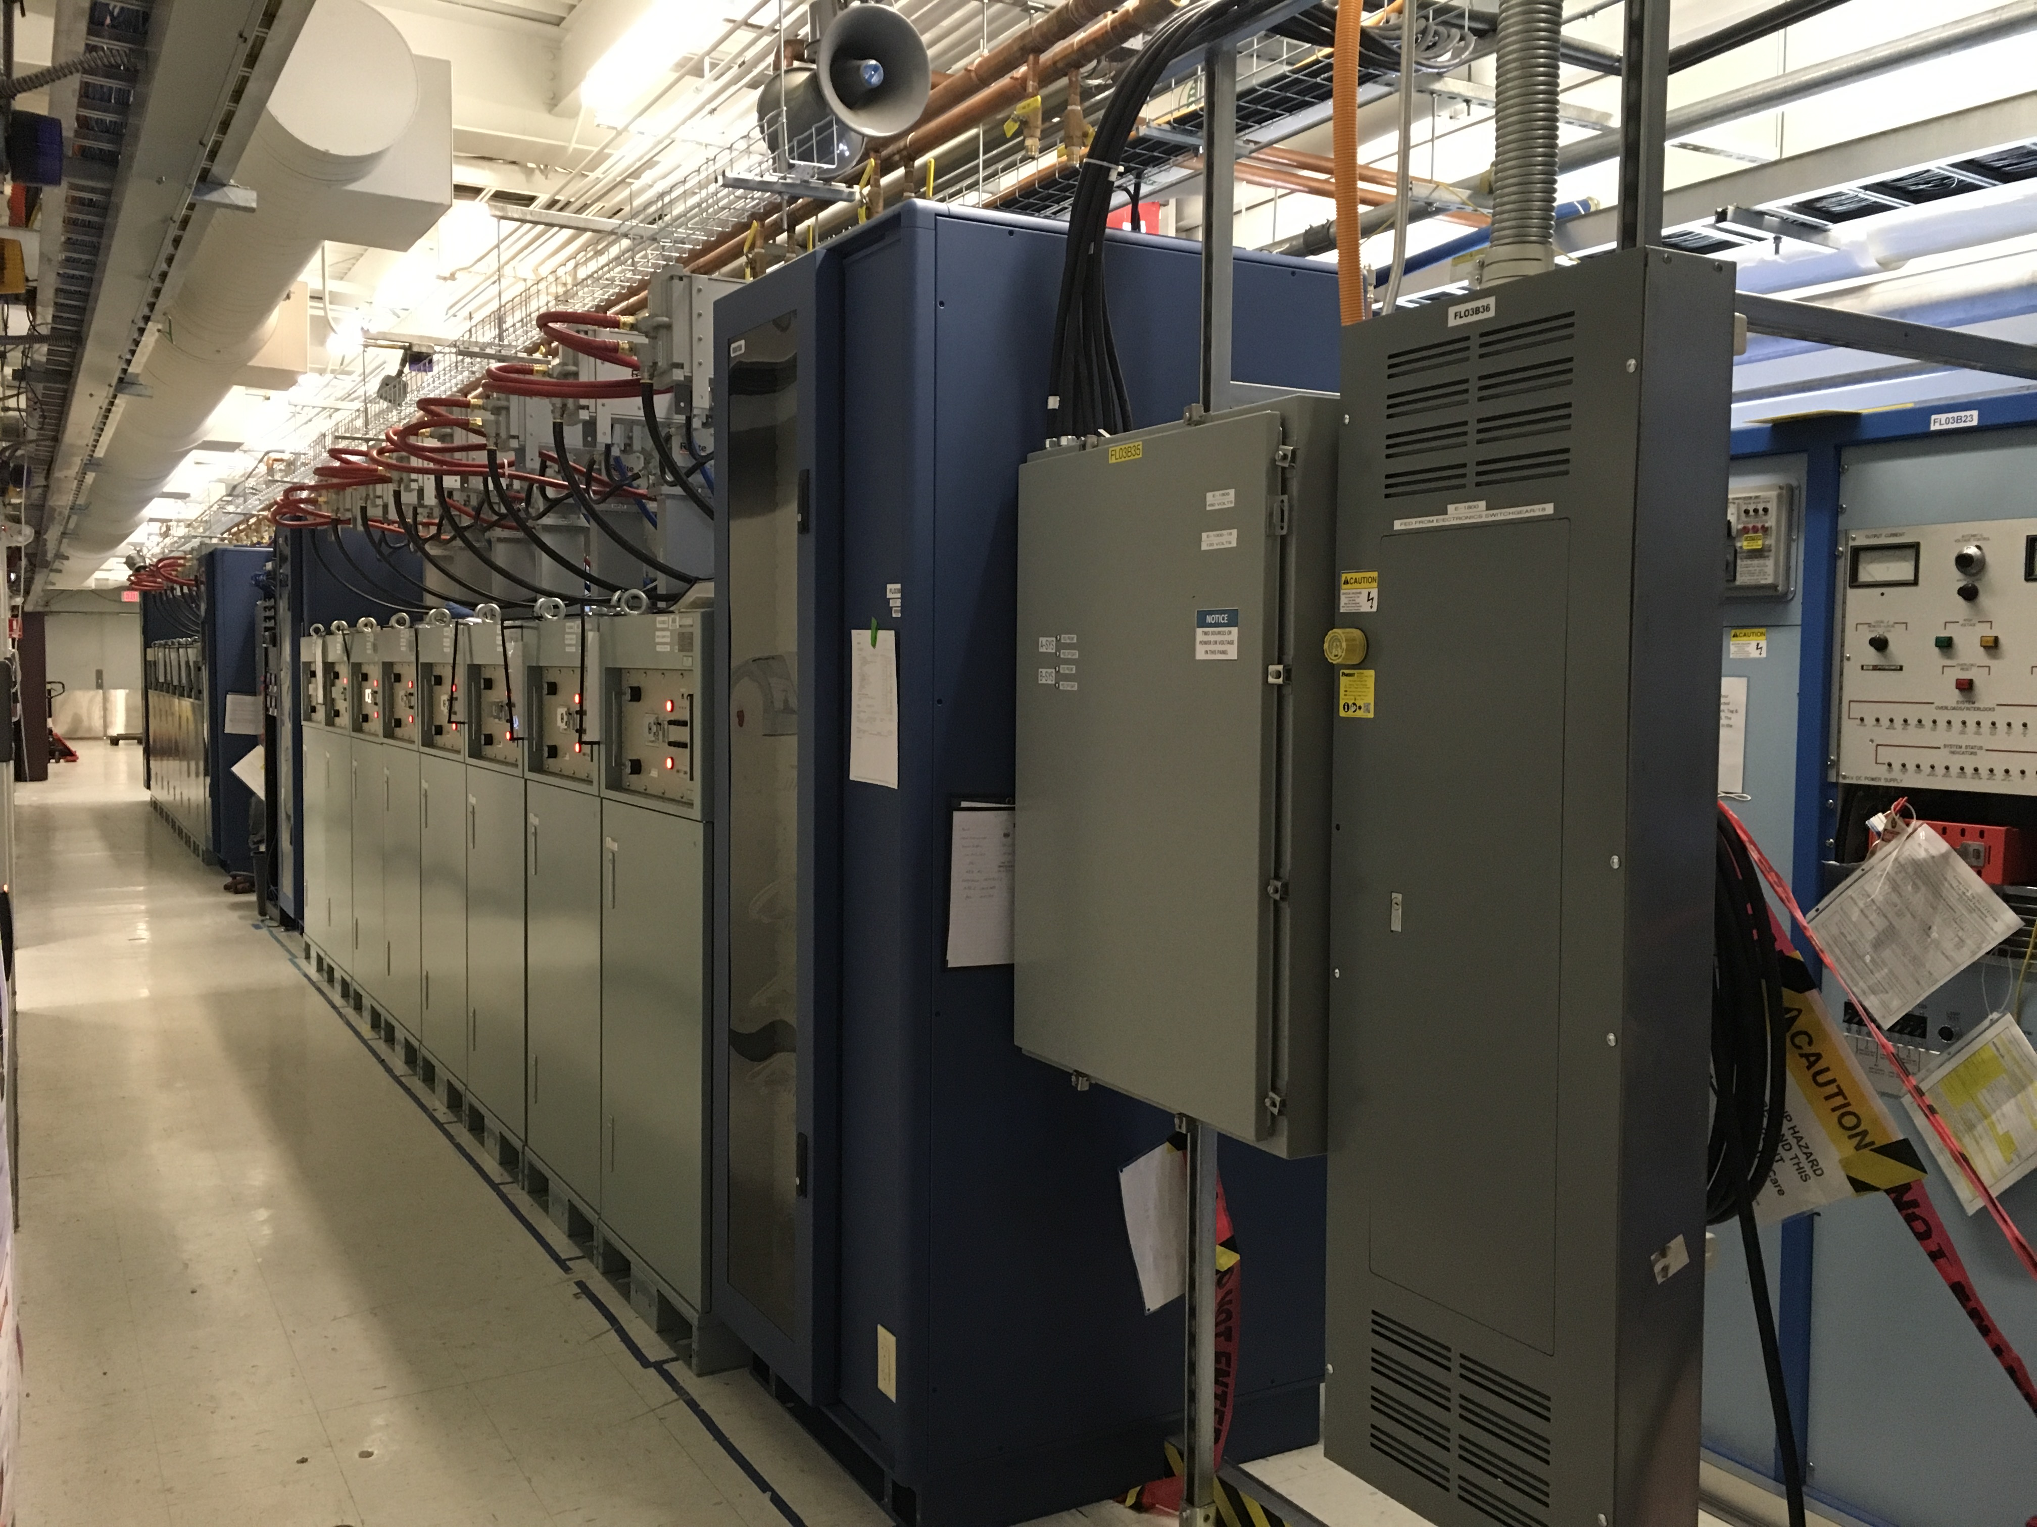
SSA’s
480VAC Breaker Panel
Figure 3: LCLS II racks
Post High Power RF testing (Shutdown):
- First, in software, change state of SSA to “RF Off” and “High Voltage Off”.
- Locate and open the 480 VAC breakers on the front of the SSA’s in use. See Figure 4
- Locate the AC circuit breaker panel behind the last pair of SSA’s and switch to the Off position.
- Reinstall Admin locks on individual breakers.

Cryogenic Procedures
Cryogenic procedures include Cool downs, warm-ups and partial cryocycles to facilitate fast cool-downs.
- Any cryogenic procedure must be scheduled, in advance, with input and approval from the Cryo Group. The Cryo Group point of contact for these operations is Joe Wilson Jr. or his designee.
  - CEBAF Operations must be aware in advance of any planned procedures.
- The Cryo group ,must be aware in advance of any test procedure, that requires the enabling and/or closing of the RT valves on either LCLS II cryomodule.

Remote Access Operations
It is expected that personnel at remote locations (SLAC in particular) will be operating various controls such as llrf, resonance controls, cryogenic controls. In general, these activities are required for software and hardware development and testing for the LCLS II accelerator.
- Personnel at remote locations must have a CUE user account. (Note: the user account cannot be a group account).
- Requirements for accessing LCLS epics – see https://wiki.jlab.org/lerf/images/c/c7/LCLS2_VDI_Access.pdf.
- Personnel at remote locations must first make contact, in advance, with either RF Test Operator or the Test Coordinator.
- A description of the work to be performed and systems affected must be documented in an ATLis.
- After the ATLis is approved, the work will be scheduled by the Test Coordinator.
- Channel Access write permissions for the appropriate systems can then be authorized by the Test Coordinator and enabled by the Crew Chief.
- An RF Test Operator or, in some cases, the Cryo Test Operator must be on-site, preferably in the LERF Control Room or MCC, to monitor remote access operations.
- The on-site Operator has authority to terminate any remote access operation if they believe there is potential for damage to equipment or harm to personnel.
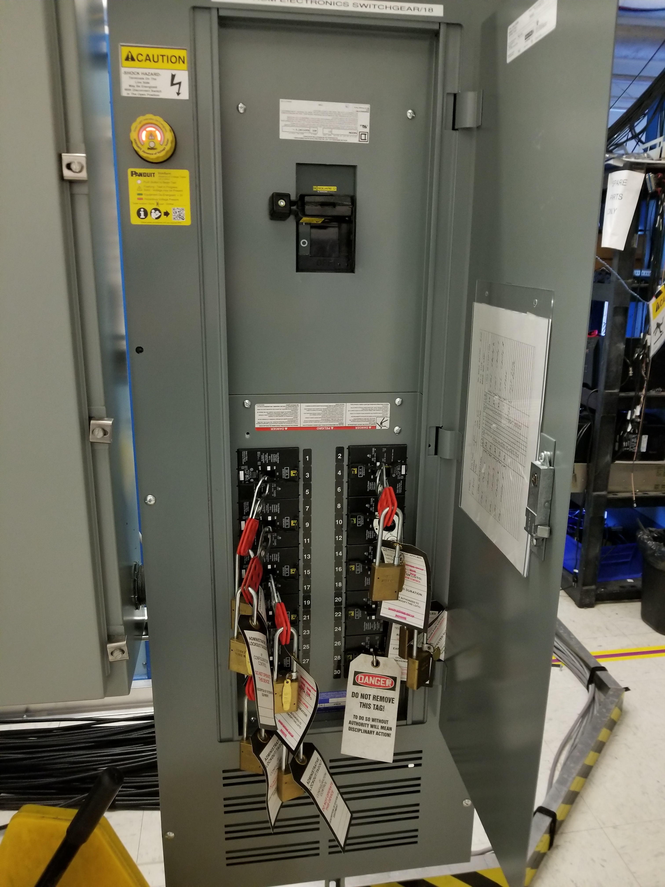
Figure 4: 480 VAC Panel

Waveguide Installation / Removal
- Before working on open waveguide, the AC Supply Power to the 1300 MHz SSA’s must be locked out and tagged out:
- AC Breaker Panel for the 1300 MHz system is located in line with the SSA’s in the gallery (See Figure 3).
- When closing or opening a disconnect breaker and disconnecting the power plug, use proper PPE:
  - Use safety glasses,
  - Heavy Duty Leather Gloves
  - A Long Sleeve Natural Fiber or Fire Retardant Long Sleeve Shirt
  - Long Pants (made of natural fibers)
- Open the main breaker for the 480VAC panel that controls the SSA’s associated with the set of waveguides to be worked on.
- Check the Voltage Presence Indicator on the breaker panel. A green light indicates that voltage has been removed from the breaker panel (See Figure 5)
- Each worker must apply a personal lock to a hasp on the main breaker.

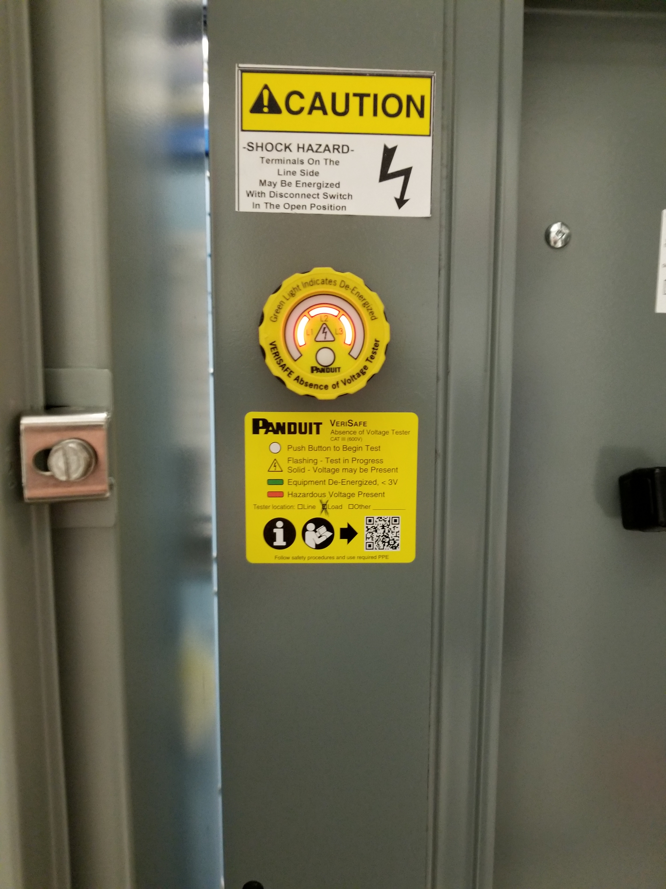
Figure 5: Voltage Indicator
Cryomodule Installation and Removal:
Activities are governed by the following
- SRF-16-62027-OSP Cryomodule Installation
- SRF-16-61608-OSP Cryomodule Removal

Cryomodule Degaussing
Degaussing operations are governed by a separate OSP. An OSP that is up to date must be available before scheduling these activities.

Emergency Procedures:
Crew Chiefs and operators (including Test Operators within the scope of this OSP) are first responders for a variety of emergency situations within the accelerator site safety fence and also play a critical role in emergency communication and coordination. When responding to emergencies on the accelerator site, the Crew Chief assumes the role of Internal Incident Commander (IIC) until relieved. If two operators are present, the RF Test Operator will fulfill the IIC role. Emergency response is guided by written procedures, which are located in the Emergency Response Binder in the MCC Control Room. The Test Coordinator or his designee must be notified as part of the emergency response.

Oxygen Deficiency
In the event of an ODH alarm or evidence of a cryogen release, all personnel in the vault, shall leave those areas and assemble outside the LERF bldg. Leave the test area immediately by the nearest exit (away from the plume if possible).
Follow the ODH Alarm Response described in MCC-PR-16-009

Possible Excessive Radiation Exposure
- Immediately call RadCon for assistance: 757 876-1743
- Turn off the high power RF by crashing the PSS system.

RF Emergency
- Turn off the high power RF by crashing the PSS system.
- Contact Rick Nelson (?) at 757-584-7185 or Andrew Kimber 757-746-9312 for assistance.

Failure of Personnel Safety System
In the event the interlock system or radiation-monitoring system operate improperly or suffer a hardware failure, the Test Operator will immediately:
- Terminate RF operations
- Notify PSS on call personnel, and Radiation Control Group on-call personnel

Contact Information:
Industrial Hygiene Group 240-0031 (EH&S Cell Phone)
On-call Cryogenic Coordinator contact through Guard House ext 5822
Contact the Guard House ext 5822 for off hours number
ESH&Q Emergency Manager Tina Menefee –ext 5490

- Notification of Affected Personnel
- The entrance to the vault is posted with signage that indicates the ODH state of the vault
- Additional signage will be placed if an RT valve is connected and enabled on either of the cryomodules to alert personnel to the changed ODH state in the vault.

- List the Steps Required to Execute the Procedure: from start to finish.
See above
Separate procedures govern the various tests performed on cavities and cryomodules.
- Back Out Procedure(s) i.e. steps necessary to restore the equipment/area to a safe level.
See Above
- Special environmental control requirements:
  - List materials, chemicals, gasses that could impact the environment (ensure these are considered when choosing Subject Mater Experts) and explore EMP-04 Project/Activity/Experiment Environmental Review below
  - Environmental impacts (See EMP-04 Project/Activity/Experiment Environmental Review)
N/A
  - Abatement steps (secondary containment or special packaging requirements)
N/A
- Unusual/Emergency Procedures (e.g., loss of power, spills, fire, etc.)
Follow guidance in this OSP or in ES&H Manual as appropriate
- Instrument Calibration Requirements (e.g., safety system/device recertification, RF probe calibration)
PSS Certification is required every six months and is carried out by the Safety Systems Group
ODH monitoring sensors are maintained by Safety Systems Group
- Inspection Schedules
PSS Certification is required every six months and is carried out by the Safety Systems Group.
Shielding and radiation monitoring configuration inspections are conducted every six months by RadCon
- References/Associated/Relevant Documentation
References:
ES&H Manual Sections:
  - 6140 Cranes and Hoists
  - 6210 General Electrical Safety
  - 6310 Ionizing Radiation Protection
  - 6315, Environmental Monitoring of Ionizing Radiation
  - 6420 Radio Frequency and Microwave Radiation
  - 6540 Oxygen Deficiency Hazard
Attachments:
SRF-16-62027-OSP Cryomodule Installation
SRF-16-61608-OSP Cryomodule Removal
SRF-16-63829-OSP RT Valve Cabling Activities
MCC-PR-17-001 PSS Sweep Procedures
MCC-PR-17-004 PSS Controlled Access Procedures
JLAB-TN-12-043 2003 ODH Risk Assessment, LERF
RCD-DEP-18 #002 LERF Shielding Requirements for LCLS II Cryomodule Commissioning
- List of Records Generated (Include Location / Review and Approved procedure)
All data acquired during operations covered by this OSP are stored in Pansophy traveler system, Docushare, folders on the M drive and ELOG entries.

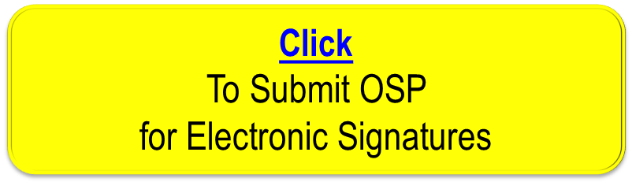
Distribution: Copies to Affected Area, Authors, Division Safety Officer
Expiration: Forward to ESH&Q Document Control

Form Revision Summary
Revision 1.5 – 04/11/18 – Training section moved from section 5 Authority and Responsibility to section 9 Training
Revision 1.4 – 06/20/16 – Repositioned “Scope of Work” to clarify processes
Qualifying Periodic Review – 02/19/14 – No substantive changes required
Revision 1.3 – 11/27/13 – Added “Owning Organization” to more accurately reflect laboratory operations.
Revision 1.2 – 09/15/12 – Update form to conform to electronic review.
Revision 1.1 – 04/03/12 – Risk Code 0 switched to N to be consistent with 3210 T3 Risk Code Assignment.
Revision 1.0 – 12/01/11 – Added reasoning for OSP to aid in appropriate review determination.
Revision 0.0 – 10/05/09 – Updated to reflect current laboratory operations
ISSUING AUTHORITY | FORM TECHNICAL POINT-OF-CONTACT | APPROVAL DATE | REVIEW DATE | REV.
ESH&Q Division | Harry Fanning | 04/11/18 | 04/11/21 | 1.5
This document is controlled as an on line file. It may be printed but the print copy is not a controlled document. It is the user’s responsibility to ensure that the document is the same revision as the current on line file. This copy was printed on 11/1/2018.

