The Thomas Jefferson National Accelerator Facility (Jefferson Lab) is located at 12000 Jefferson Avenue in Newport News, Virginia. The main entrance to the facility is on Lawrence Drive.
DRIVING DIRECTIONS
12000 Jefferson Avenue, Newport News, VA 23606
Click HERE for Google Map Directions.
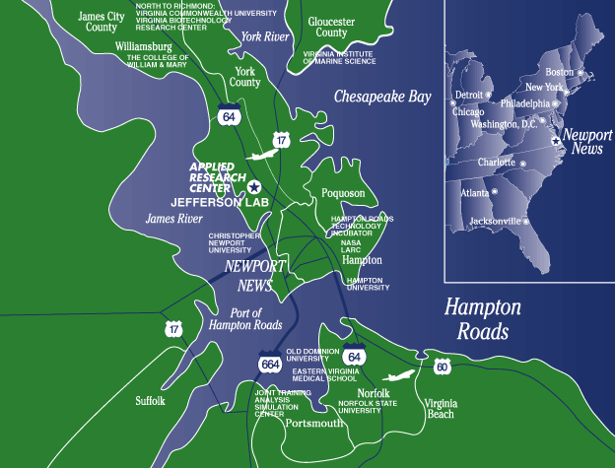
FROM WASHINGTON, D.C.
Take I-95 South toward Richmond
Merge onto I-295 South near Richmond to I-64 East
Follow I-64 East to Newport News
Take exit 255A onto Jefferson Avenue, Rout 143 South
In approximately 1 mile, turn left onto Lawrence Drive –This is the main entrance to Jefferson Lab
Make the next right onto Kelvin Drive–This will take you by CEBAF Center, the facility’s main administrative building
Visitor Parking is available immediately on the left. If this parking area is full, additional parking for guests is available in the main staff parking lot behind CEBAF Center.
FROM NORFOLK/VIRGINIA BEACH
Take I-64 West toward Richmond
Take exit 255A onto Jefferson Avenue, Rout 143 South
Once on Jefferson Ave (143S)
In approximately 1 mile, turn left onto Lawrence Drive –This is the main entrance to Jefferson Lab
Make the next right onto Kelvin Drive–This will take you by CEBAF Center, the facility’s main administrative building
VISITOR PARKING
Visitor Parking is available immediately on after turning on Kelvin Drive. If this parking area is full, additional parking for guests is available in the main staff parking lot behind CEBAF Center.
BUILDING ACCESS
Access to buildings on campus are by Jefferson Lab identification card key or under escort. Visitors without a key card must first sign in at the Welcome Desk, located in the front Atrium of CEBAF Center and connect with their escort before proceeding to their destination.
For assistance, please contact the receptionist at 757-269-7100.

