Polarized Positrons in Jefferson Lab Electron Ion Collider (JLEIC)
Fanglei Lin^{1, a)}, Joe Grames^{1, b)}, Jiquan Guo^{1, c)}, Vasiliy Morozov^{1, d)}, Yuhong Zhang^{1, e)}
¹Thomas Jefferson National Accelerator Facility, Newport News, VA, 23606
^{a)} fanglei@jlab.org
^{b)} grames@thisaddress.yyy
^{c)} jguo@jlab.org
^{d)} morozov@jlab.org
^{e)} yzhang@jlab.org
Abstract. The Jefferson Lab Electron Ion Collider (JLEIC) is designed to provide collisions of electron and ion beams with high luminosity and high polarization to reach new frontier in exploration of nuclear structure. The luminosity, exceeding 10³³ cm⁻²s⁻¹ in a broad range of the center-of-mass (CM) energy and maximum luminosity above 10³⁴ cm⁻²s⁻¹, is achieved by high-rate collisions of short small-emittance low-charge bunches with proper cooling of the ion beam and synchrotron radiation damping of the electron beam. The polarization of light ion species (p, d, ³He) and electron can be easily preserved, manipulated and maintained by taking advantage of the unique figure-8 shape rings. With a growing physics interest, polarized positron-ion collisions are considered to be carried out in the JLEIC to offer an additional probe to study the substructure of nucleons and nuclei. However, the creation of polarized positrons with sufficient intensity is particularly challenging. We propose a dedicated scheme to generate polarized positrons. Rather than trying to accumulate “hot” positrons after conversion, we will accumulate “cold” electrons before conversion. Charge accumulation additionally provides a novel means to convert high repetition rate (>100 MHz) electron beam from the gun to a low repetition rate (<100 MHz) positron beam for broad applications. In this paper, we will address the scheme, provide preliminary estimated parameters and explain the key areas to reach the desired goal.

Introduction
The proposed Jefferson Lab Electron Ion Collider (JLEIC) has been developed to achieve the physics requirements outlined in the EIC white paper [1]. The overall design strategies towards high luminosity and high polarization have not changed over a decade, but technical design aspects have evolved. The design considers a balance of machine performance, technical risk, cost and path for future upgrade. In addition to the electron and ion collision as it is carried out in the JLEIC, physicists also found that collision of polarized positron and ion beams provide more capabilities to study the physics world [2, 3, 4, 5, 6, 7, 8, 9]. From the accelerator design point view, acceleration, accumulation and store of polarized electron and position have no significant difference, as long as polarities of powered magnets are inversed and some charge-related collective effects are solved. The most, probably the only, challenging part is the generation of intense positron beams with high polarization. Several methods to create polarized positrons have been explored and/or applied at different circumstances [10, 11, 12, 13, 14, 15]. However, each scheme has its own advantages and disadvantages, and does not satisfy the JLEIC injection and current requirements.
A new approach, referred to as the Polarized Electrons for Polarized Positrons (PEPPo) technique [16, 17], has been investigated at the Continuous Electron Beam Accelerator Facility (CEBAF) of the Thomas Jefferson National Accelerator Facility. Polarized positrons are generated by the bremsstrahlung radiation of low energy longitudinally polarized electrons within a high-Z target and e⁺e⁻ pair production. The PEPPo concept can be developed efficiently with a low momentum (10 – 100 MeV/c) and high polarization (>80%) electron beam driver. This opens access to polarized positon beams to a wide community and without creating a highly radioactive environment. The experiment demonstrates highly efficient transfer of polarization from 8.19 MeV/c primary electrons to the produced positrons [18].
In the paper, we first provide an overview of JLEIC baseline design. Then a description of generating high polarized positron beams for the JLEIC on the basis of PEPPo technique is followed, and some key areas to reach the desired performance are discussed.

jleic design overview
Physics motivations of electron-ion collisions have been addressed in detail in the EIC white paper [1]. The design performance of JLEIC [19] is consistent with the requirements of the science program in the white paper. The JLEIC is designed as a traditional ring-ring collider. The electron complex is composed of CEBAF and electron collider ring. The existing CEBAF serves as an electron injector of the collider ring. The ion complex is composed of ion source, SRF linac, booster and ion collider ring. The green field new ion complex and electron collider ring provide opportunity for a modern design to achieve highest performance. The central part of JLEIC is two figure-8 shape collider rings that are vertically stacked and housed in the same tunnel. The figure-8 crossing angle is 81.7°, partitioning a collider ring into two arcs and two long straights. The ion beam excuses a vertical excursion to the plane of electron ring for a horizontal crossing during the electron-ion collisions. Two collider rings have nearly identical circumferences and fit well in the Jefferson Lab site. Figure 1 shows a cartoon model of the layout of JLEIC accelerator complex.

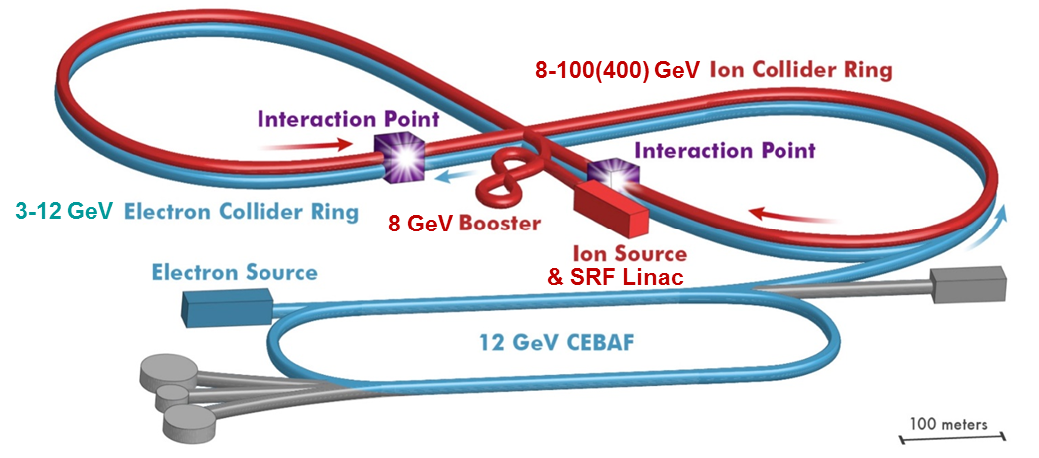
Figure 1. A layout of JLEIC accelerator complex.

The design strategy to reach high luminosity in the JLEIC is high bunch repetition rate collision of beams. Both electron and ion beams have very short bunch length and small transverse emittances so that beam sizes at the collision point can be focused to a micrometer level. This configuration, combining with a the high bunch repetition rate, can significantly boost the collider luminosity. This high bunch repetition rate ensures small bunch charge of colliding beams, leading to relatively weak collective and inter-beam scattering effects, while maintains high bunch beam current to provide high luminosity. Such luminosity strategy has been validated by the lepton-lepton B-factory colliders worldwide. For example, the KEK-B factory has reached a world record luminosity of a few of 10³⁴ cm⁻²s⁻¹ [20], and Super-KEKB factory is aiming for a luminosity of 10³⁶ cm⁻²s⁻¹ [21].
The design strategy to reach high polarization is adopting figure-8 shape ring [22] (ion booster, ion and electron collider rings) to preserve and control the polarization. Because of the opposite dipole fields in two arcs in a figure-8 shape ring, the net spin rotation majorly due to arc dipoles is zero and the whole ring becomes “transparent” for the spin. Any spin orientation at any orbital location repeats every turn, and there is no preferred polarization. In another world, the spin tune in a figure-8 shape accelerator is zero and energy independent. This novel concept eliminates spin despoliation resonances during the acceleration and polarization at the collision point can be easily stabilized and controlled using weak-field compact magnet insertions [23, 24]. This property is universal and does not depend on the particle type. In particular, the figure-8 shape ring provides a real, perhaps the only, opportunity for obtaining polarized deuteron beams with energies greater than a few tens of GeV [25].
One key feature in the JLEIC is the full detector acceptance to all fragments produced in collisions. The primary detector region [19] is essentially designed to meet such requirement by having scattered particles being detected at the center detector and downstream detectors along the beam lines with close to 100% acceptance and necessary resolution. 50 mrad crossing angle is introduced at the collision point to separate two beams quickly after collision to avoid the parasitic collision. Such large crossing angle also improves the detection by moving spot of poor resolution along the detector solenoid axis into the periphery. In addition, the detector region design also satisfies requirements of beam dynamics and geometric matching.
Table 1 presents the JLEIC baseline design parameters at three representative design points in the low, medium and high CM energy regions, respectively [26]. The luminosity is above 10³³ cm⁻²s⁻¹ in all these design points, and reaches 2.1×10³⁴ cm⁻²s⁻¹ at the medium CM energy of approximately 45 GeV. At the low energies, space charge of the low energy ion beam severely limits the bunch charge, particular for the short bunches in the JLEIC. Therefore, a relatively long bunch length is preferred to accommodate the full bunch charge while still remaining the design limit for the Laslett space charge tune-shift of 0.06. At the high energies, synchrotron radiation of the electron beam is the dominating effect. The electron beam current needs to be scaled down proportionally to the 4th power of the beam energy to reduce the synchrotron radiation power to a reasonable level of 10 MW. To compensate the reduction of electron beam current, a relatively low bunch repetition rate and proportionally increased bunch charge are adopted to boost the luminosity. At the medium CM energies, the strong beam-beam effect dominates the JLEIC luminosity. An optimum luminosity above 10³⁴ cm⁻²s⁻¹ can be achieved by combining a high bunch repetition rate, small beam emittance and small β* at the IP. This energy region delivers the highest luminosity in the JLEIC.

TABLE 1. JLEIC baseline design parameters for e⁻p collisions.

 | Unit | Beam Parameters
Center of mass energy | GeV | 21.9 |  | 44.7 |  | 63.3
Species |  | p | e⁻ | p | e⁻ | p | e⁻
Beam energy | GeV | 40 | 3 | 100 | 5 | 100 | 10
Collision frequency | MHz | 476 |  | 476 |  | 476/4=119
Particle per bunch | 10¹⁰ | 0.98 | 3.7 | 0.98 | 3.7 | 3.9 | 3.7
Beam current | A | 0.75 | 2.8 | 0.75 | 2.8 | 0.75 | 0.71
Polarization | % | 80 | 80 | 80 | 80 | 80 | 75
Bunch length, RMS | cm | 3 | 1 | 1 | 1 | 2.2 | 1
Norm. emit., horiz./vert. | μm | 0.3/0.3 | 24/24 | 0.5/0.1 | 54/10.8 | 0.9/0.18 | 432/86.4
Horizontal & vertical β* | cm | 8/8 | 13.5/13.5 | 6/1.2 | 5.1/1 | 10.5/2.1 | 4/0.8
Vert. beam-beam param. |  | 0.015 | 0.092 | 0.015 | 0.068 | 0.008 | 0.034
Laslett tune-shift |  | 0.06 | 7×10⁻⁴ | 0.055 | 6×10⁻⁴ | 0.056 | 7×10⁻⁵
Detector space, up/down | m | 3.6/7 | 3.2/3 | 3.6/7 | 3.2/3 | 3.6/7 | 3.2/3
Hourglass (HG) reduction |  | 1 |  | 0.87 |  | 0.75
Luminosity/IP, w/HG, 10³³ | cm⁻²s⁻¹ | 2.5 |  | 21.4 |  | 5.9

The highest CM energy in the JLEIC is mainly dominated by the ion beam energy, which is determined by the maximum arc dipole field. The higher the maximum dipole field is, i.e. the higher the ion beam energy can be reached, the wider the CM energy region will be. The baseline design adopts a cost-effective super-ferric-type superconducting magnet for the arc dipoles. Current maximum field of such magnet is ~3 T, resulting a maximum proton beam energy of 100 GeV. Then, the maximum CM energy is about 63 GeV. For the future energy upgrade, both maximum luminosity and maximum CM energy can be expanded with high dipole field. Figure 2 illustrates general trends of JLEIC luminosity for e⁻p collisions in the CM energy region with different maximum arc dipole fields [26].

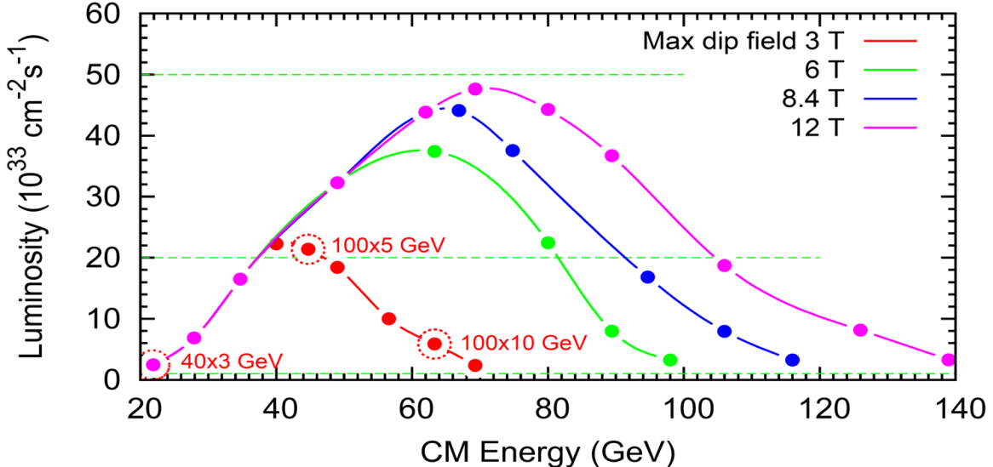
Figure 2. Luminosity of e⁻p collisions in the JLEIC with different maximum arc dipole fields a) red dots represent the luminosity in the baseline design with a 3 T super-ferric-type maximum arc dipole field, b) green dots represent the luminosity with a 6 T (super-ferric- or cosθ-type) maximum arc dipole field (proton energy up to 200 GeV, CM energy up to ~100 GeV), c) blue dots represent the luminosity with a 8.4 T LHC-type maximum arc dipole field (proton energy up to 280 GeV, CM energy up to ~115 GeV), d) purple dots represent the luminosity with a possible future 12 T maximum arc dipole field (proton energy up to 400 GeV, CM energy up to ~140 GeV).

jleic with polarized positrons

Physics Interest and Requirements
Recently, an interest in polarized positron-ion collisions at a future EIC has revived. Physicists believe this offers EIC an additional probe to study the substructure of nucleons and nuclei. For instance, with both polarized electron and positron beams at EIC, one could obtain a full flavor decomposition of the nucleon quark and antiquark distributions, as well as provide understanding the meson cloud effects and diffractive contributions to structure functions [2]. The flavor separation of the pion and kaon structure could be achieved by comparing the difference between electron and positron interactions involving the Sullivan process [3] with neutral and charged currents. Note that the availability of positron beams may be the only way to get to quark flavor decomposition of the pion and kaon structure, and allow comparisons of the quark and gluon distributions in the pion, kaon and proton.
The charged-current deep inelastic scattering (DIS) cross section measurements provide possibly the most direct information on the flavor dependence of quark and antiquark distributions. Depending on the charge of the exchanged W boson, the charged current process will be sensitive to either up-type or downtype flavors. Furthermore, charm and anticharm production in charged current DIS offers the best way to obtain information on strangeness in the nucleon, and the availability of polarized positron and electron beams would provide the necessary tools to extract strange and antistrange distributions unambiguously [6, 7]. Likewise to the production of Ds⁺ mesons in diffractive charged current DIS, that could provide information on the gluon structure of nucleons and the diffraction mechanism in QCD [8].
In addition, the charged current DIS measurements may provide new possibilities to probe for physics beyond the Standard Model. The Standard Model does not predict right-handed charged currents, so that the cross section for electron (positron)-proton charged current DIS with helicity +1(-1) is expected to vanish. Measuring the beam longitudinal polarization sensitivity of the total charged current cross section allows one to set limits on the right-handed W-boson exchange. This requires polarization measurements with high precision [9]. A longitudinally polarized positron beam also offers sensitivity, for example, to squark production in R-parity violating SUSY models, where only left- (right-) handed electrons (positrons) contribute. For leptoquark searches, different lepton beams and polarizations will allow selective increase in the sensitivity to different leptoquark types.
High luminosity and high polarization are essential to perform these measurements. Ideally, machine performance of positron-ion collisions should be similar to that of electron-ion collisions at the JLEIC, if the polarized positron source has the same efficiency as the current electron source. However, the generation of positron beams with high polarization and high bunch charge is particularly challenging. Considering a balance of accelerator design and physics requirement, collision luminosity of ~10³³ cm⁻²s⁻¹ and position polarization ~ 40% are proposed as a reasonable low threshold of requirements for valuable science program at an EIC [27].

PEPPo Based Polarized Positron Injector
Schemes for creating polarized positron beams have been explored in the past, and some of them are even applied in an accelerator. Radioactive sources can be used for low energy positrons [10], but the flux is restricted. Storage or damping rings can be used at high energy, taking advantage of the self-polarizing Sokolov-Ternov effect [11], however, this approach is generally not suitable for external beams and continuous wave injection facilities. Two schemes based on the e⁺e⁻ pair creation process from circularly polarized photons [12, 13] have been explored and investigated successfully: the Compton backscattering of polarized laser light from a GeV unpolarized electron beam [14], and synchrotron radiation of a multi-GeV unpolarized electron beam travelling within a helical undulator [15]. Both experiments demonstrated high positron polarization, confirming the transfer efficiency of the pair production process for a polarized positron. However, both techniques require high energy electron beams and further development of challenging technologies.
A new approach, referred to as Polarized Electrons for Polarized Positrons (PEPPo) technique [16, 17, 18], has been investigated at the CEBAF of the Thomas Jefferson National Accelerator Facility. Taking advantage of advances in high polarization, high intensity electron sources [28], it exploits the fact that polarized photons generated by the bremsstrahlung radiation of low energy longitudinally polarized electrons within a high-Z target produce polarized e⁺e⁻-pairs. It is expected that the PEPPo concept can be developed efficiently with a low momentum (10 - 100 MeV/c), high intensity (> 1 mA) and high polarization (>80%) electron beam driver. While the polarization transfer by bremsstrahlung and pair creation is similarly efficient for any incident electron energy, the yield of positrons is not. Rather, the positron yield scales approximately with the beam energy. In the energy range of ~10 – 100 MeV, the positron conversion/collection efficiency is relatively low, ~ 10⁻⁵ to 10⁻³.
The strategy to compensate for the low positron efficiency is to accumulate charge on the basis of PEPPo technique. However, rather than accumulating “hot” positrons with large phase space distributions after conversion, we propose to accumulate “cold” dense electrons before conversion. A high-level diagram of the polarized positron injector, satisfying the requirements of luminosity and polarization for the JLEIC [27], is show in Fig. 3 along with preliminary parameters at each step along the injection chain.

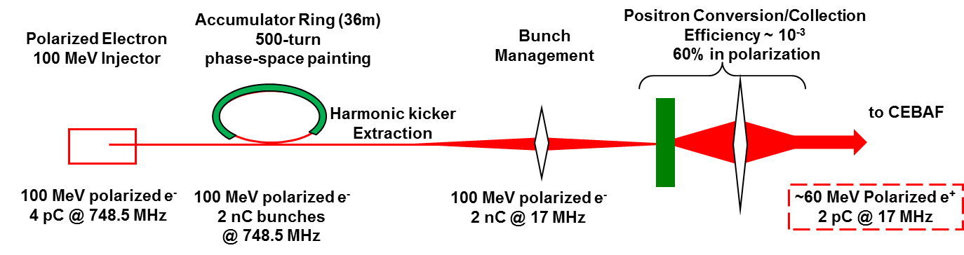
Figure 3. Polarized positron injector for the JLEIC.

Accumulation of polarized positrons for the JLEIC collider ring requires an average polarized positron current of about 10 nA, considering a reasonably short injection time and sufficient injected beam current to maintain high equilibrium polarization. Figure 4 shows the polarized positron bunch train pattern injected into the JLEIC collider ring. The 17 MHz micro bunch train from the polarized positron injector matches the RF frequency of CEBAF 1497 MHz (1/88 of 1497 MHz) and the one of JLEIC 476 MHz (1/28 of 476 MHz). The injected beam into the JLEIC collider ring is not exactly a CW fashion because the bunches need on the order of a few tens of millisecond (20 – 85 ms in Fig. 4) to damp to the design orbit. Thus, the key of polarized positron injection into the JLEIC is a positron source that provides a low-duty, relatively high-current micro bunch structure with low average current. As shown in Fig. 3, lowering the duty factor is accomplished by collecting the beam coming from the electron source within an accumulator ring.

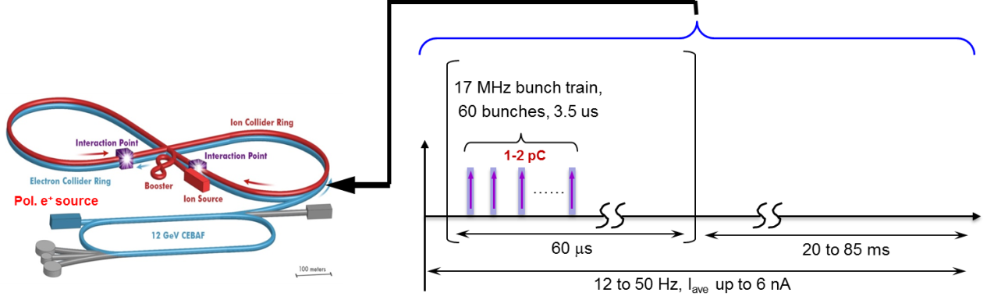
Figure 4. Polarized positron injection bunch pattern into the JLEIC electron collider ring.

As the beginning of this injector chain, spin polarized GaAs-based photo-guns must exhibit long photocathode operating lifetimes and can provide a micro pulse current up to 3 mA. A dc-high voltage GaAs photo-gun has been built at Jefferson Lab based on a compact inverted insulator design [29] for high average current photocathode lifetime studies at a dedicated test facility up to 4 mA of polarized beam, which meets the requirement of a 3mA micro pulse current from the polarized electron source in the proposed position injector scheme. In achieving this, the photo-gun employs the best learned practices, e.g. (a) operating with the drive laser beam positioned away from the electrostatic center of the cathode/anode, (b) limiting the photocathode active area to eliminate photoemission by stray light, (c) using a large drive laser beam to distribute ion dam-age over a larger area, (d) applying low bias voltage to the anode to repel ions downstream of the gun, and (e) operating with immeasurable field emission. However, a very high voltage at the photo-gun minimizes the ill-effects of space charge forces which degrade the emittance and introduce beam loss leading to a diminished photo-gun charge lifetime. High voltage increases QE by lowering the potential barrier (Schottky effect) [30] and suppresses the surface charge limit [31]. In addition, a very high bias voltage may enhance the operating lifetime of the photo-gun by quickly accelerating the beam to energy with very small ionization cross section. Further gains are necessary in order for sustained operation of the polarized electron source at milliAmpere currents to be realized.
Beam accumulation in the accumulator ring is the essential step in the positron injector. The main function of the accumulator ring is to convert the high duty factor, low intensity electron bunch train available from the electron gun into low duty factor and high charge per bunch beam, using multi-turn phase painting injection that has been successfully demonstrated for 75 turn injection of Pb⁵⁴⁺ in the LEIR at CERN [32]. The phase-space painting does not increase the local phase-space density but accumulates the beam at the expense of increasing its 6D emittance. Therefore, rather than accumulating low phase-space density polarized positrons, electron bunches with very small emittances from the photo cathode can be efficiently stacked in the accumulator ring. A high bunch repetition rate, 748.5 MHz shown in Fig. 3, in the accumulator ring is preferred to keep the ring relatively compact. A stripline RF kicker is fired to create 17 MHz pulses with a short pulse width to extract 1 in every 44 bunches in the accumulator ring, leaving the rest bunches unperturbed. The longitudinal dynamics will be managed by a low voltage RF cavity running at 1497 MHz or a sub-harmonic and by an appropriate adjustment of the compaction factor. To preserve the polarization, a full solenoid Siberian snake is placed at the symmetry point θ=π with respect to the injection location in the accumulator ring. This guarantees that the injected beam’s polarization is aligned with the store beam’s one during the accumulation.
Polarized electron beam strikes a high-Z target, and results in an efficient electro-magnetic shower. Then spin-polarized positrons are generated by transferring spin first from electrons to photons (polarized bremsstrahlung) and second from photons to positrons (polarized pair-creation). In order to handle positrons, electron beam parameters are optimized at the radiator firstly. For any reasonable electron beam size at the target, the positron angular spread greatly dominates over the initial electron angular spread. Therefore, the rms positron emittance ε_{x,y} in each plane after the target can be written as ε_{x,y} ≈ σ_{x,y} θ_{rms}, where σ_{x,y} is the horizontal/vertical electron beam size at the radiator. Obviously, minimizing the electron beam size at the radiator lowers the final positron emittance, however, leading to a high instantaneous power density at the beam spot location on the target. This problem may be solved by considering a liquid metal design demonstrated by Niowave Inc [33].
The end of the injector chain is the existing CEBAF, which accelerates positron beam from the injected low energy to the desired high energy. Therefore, CEBAF, used as an continuous electron beam facility, needs to be demonstrated that it has the capability to accelerate positron beams. First investigation of CEBAF magnet and diagnostic system has been performed [34, 35]. For those bipolar powered magnets, most quadrupoles and correctors, they need set point for a polarity inversion only. Given availability of tune-up diagnostics, none of the bipolar magnets have any known problems with polarity inversion. For those unipolar powered magnets, recirculation arc dipoles and spreader/recombiner vertical dipoles, need to swap the lead on the “shunt” controls attached to the magnet string being inverted. They also need swap power leads at the power supply. The concerns of magnet over-temperature sensors, ground fault detection and power supply internal protections are all independent of polarity inversion. All diagnostic systems should work for a positron beam with a pulse current of a few tens of microampere and peak power of 0.6 kW.
The preliminary JLEIC parameters for collision of polarized positron and proton beams at three CM energies are listed in Table 2. The parameters are estimated using the proposed positron generation scheme for the injection of beam to the collider ring. The luminosity below 10³³ cm⁻²s⁻¹ at the low CM energy 21.9 GeV is limited by the space charge effect of proton beam at the low energy. Figure 5 shows the potential luminosity of e⁺p collision at three CM energies given in the Table 1, plus an additional CM energy 33.5 GeV (collision of 70 GeV proton and 4 GeV positron beams). As it is shown, the luminosity is above 10³³ cm⁻²s⁻¹ when the CM energy is higher than 33.5 GeV. The luminosity degrades at high energies (but still above 10³³ cm⁻²s⁻¹) due to the large electron beam emittance (resulting in large beam sizes at the collision point).
TABLE 2. Preliminary JLEIC parameters for e⁺p collisions.

 | Unit | Beam Parameters
Center of mass energy | GeV | 21.9 |  | 44.7 |  | 63.3
Species |  | p | e⁺ | p | e⁺ | p | e⁺
Beam energy | GeV | 40 | 3 | 100 | 5 | 100 | 10
Collision frequency | MHz | 476/4=119 |  | 476/4 = 119 |  | 476/4 = 119
Particle per bunch | 10¹⁰ | 1.1 | 1.1 | 2.1 | 1.1 | 3.9 | 1.1
Beam current | A | 0.2 | 0.2 | 0.4 | 0.2 | 0.75 | 0.2
Polarization | % | 80 | 40 | 80 | 40 | 80 | 40
Bunch length, RMS | cm | 3 | 1 | 2 | 1 | 2 | 1
Norm. emit., horiz./vert. | μm | 0.3/0.3 | 24/24 | 0.5/0.1 | 54/10.8 | 0.9/0.18 | 432/86.4
Horizontal & vertical β* | cm | 8/8 | 13.5/13.5 | 6/1.2 | 5.1/1 | 10.5/2.1 | 4/0.8
Vert. beam-beam param. |  | 0.004 | 0.091 | 0.004 | 0.144 | 0.002 | 0.034
Laslett tune-shift |  | 0.059 | 3×10⁻⁴ | 0.059 | 2×10⁻⁴ | 0.061 | 6×10⁻⁶
Detector space, up/down | m | 3.6/7 | 3.2/3 | 3.6/7 | 3.2/3 | 3.6/7 | 3.2/3
Hourglass (HG) reduction |  | 0.98 |  | 0.77 |  | 0.77
Luminosity/IP, w/HG, 10³³ | cm⁻²s⁻¹ | 0.18 |  | 2.9 |  | 1.7

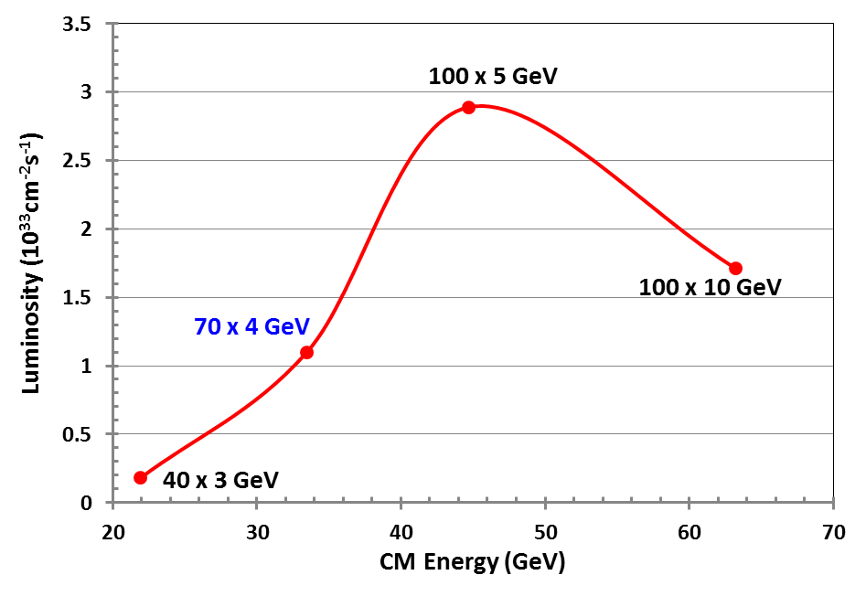
Figure 5. Potential luminosity of e⁺p collision in the JLEIC.

conclusion
The Jefferson Lab Electron Ion Collider (JLEIC) design parameters meet the science program requirements of high luminosity and high polarization. The baseline design is the result of optimization of machine performance, project cost, technical risk assessment and potential for future upgrades. An overview of JLEIC accelerator design is reported. Considering a rich science program with collision of polarized positron and ion beams, this paper presents a proposal of generating a polarized positron beam for the JLEIC on the basis of PEPPo technique. Preliminary parameters in each step of the injector chain are presented, as well as technical description of each subsystem. Detail simulation and/or experimental demonstration will be performed to validate this polarized positron injection scheme.

Acknowledgments
Authors would like to thank R. Ent for his inspiration and support of exploration of polarized positrons in the JLEIC, thank Y. Furletova, W. Melnitchouk, F. Selim and E. Voutier for providing physics impact and benefits of studying positrons in a wide physics community.

References
- A. Accardi et al., arXiv:1212.1701 (2014).
- A. Accardi et al., Eur. Phys. J. A 52, 268 (2016).
- J.R. Mckenney, N. Sato, W. Melnitchouk and C.-R. Ji, Phys. Rev. D 93, 054011 (2016).
- V. Chekelian, in DIS2010 (PoS, 2010) 187 (2010).
- F.D. Aaron et al. (H1 Collaboration), JHEP 1209, 061 (2012).
- Z. Zhang (H1 Collaboration), in ICHEP2012 (PoS, 2013), 289 (2013).
- V. Barone, U.D’ Alesio and M. Genovese, hep-ph/9610211.
- Z. Song and K.-T. Chao, Phys. Lett. B 529, 77 (2002).
- U. Stoesslein et al., Tech. Rep. ZEUS-05-003.
- P.W. Zitzewitz, J.C.V. House, A. Rich and D.W. Gidley, Phys. Rev. Lett. 43, 1281 (1979).
- A. Sokolov and I.M. Ternov, Sov. Phys. Dokl. 8, 1203 (1964).
- H. Olsen and L. Maximon, Phys. Rev. 114, 887 (1959).
- E.A. Kuraev, Y. Bistritskiy, M. Shatnev and E. Tomasi-Gustafsson, Phys. Rev. C 81, 055208 (2010).
- T. Omori et al., Phys. Rev. Lett. 96, 114801 (2006).
- G. Alexander et al., Phys. Rev. Lett. 100, 210801 (2008).
- E.G. Bessonov and A.A. Mikhailichenko, in EPAC96 (JACoW, 1996), THP071L (1996).
- A.P. Potylitsin, Nucl. Inst. Meth. A 398, 395 (1997).
- D. Abbott et al., Phys. Rev. Lett. 116, 214801 (2016).
- S. Abeyratne et al., arXiv:1504.07961 (2015).
- Y. Funakoshi et al., in Proc. of EPAC2004, 707 (2004).
- “Super KEKB Design Report”, http://www-superkekb.kek.jp/documents.html.
- Y.S. Derbenev, University of Michigan report UM HE 96-05 (1996).
- A.M. Kondratenko et al., in proc. of PSTP 2013, 026 (2013).
- A.M. Kondratenko et al., in proc. of IPAC14, MOPRO004, (2014).
- A.M. Kondratenko et al., in Proc. of IPAC2017, WEPIK038 (2017).
- JLEIC Design Update, https://jleic-docdb.jlab.org/DocDB/0000/000031/002/JLEIC-Apr-2017.pdf.
- R. Ent, Y. Furletova (private communication).
- P. Adderley et al., Phys. Rev. St Acc. Beams 13, 010101 (2010).
- R. Suleiman, et al., in Electron Ion Collider Workshop (Jefferson Lab, 2014).
- J.R. Howorth et al., App. Phys. Lett. 23, 123 (1973).
- G.A. Mulhollan et al., Phy. Lett. A 282, 309 (2001).
- A. Fowler, K.D. Metzmacher, CERN-PS-CA-Note-98-22-Tech (1998).
- T. Grimm, C. Boulware, NP SBIR/STTR Exchange Meeting, Gaithersburg, MD (2016).
- M. Tiefenback, “Bipolar Operation of CEBAF Magnets - Considerations and Implications”, in this proceeding.
- M. Tiefenback, “An Operational Diagnostic Complement for Positrons at CEBAF/JLab”, in this proceeding.

