  - Experiment Experiment Number - Click here to enter a date.

  - Contents

- Preface
- Documentation
- Shift Personnel Training
- Organization and Administration
  - LERF Run Coordinator
  - LERF Accelerator-Physics Experiment Liason (APEL)
  - LERF Work Coordinator
  - Shift Leader
  - Shift Member
- Operating Procedures
  - Shift Routines
    - Operating Shifts
    - Standby shifts
    - Shift Team turnover
    - Timely Orders to Operators
    - Operator Aid Postings
  - Vault Access
  - Experiments Request for Laboratory resources
  - Scheduling of Work by Outside Groups
  - Control of equipment and System Status
  - Independent Verification
  - Logkeeping
  - Scheduling of Work during the Decommissioning Phase

A. Special Procedures for the LERF
B. Special Procedures for Experiment number
C. Signature sheets

Jefferson Lab, LERF Conduct of Operations
Experiment Number: | Experiment number
Experiment Name: | Experiment Name.
Lead Scientist:: | Lead scientist.
Date: | [ the date]
Expiration Date:: | Max 180 days from Approval.

  - 1 Preface

As part of its mission, JLab provides the resources necessary for international collaborations of scientists to carry out basic research in nuclear physics and related disciplines. This research must be conducted in a manner that ensures that environmental, health and safety (EH&S) concerns receive the highest consideration. At the same time the programmatic goals of the laboratory require that it produce the highest quality physics results efficiently.

Guidance on how to balance thoughtful, measured EH&S concerns with efficient operation has been taken from the Department of Energy (DOE) Order 5480.10, ``Conduct of Operations," the JLab EH&S Committee, the JLab EH&S Manual, and the JLab Director's Office. A graded approach is followed in which the measures taken are matched to the scale, cost, complexity, and hazards of the operation.

This document outlines how approved experiment collaborations will conduct operations in a safe and effective manner during the time period that experiment Experiment number is on the floor. Installation and commissioning periods are not covered by this document. Furthermore, this document is directed to Experimental Users and Experimental staff rather than the LERF technical staff. It must be read, understood, and followed by all members of the collaboration.

  - 2 Documentation

This experiment uses the standard LERF equipment. All of the procedures to be used during the course of the experiment are contained in the following documents:

- The Conduct of Operations for JLab Experiments (COO), the document you are now reading.

- Experiment Safety Assessment Document (ESAD) for Experiment Number (referring to the base equipment as well as any experiment-specific changes)

- Radiation Safety Assessment Document (RSAD)

- LERF Experimental Equipment Operations Manual (EEOM)

- Personnel Allowed to Operate LERF Equipment

- JLab Emergency Response Plan

Reference copies of these documents will be available in the LERF Control Room for the duration of the experiment. The present document shall hereafter be referred to as the COO. The Experiment Safety Assessment
Document shall hereafter be referred to as the ESAD, and the Radiation Safety Assessment Document shall be referred to as the RSAD.
The ESAD and COO may also be available on the WWW at an experiment-specific web site. The COO, the ESAD and the RSAD are required reading for shift personnel.

A full description of the physics motivation for the experiment, collaboration list, and the general plan for carrying out the experiment can be found in the proposal(s) to the JLab Program Advisory Committee (PAC).

  - 3 Shift Personnel Training

All personnel on shift are required to have successfully completed and be current in the following JLab safety training:

- EH&S Orientation (SAF 100)

- Radiation Worker Training (SAF 801)

- Oxygen Deficiency Hazard Training (SAF 103)

- Safety Awareness Walk-Through ( SAF 143kd)

All experiment personnel are required to have radiation badges in their possession during their shifts.
The Safety Awareness Walk-Through will emphasize any hazards that are peculiar to the current experimental setup.
In addition, all shift personnel will be trained in the safety procedures to be followed for access to the LERF. This training will include a brief discussion of the purpose and operation of the Personnel Safety System (PSS) and Laser Personnel Safety System (LPSS) for the LERF. Individuals within the collaboration may be required to have other, equipment or procedure-specific training. The need for such training shall be determined by the Experiment Spokesperson in consultation with the LERF Hall Leader and EH&S personnel.

In addition, experiment personnel must familiarize themselves with the sections of the JLab EH&S Manual relevant for their work in the LERF. A reference copy of this document is available in the Control Room of the LERF. It is also available via http://www.jlab.org/ehs/manual/EHSbook.html

Finally, JLab Lock and Tag* training is required for all staff/users who will be performing maintenance on electrical and mechanical equipment which cannot be physically and verifiably isolated from an energy source.

  - 4 Organization and Administration

The operation of the experiment is directed by the Spokesperson(s) and the Hall
Leader. An organization chart for the experiment is found in Figure 1

  - 4.1 Run Coordinator

The Run Coordinator is the immediate on-site manager of the experiment and is responsible for ensuring that the goals of the experiment are met. This individual is designated by the Director of Accelerator Operations and approved by the Hall Leader. The Run Coordinator shall ensure that the Hall Leader, and at least one Spokesperson are aware of all pertinent issues concerning the experiment. The Run Coordinator shall promote an environment in which the highest safety standards are maintained. The functions of the Run Coordinator are:

I. To manage daily operation of the experiment:

- to ensure that the run plan is clear in the Program Deputy shift plan to the LERF Operator(s).
- to ensure that the run plan is clear to the on-shift experimental personnel based on input from the Spokesperson(s).
- to define the data quality appropriate for the goals of each shift based on input from the Spokesperson(s).
- to track the progress of the experiment.
- to coordinate and schedule activities (e.g., Hall accesses) in order to optimize productivity.

- to ensure that the exeriment is manned appropriately: i.e., sufficient personnel are present to safely carry out the experimental program or monitor the apparatus as needed.

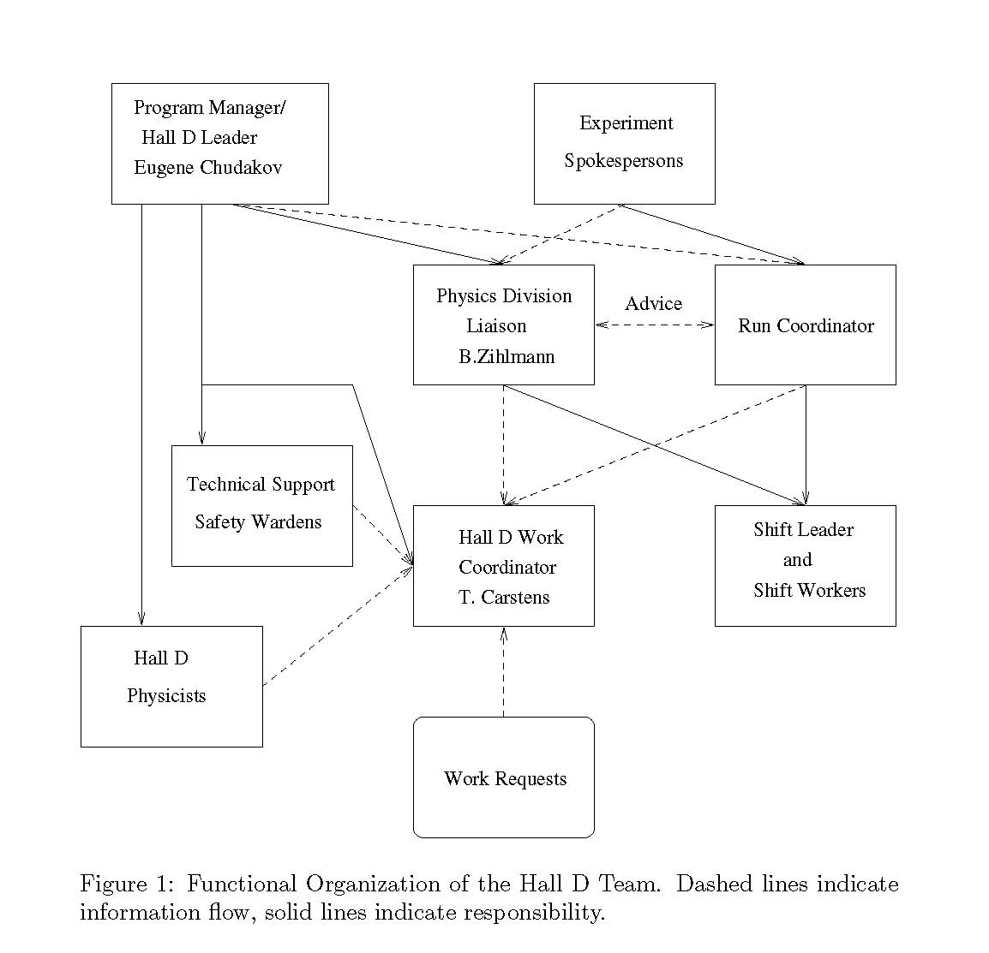
Picture of your
Org structure here
Example of Hall D shown

II. To coordinate interactions between Jlab and the experiment. This entails:

- informing the Program Deputy of the experiment's status and plans at a 7:45 AM meeting in the MCC during the working week, and at an agreed upon time on weekends or holidays.
- representing the experiment at the 8:00 AM meetings in the MCC during the work week.
- attending the 1:30 PM Wednesday scheduling meeting in the MCC conference room to represent the collaboration and to present a report on the proceeding week.
- remaining in the local area and being available by cell-phone/pager at all times.
- in conjunction with the Hall Work Coordinator, scheduling work by groups outside the collaboration.
- interact with the Accelerator Program Deputy to plan and conduct unscheduled activities.

III. To submit a written report to the Hall Leader which includes run time statistics and a description of any significant problems with the Hall instrumentation.

  - 4.2 LERF Accelerator-Physics Experiment Liason (APEL)
The LERF Accelerator-Physics Experiment Liaison (APEL) is an accelerator scientist who is appointed by the Director of Accelerator Operations to serve as a liaison for the LERF program. Specific responsibilities are as follows.
• Collaborate with the Experiment Lead Scientist for each experiment. This includes regularly attending any collaboration meetings and proactively advancing known beam transport and beam quality issues.
• Develop and own the beam transport lattice for the LERF and integrate this with all standard operations tools.
• Work with the Operations LERF Liaison (see Section 3.2.1.11 on page 3-12) to develop control room procedures and operator training.
• Work with the LERF Geographic Integrator (see Section 4.1.3 on page 4-3) to ensure that the hardware design and installation meets the experiment requirements.
• Participate in experiment commissioning activities.
• Regularly attend B-Team meetings.
• Maintain LERF Scientist on Shift (LSOS) training qualifications for the LERF (Section 3.2.1.6 on page 3-10).

  - 4.3 LERF Work Coordinator

The LERF Work Coordinator's responsibilities are:

- to act as the single point of contact for all work in building 18.
- to determine if the scheduled activities in the hall can be done safely.

These activities shall be coordinated with the LERF Operations Coordinator and the Run Coordinator.

- to ensure that workers are properly trained, are familiar with all significant hazards, and are aware of all applicable work control documents associated with the project.
- in coordination with the Run Coordinator ensure that the apparatus is made safe before giving permission to make a transition to Restricted Access (e.g., turn off unused magnets, install protective shields as needed, fulfill specific requirements in the ESAD, etc.).

  - 4.4 Shift Leader

Each shift is led by a Shift Leader. The selection of shift leaders
is the responsibility of the Run Coordinator and Experimental Spokesperson.
The Shift Leader has the following responsibilities:

- to carry out the scientific program planned for the shift in a safe and efficient manner.
- to ensure that the logbook contains a complete and accurate description of the events and actions which occurred during the shift.
- to serve as primary contact between the machine control center (MCC) and experiment personnel.
- to oversee that experimental equipment is operated properly.
- to ensure that experimental equipment malfunctions are properly labeled and locked-out if necessary and to communicate this to shift personnel and subsystem experts.
- to note in the logbook when workers from outside groups (such as survey and alignment) stop by building 18 before entering the Vault when in Controlled Access. Furthermore, to confirm that these workers have communicated with the Run Coordinator and the Hall Work Coordinator.
- to coordinate the response of the shift crew to any emergency situation, including the notification of appropriate individuals as outlined in the JLab Emergency Response Plan.
- to ensure that in any emergency situation the Crew Chief, Run Coordinator and Hall Leader are notified immediately.
- to notify the Run Coordinator and the Hall Leader, if the hall is down due to equipment failure for more than four hours.

The Shift Leader has the following authority:

- to assign tasks to the shift members as needed.
- to request that the state of the hall be changed (Request for a change to Restricted Access must be approved by the Experiment Spokesperson)
- to limit the number of people in the User Lab or building 18 Control Room if required to effectively and safely carry out the experiment.
- to limit access to building 18 on-line computers if required to effectively and safely carry out the experiment.
- to authorize qualified personnel to make modifications in the experiment configuration within the allowed parameters, as specified in the EEOM.
- to authorize time accounting for the shift.

  - 4.5 Shift Member

The responsibilities of each shift member are to:
- carry out the scientific goals of the shift in a safe and efficient manner under direction of the shift leader.
- read the logbook to be aware of changes in goals, operating parameters, and new documentation.
- monitor the equipment for problems.
- maintain adequate records of the progress of the shift.
- be present before the start of each shift and coordinate current operating conditions with the previous shift.
- keep all training up-to-date.

  - 5 Operating Procedures

  - 5.1 Shift Routines

There are two types of shifts for active LERF experiments:
Operating and Standby. Operating shifts are the normal status when beam is available for the experiment. Standby shifts are periods designated by the Run Coordinator when beam is not available or not in use in the hall and none of the equipment, except for the target, requires continuous monitoring. Standby status may result from normal operational planning or from abnormal conditions such as a major down time due to equipment failure.

5.1.1 Operating Shifts
During operating shifts, 24 hour occupation of the User Lab in building 18 will be maintained by crews of at least two persons in 8 hour shifts. One person per shift is designated as the Shift Leader.

The number of persons assigned to a shift will depend on the tasks assigned during the shift. A shift schedule will be posted in the Counting House listing the times and names of personnel on shift and identifying the Shift Leader and Run Coordinator. The shift schedule may be available at an experiment-specific website. The Run Coordinator may also designate and supervise other teams for duties such as offline analysis.

5.1.2 Standby Shifts
During Standby shifts, shift personnel are not required to be on site at JLab but must be available through telephone contact to come in if they are needed. Monitoring the target system can require the presence of a Target Operator during a standby shift. The Target Operator then also acts as Shift Leader. The Run Coordinator will ensure that the shift checklist is executed at least once every 24 hours. The readiness review committee may require more
personnel depending on the complexity of the experiment. Two people are the minimum required for safe operations.

5.1.3 Operations Turnover
The electronic log book, accessible from the web, is a very effective means of remotely obtaining information about experimental operations. This allows experimenters to log in remotely and view all log book entries prior to commencing their shift. Information which can only be recorded in the paper log book, should be noted accordingly and communicated between incoming and outgoing shift personnel directly.

Efficient and effective shift changeovers during experiment operation are enhanced by overlapping shifts. Therefore, whenever possible, shift leaders and workers are scheduled in shifts that are staggered by four hours, leading to an overlap of half a shift.

5.1.4 Timely Orders to Operators
The initial run plan is the responsibility of the Run Coordinator and shall be clearly recorded in the log book. This plan specifies the tasks to be performed in the next 48 - 72 hours, including any special conditions or data runs, updated documentation and its location and/or alternate plans. Any changes to the run plan shall be recorded in the log book and the white board in the counting house.

5.1.5 Operator Aid Postings
The day-to-day schedule, contact instructions for key personnel, and any other information relevant to current activities are located on the white board in the Counting House. Shift personnel should consult the white board, especially at the beginning of their shift, to be aware of any updates to current running conditions.

Information pertaining to activities in LERF must be written on the white board in the building 18 break area.

5.2 Vault Access
Access to the vault will be governed by the JLab Beam Containment Policy, and work in designated radiation
areas will be carried out in accordance with the JLab RadCon Manual. In particular, no material may be removed from the vault after beam delivery without proper approval from the RadCon Group.
During operations, no one is allowed in the vault without either being accompanied, or informing shift personnel
and checking in on a regular basis. This rule applies at all times regardless of the access state of the vault.

During a running experiment the vault will normally be in Beam Permit. When temporary access to the vault is needed the Shift Leader can ask the MCC to bring the vault to Controlled Access. If long term access to the vault is
required, the Shift Leader may request the vault be brought to Restricted Access. Such a request requires prior approval from the Operations Coordinator(??), while the actual transition will be supervised by the LERF Work Coordinator.

Restricted Access is a state where delivery of beam and/or RF power is not permitted, and entry to and exit
from the vault is not controlled by the Personnel Safety System. This is the normal state of the vault when the accelerator is off and no experiments are running. Access is ``restricted'' only in the sense that the vault is not open
to the general public. Well-defined check-list procedures are to be followed whenever the vault is brought to and from Restricted Access.

Restricted Access is the period when all major work must be completed in the vault. Consequently, all activities require advanced planning and must be scheduled for resources and safe operation. In order to streamline the
activities in the vault and ensure everyone has ready access to the current status and requirements for work, there
are two important resources:
- Single point of contact, which is the ``LERF Work Coordinator''
- Information board at the entrance to the vault
All work must be scheduled through the LERF Work Coordinator. The content on the information board is the responsibility of the LERF safety warden and the LERF Work Coordinator. The information board will contain all critical
information required for safe entry into the vault. This information will include a succinct, one page safety summary covering the vault's current safety hazards and mitigating measures (to be read by all persons working
in the vault), active Operational Safety Procedures (OSPs) and Temporary Operational Safety Procedures (TOSPs), required temporary work permits (e.g., Radiation Work Permits), current activities in the vault, points of contact, and required training and safety equipment.

5.3 Experiment Request for Laboratory Resources
The collaboration may request additional services from Accelerator Division through the Operations Coordinator (??Hall Leader??). These requests should be noted in the logbook. Some requests may require that an
SOP, OSP, or TOSP be developed.

Major, abnormal, or unanticipated configuration modifications such as stacking or movement of significant shielding, unanticipated vacuum work, unanticipated beam line modifications, the replacement of a wire chamber, etc., require
approval of the LERF Hall Leader, and the use of appropriate personnel. The Hall Leader may require that a SOP, OSP, or TOSP be prepared.

5.4 Scheduling of Work by Outside Groups
Work in the vault that is to be performed by groups outside the collaboration such as survey and alignment, plant services, air conditioning , etc., must be scheduled so that it does not endanger personnel or equipment or interfere with the experiment. Non-emergency activities by these groups should be scheduled to coincide with the planned accelerator maintenance periods. To maximize efficiency, the Run Coordinator (representing the collaboration)
and the LERF Work Coordinator (representing the LERF) will concur on work scheduling.
The LERF Work Coordinator's job is to coordinate activities in the vault so that work can take place smoothly
and safely and to insure that multiple activities do not interfere.

The LERF Work Coordinator and the Run Coordinator will meet as needed to plan the work scheduled for the upcoming maintenance period. The product of this meeting will be a list of work in the vault, the required access state of the vault (Controlled or Restricted), appropriate work control documents, and educational or other
safety measures (such as escorts) that are needed.

5.5 Control of Equipment and System Status
The operation of the experimental equipment is documented in the LERF Experimental Equipment Operations (????) Manual. This document includes information on the normal response to alarms and equipment malfunctions. Supplementary information specific to experiment may be found in the ESAD.

The document ``Personnel Allowed to Operate LERF Equipment'' lists the authorized subsystem experts. This list may be amended as necessary to reflect personnel and training changes with the signed authorization of the subsystem Subject Matter Expert (SME). A copy of these amendments will be attached to the main document and kept in the
LERF Control Room.

All general equipment installation, maintenance, and testing activities are to be carried out in accordance with the JLab EH&S Manual.

Equipment and Piping Labeling
The experiment and hall equipment shall be properly labeled so it can be quickly identified by both shift and maintenance personnel. Proper labeling helps prevent incorrect operation or modification of equipment by non-experts and facilitates proper and efficient operation by qualified personnel. Labeling also increases the likelihood that proper procedures will be followed in case of emergency.

Improper labels should be corrected immediately if possible. Otherwise, the Shift Leader should be notified so that correct labeling can be requested from the qualified expert.

5.6 Independent Verification
The Run Coordinator will provide the shift crew with a set of measures for checking the quality of the experimental data.
The up-to-date shift checklist (and instructions) shall be made available to shift personnel at LERF-specific sites on the data acquisition computers. The checklist will be completed at least once per shift during operating shifts and once per day during standby shifts. Additional items may be added to the list by the Run Coordinator or subsystem experts.

The LERF Experimental Equipment Operations Manual provides more general check lists for closing the experimental Hall and conditions when the Hall is used as an accelerator dump.

5.7 Logkeeping
Shift personnel will update the electronic logbook, which serves as the record of the experiment.
The quality of the information recorded in the logbook determines the utility of the data. All data recorded electronically will be referenced in the computer logbook with the appropriate run number and run information. All relevant activities are to be recorded, including all changes of experiment conditions and equipment failures.

Checklists performed using LERF-specific forms should also be scanned into the computer logbook when completed. All deviations from normal operating parameters shall be recorded in the logbook.

The computer logbook will also serve as the primary reference for the determination of the operational efficiency of the experimental apparatus in the Vault. As such it is essential that it provide an accurate record of the capability of the equipment to carry out the intended research program. Finally, the computer logbook is the place of record for all safety issues and introductions of new or updated documentation and procedures.

5.8 Scheduling of Work during the Decommissioning Phase
The collaboration may request additional services after the experiment has been completed, e.g., for survey and alignment, target measurements, or removal of equipment. Such requests shall be made through the Operations Coordinator (??Hall Leader??) , who will coordinate this with the LERF Work Coordinator.

The decommissioning phase of an experiment will often imply major and abnormal configuration modifications such as beam line modifications, movement of significant shielding, the replacement of user-supported equipment, etc.
Such configuration changes can affect site boundary doses and the production of airborne radioactivity. They require consulting with RadCon or EH&S personnel, as appropriate. Any user activities during the early phase of decommissioning that involve such a configuration modification require prior approval by EH&S personnel.

The readiness review committee may require more personnel depending on the complexity of the experiment. Two people are the minimum required for safe operations.
EH&S Manual, Appendix 6310-T2.

