Status Of RAL And CERN Proton Driver Scenarios
J W G Thomason¹, R Garoby², S Gilardoni², L J Jenner^{3, 4}, J Pasternak^{1, 3}
¹STFC, RAL, ISIS, OX11 0QX, UK
²CERN, BE/HDO, 1211 Geneva 23, Switzerland
³Imperial College, London, SW7 2BW, UK
⁴Fermilab, Batavia, USA
Abstract. The proton driver is a key component of any accelerator based neutrino facility. Possible upgrades to either the ISIS facility at RAL or the CERN accelerator chain could be envisaged as the starting point for a proton driver shared with a neutrino facility. The current status of plans will be described.
Keywords: Accelerator, proton driver, neutrino factory
PACS: 29.20.D-

Introduction
The concept of sharing a high power (MW-class) proton driver between other facilities and a neutrino facility is an attractive, cost-effective solution which is being studied in site-specific cases, particularly in the context of the neutrino factory (NF) [1]. To meet the NF specification the proton driver will be required to deliver a multi-GeV, 4 MW proton beam at 50 Hz to the target. In addition, the NF specifies a particular time structure consisting of three short (1 – 3 ns rms) bunches separated by about 120 µs. In order to achieve such short bunches, a dedicated bunch compression system must be designed to deal with the very strong space-charge forces.

PLANS at RAL

ISIS Megawatt Upgrades
Rutherford Appleton Laboratory (RAL) is the home of ISIS, the world's most productive spallation neutron source. ISIS has two neutron producing target stations (TS-1 and TS-2), driven at 40 Hz and 10 Hz respectively by a 50 Hz, 800 MeV proton beam from a rapid cycling synchrotron (RCS), which is fed by a 70 MeV H⁻ drift tube linac [2]. Potential upgrades of the ISIS accelerators to provide beam powers of 2 – 5 MW in the few GeV energy range could be envisaged as the starting point for a proton driver shared between a short pulse spallation neutron source and the NF. Although the requirements for the NF baseline proton energy and time structure are different from those for a spallation neutron source, an additional RCS or FFAG booster bridging the gap in proton energy and performing appropriate bunch compression seems feasible.
After initial work to address obsolescence issues with the present ISIS linac (which could involve installation of a higher energy linac and a new optimised injection system into the present ring [3]), the next upgrade stage is a new ≈3.2 GeV RCS that can be employed to increase the energy of the existing ISIS beam to provide powers of ≈1 MW. This new RCS would require a new building, along with a new ≈1 MW neutron producing target station. There are a number of possible candidates for the ≈3.2 GeV, 50 Hz RCS, but studies are presently focused on a 3.2 GeV doublet-triplet design with five superperiods (5SP) and a 3.2 GeV triplet design with four superperiods (4SP), both of which will include features required for fast injection directly from the existing ISIS RCS, together with the option for optimised multi-turn injection from a new 800 MeV H⁻ linac [4].
The final upgrade stage is to accumulate and accelerate beam in the ≈3.2 GeV RCS from a new 800 MeV linac for 2 – 5 MW beams [5]. It should be noted that a significant collimation section or 'achromat' would be required after the linac to provide a suitably stable beam for injection into the RCS.

Common Proton Driver
In a common proton driver for a neutron source and the NF, based on a 2 – 5 MW ISIS upgrade, bunches of protons are shared between the two facilities at ≈3.2 GeV, and a dedicated RCS or FFAG booster must then accelerate the NF bunches to meet the requirements for the NF baseline. Possible bunch sharing scenarios [6] suggest that 6.4 – 10.3 GeV RCS and FFAG booster designs are to be considered.
Booster RCS designs [7] have concentrated on achieving the necessary acceleration and bunch compression with present-day, cost-effective RCS technology, but although the preliminary lattice design has been produced a great deal of work remains to be done to produce a full conceptual scenario. FFAG options are yet to be explored, and would be based on technology which remains to be fully tested, but in principle would offer the advantage of allowing all the bunches to be extracted to the NF target with the same energy (unlike the RCS where the 120 µs sequential extraction delay required by the NF baseline would give time for the main magnet field to vary between bunches).
The NF specification requires compression of the proton bunch length from the ≈100 ns for the neutron source to 1 – 3 ns at the NF target. Several methods have been proposed in order to reach this goal, based on either adiabatic compression during acceleration or fast phase rotation at the end of acceleration (or in an additional compressor ring).

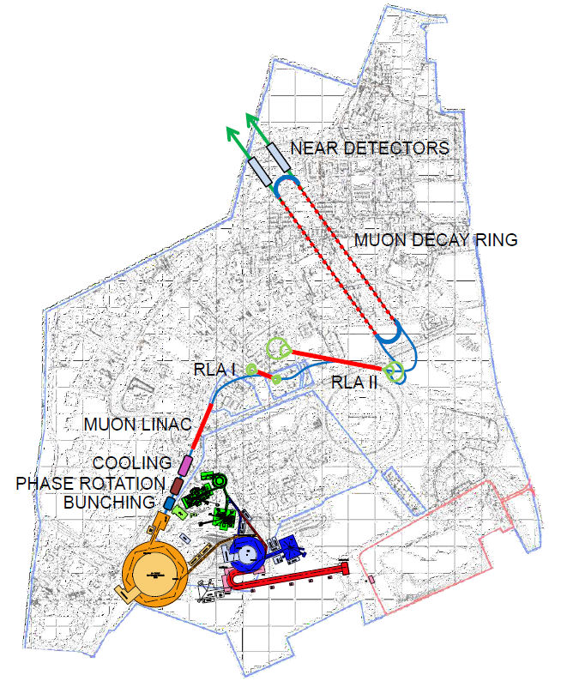
Figure 1. Schematic layout of the NF on the Harwell Oxford site with neutrino beams pointing at Norsaq in Greenland. The conceptual layout of the proton driver is shown with ISIS (green), ≈3.2 GeV RCS (blue), 800 MeV linac (red) and dedicated NF booster (orange).

The site-specific NF design at RAL is in a preliminary stage, and will require extensive effort on beam dynamics and accelerator engineering (and strategic research and development in a number of key areas such as high power front ends, RF systems, stripping foils, kickers and diagnostics) before it can be regarded as viable. The common proton driver could fit onto the RAL site, on land already set aside for large facilities and research expansion, but the complete NF would require the use of part of the Harwell Oxford Campus. A possible schematic layout of the NF on the Harwell Oxford site is shown in figure 1, however MW-class ISIS upgrades are unlikely to be realised in the foreseeable future unless a decision is made to site the NF at RAL, and funding for the common proton driver is forthcoming.

PLANS at CERN

The Neutrino Factory
The CERN NF scenario would be based on the proposed 5 GeV, high-power version of the Superconducting Proton Linac (SPL) [8], which can deliver 10¹⁴ H⁻ ions at a repetition rate of 50 Hz [9]. In the recent past, the SPL study evolved into an international collaboration whose aim is the optimisation of the architecture of a pulsed superconducting high-power proton linac. The most recent design of the SPL and the description of the goals of the collaboration, can be found in [10].
In the CERN scenario, the chopped beam from the SPL would be injected into an isochronous accumulator ring in which 120 ns long bunches are formed without the need for an RF system. The absence of synchrotron motion in the accumulator ring makes it important to study the stability of the beam in the presence of space-charge. As presented in [11], transverse stability can be obtained with a suitable choice of chromaticity and longitudinal stability can be achieved by limiting the longitudinal broad-band impedance to a few ohms. Two-dimensional phase-space painting is used in the stripping injection into the accumulator ring, allowing the temperature of the stripping foil to be kept below 2000 K. The beam parameters after accumulation are obtained as a compromise between the competing requirements of minimising the heating of the injection foil, maximising the aperture, and adequate compensation of the space-charge forces and are set to allow for RF phase-rotation in the downstream compressor ring. The size of the two rings is determined by the requirement that successive bunches must arrive at the correct location in the compressor ring. The compressor ring has a large phase-slip factor, which is needed for the fast phase rotation. Tracking simulations have been performed using the ORBIT code [12], and demonstrate good performance of the compressor ring. The simulations have also been used to investigate the transverse phase space and show that the transverse space-charge can be tolerated due to the limited number of turns of the beam in the compressor ring and the relatively large dispersion, which effectively lowers the tune shift by enlarging the beam size. More details of the CERN proton driver scenario can be found in [13]. The low energy normal-conducting part of the SPL is currently under construction under the name of “Linac4” [14], as part the LHC Injectors Upgrade Project [15] aimed at increasing the LHC luminosity during the next decade. Beam commissioning is planned in 2014-2015, followed by a reliability run. Linac4 will then be available as a replacement for the current proton linac (Linac2) as soon as the PSB has been modified for charge exchange injection at 160 MeV.
Figure 2 shows a preliminary layout of the NF on the CERN site, using the SPL followed by a transfer channel towards the accumulator and compressor rings. This geometry is constrained by the location of Linac4 and the space needed for the muon front-end and muon acceleration chain.

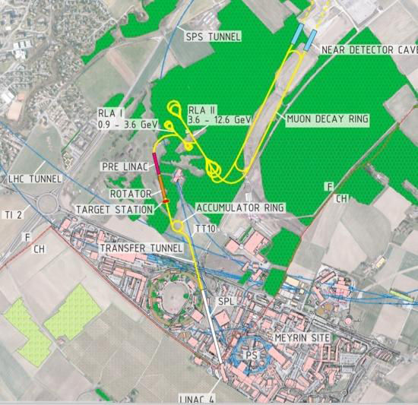
Figure 2. Preliminary layout of the NF on the CERN site, with neutrino beams pointing at the Pyhäsalmi mine in Finland.

Super-Beams And Beta-Beams
As well as provision for the NF, other new proposals are being made for experiments at CERN requiring higher beam power to produce neutrinos by either exploiting the SPS or assuming the construction of a 2 MW, 50 GeV synchrotron using the low-power SPL as the injector, or of the 4MW, 5 GeV SPL-based proton driver.

Neutrino Experiments With Existing Accelerators
The CNGS experiment [16] is currently operating using a 500 kW proton beam from the SPS and sending neutrinos to the Gran Sasso underground laboratory 730 km away. The SPS performance is expected to improve by the end of the decade, as a result of the ongoing upgrade programme of the LHC injectors [15]. The recently started LAGUNA-LBNO Design Study [17] is aimed at making use of the increased SPS beam power, tentatively set at 750 kW, for generating a conventional ν_{µ} beam and sending it to a new underground experiment located in Pyhäsalmi (Finland), at a distance of 2300 km. Beyond the upgrade of the SPS and PS complex which is foreseen in the context of the high-luminosity upgrade of the LHC, this proposal assumes some additional improvements (under study in the context of the LAGUNA-LBNO Design Study) and the construction of a new transfer line from the SPS to a new target area and decay tunnel oriented towards Finland.

Neutrino Experiments Based On The SPL
In the context of the LAGUNA-LBNO Design Study a High Power Proton Synchrotron (HP-PS) is being studied which would deliver 2 MW of beam power onto the target and decay tunnel first used by the SPS and aimed at Pyhäsalmi. The exact energy will be defined in interaction with the experimenters within LAGUNA-LBNO, but is expected to be in the range 30 – 50 GeV. Thereafter the accelerator will be designed using the work done for PS2 [18] [19]. The injector will be a slower cycling and hence lower power version of the SPL. Unlike PS2, the HP-PS will be dedicated to neutrino production and will not be connected to the SPS.
Another possibility is that the SPL beam is accumulated in a 200 – 300 m circumference fixed-energy ring (which does not need to be isochronous as in the NF case), using charge exchange injection. To generate a conventional low energy ν_{µ} beam from π decay, the beam is fast ejected from the accumulator onto the target. In such a scenario, a fraction of the linac beam (≈200 kW) could be diverted to a radioactive ion production system of ISOL-type to generate a beta-beam [20].

References
1. R. J. Abrams et al. IDS-NF-020 (2011).
2. D. J. S. Findlay Proc. PAC’07 (Albuquerque, USA, June 2007) p 695 (2007).
3. C. M. Warsop et al Proc. IPAC’11 (San Sebastian, Spain, September 2011) p 2760 (2011).
4. J. W. G. Thomason et al Proc. HB2008 (Nasville, USA, August 2008) p 434 (2008).
5. D. C. Plostinar et al. Proc. IPAC’11 (San Sebastian, Spain, September 2011) p 2100 (2011).
6. J. W. G. Thomason and J. Pasternak Proc. IPAC’11 (San Sebastian, Spain, September 2011) p 2757 (2011).
7. J. Pasternak and L. J. Jenner Proc. IPAC’11 (San Sebastian, Spain, September 2011) p 2751 (2011).
8. F. Gerigk et al. Tech. Rep. CERN-CERN (2006).
9. R. Garoby Proc. SRF’09 (Berlin, Germany, September 2009) p 930 (2009).
10. F. Gerigk et al. Tech. Rep. CERN-ATS-CERN (2010).
11. E. Benedetto Proc. NuFact’09 (Chicago, USA, July 2009) p 283 (2009).
12. http://neutrons.ornl.gov/APGroup/Codes/orbit.htm
13. R. Garoby Tech. Rep. CERN-NEUTRINO-FACTORY-NOTE-157 (2009).
14. L. Arnaudon et al. Tech. Rep. CERN-AB-ABP/RF and CARE-Note-2006-022-HIPPI (2006).
15. R. Garoby et al. Proc. IPAC’12 (New Orleans, May 2012) p 1010 (2012).
16. K. Elsener ed. The CNGS (Conceptual Technical Design), CERN 98-02 (1998).
17. LAGUNA-LBNO Design Study European Commission 7th Framework Programme - Grant agreement no: 284518 (2011).
18. M. Benedikt, B. Goddard Proc. PAC’09 (Vancouver, Canada, May 2009) p 1828 (2009).
19. R. Garoby Synergies between the needs of LHC, neutrinos and Radioactive Ion Beams CERN sLHC Project Report 0034 (2010).
20. Final report of the EURISOL Design Study EUROPEAN COMMISSION CONTRACT No. 515768 RIDS, http://www.eurisol.org/doc_details.php?operation=download&docu=1075 (2009).

