Imaging of internal density structure of volcanoes with cosmic muon : past and recent works
Seigo Miyamoto*, Hiroyuki Tanaka*, and V. Tioukov**
*Earthquake Research Institute, the university of Tokyo1-1-1, Yayoi, Bunkyo, Tokyo 113-0032, Japan
**Sezione di Napoli, Istituto Nazionale di Fisica Nucleare (INFN), via Cintia, I-80126, Naples. Italy
Abstract. The original idea of radiography by using cosmic-ray muons is very old. The researchers have been tried to find something hidden in various structure. Unfortunately they couldn't find anything new at that time. Meanwhile the muon detection technology has been highly developed till today. The first successful work was done by Tanaka et al (2007). They also succeeded to detect the internal structure of the shallow conduit in an active volcano, Mt. Asama. They have been succeeded to make the internal image of several volcanoes in Japan. The most recent innovative work was the observation of the seismic fault zones in Itoigawa-Shizuoka Tectonic Line by Tanaka et al in 2010. The plastic scintillator bar and photo multiplier array detected another hidden fault. The decreases of muon flux and time delay in a certain part of the fault outcrop in rany days were also observed. I will give a review of the past and recent works of muon radiography.
Keywords: muon, radiography, volcanology, cosmic-ray, scintillation detector, nuclear emulsion
PACS: 96.50.S-, 29.40.Rg 91.40.-k, 14.60.Ef, 29.40.Mc

Introduction
The cosmic-ray muons are produced by the interactions of primary high energy protons and the molecules in the sky. The energy peak is 1 GeV at the zenith angle = 0 degree and the flux decrease with E^{-2.7}. The high energy cosmic-ray muon can penetrate the rock which has the thickness more than 1 km. So it is possible to make the internal structure of big material by detecting the attenuation of cosmic-ray muons and the researchers have been tried to find something hidden in a big material[1]. Meanwhile, the muon detection technologies have been developed in high energy physics. That makes the recent innovative works especially for imaging the internal structure of volcanoes.

The principle of muon radiography
One of the easy solutions to understand the basic principle of muon radiography is to see the analogy with X-ray examination. X-ray generator is correspoinding to cosmic-ray muons, the human body is correspoinding to the target material to be clarified the internal structure of it, and the X-ray film is corresponding to the muon detector.
The following is the procedures to make a projected average density map of the target material:
- Make the muon path length map in the target material in various azimuth and zenith angle direction. The detector position, direction measured by GPS or the gyro and the degital elevation map is typically used for caliculate the muon path in the case of volcano imaging.
- Measure the number of the penetrating muon and calculate the muon attenuation ratio in each direction.
- The muon energy spectrum and the energy deposit in each energy and the material are well known. So we can calculate the range, which is density times muon path length( FIGURE 1. ).
- The projected average density is determined by (range)/(muon path length).

The features of muon detectors
There are two types of detectors roughly, which is sensitive for the minimum ionization particles. The first is electronic detectors, for example scintillator + PMT array(FIGURE 2.), gas detector, silicon detectors, so on. The second is photo graphic detector, which is called nuclear emulsion([2], FIGURE 3.) and high speed muon track readout systems[3]. The features of these two detectors are tabulated in TABLE 1. The main defferences are the necessity for electricity and the real-time monitoring is available or not. The nuclear emulsion film detector doesn’t need electricity, while real-time monitoring is not avalable. The time information can be added to nuclear emulsion film detector [4].

TABLE 1. The advantages and dis-advantages of Electronic detectors and photographic detectors for muon radiography.
Column Header Goes Here | Electronic detector | Photographic film detector
Power supply | Need electricity | No electricity
Portability | need large space | compact
Stability for environment | Need protection for water and shock | Stable for shock, water and low temperature,  but unstable in more than 25 C
DAQ | Real time monitoring | Need development and analysis by readout system
Spread of the technology | High | Low

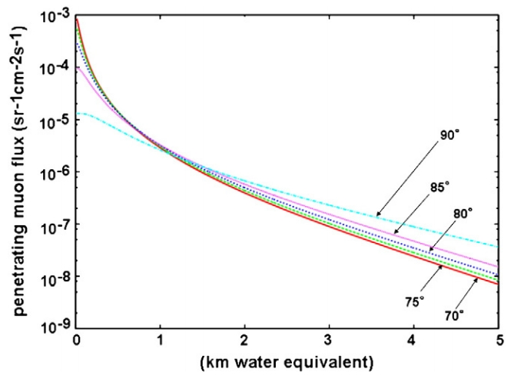Figure 1. Integratedflux of cosmic-ray muons at various zenith angles penetrating through a given thickness of rock. The thickness is given in km-water-equivalent.

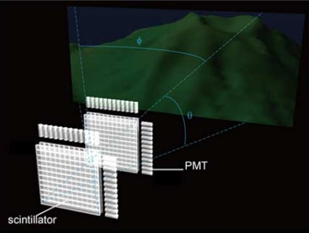
Figure 2. The conceptual diagram of detecting muon by scintillator array + PMT.

Recent works

The first successful result of muon radiography
The first successful work was done by Tanaka et al., they succeeded to observe the shallow conduit in an active volcano, Mt. Asama(2007)[5,6,7]. They placed the 0.2m² nuclear emulsion detector in the small room one km far from the creator for 2 months. The image of the dense rock in the cap of the conduit and lower density below the cap, which is thought as drain back phenomenon was observed.

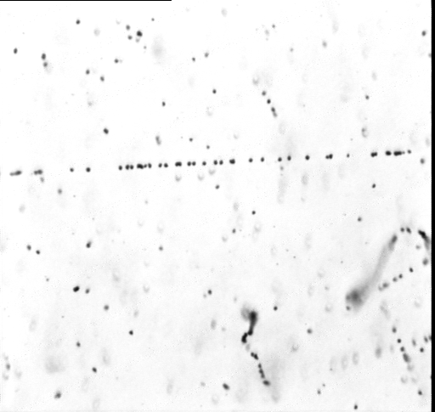 Figure 3. The microscopic view of the nuclear emulsion film. The field of view is about 150 micron horizontally and 100 micron vertically. The aligned grains passes through the center of picture horizontally is the trajectory of muon. The curved trajectory is sevel hundreds keV of electron.

The imaging of volcanoes by muon radiography
They also succeeded to observe the internal structure of lava dome in Showa-shinzan(2007)[8]. There was some lava dome growth model theories [9] before this observation.
Satuma-Iwojima is an active volcano located in the south part of Japan. The one of main features volcanologists were interested in is the continueous gas emittion during more than 10,000 years. Some of them made the magma convection model in the conduit. The water rich magma is less dense than water poor magma. That makes the magma convection in the conduit and when the pressure decreases, they start bubbling and emit volcanic gas. Tanaka et al observed the lower density reigion in this volcano, which is the magma bubbling part[10].
The stereo graphic observation is possible also in muon radiography. The unknown parameters exists when we see the 3D object by just two directions projections, so there should be some assumption for the numerical model to solve the 3D density structure map. Taira et al succeeded to make 3D density map for
Mt Asama[11].
The gravity measurement is one of probe to see the density structure in the ground. The common point for muon radiography and gravity measurement is sensitivity for the density. So the joint 3D density map inversion is possible by using muon radiography data and gravity measurement data. Nishiyama et al achieved to apply this method for Mt. Showa-Shinzan in 2012.

The hidden fault search and rainfall water monitoring
The observation of the fault along Itoigawa-Shizuoka Techtonic Line(ISTL) was one of most innovative recent works[12]. ISTL is a one of largest fault in Japan. There is a known fault outcrop in Itoigawa and we can see the fault directly, however it’s not parallel to ISTL. The main purposes of this observation are (1) to measure the detail information about fault already known. For example, the width of crushed zone, the porosity, and the permeability and whether they change with depth and (2) to discover another fault hidden around this region.
The 0.4m² scintillator array was located 6 m from the fault outcrop for two weeks. The results were the following:
- The width of crushed zone in the fault is about 20m and the porosity is about 20%.
- The time dependence of the density in the fault was observed(FIGURE 4.). This data clarify the permeability of this fault.
- Another hidden falut parallel to ISTL was found. The width and the permeability are similar with pre-existed fault.
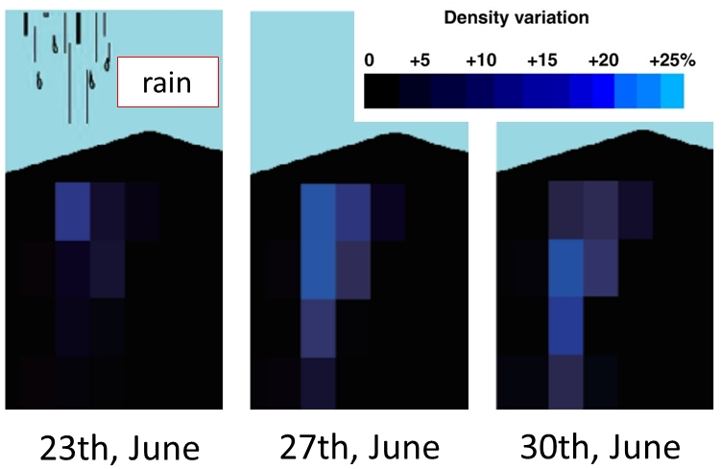
Figure 4. The time dependence of density variation in the fault before and after rainfall. The brighter blue represents the more dense part, which is due to rainfall water immersion.

Going-on projects

Imaging of latest lava dome in Mt. Unzen, Japan
The lava dome in Mt. Unzen was formed in the eruption from January 1991 to early 1995 and the activity calmed down in 1995. The researchers kept to observe the eruption in this period precisely[13,14,15]. Some of them proposed the lava dome growth model, another person proposed different model from their data[16,17]. It is significant for the growth model of lava dome which has viscous magma to investigate the density structure in it. The observation of the lava dome density 2D map was performed by using cosmic-ray muon and muon detector in Unzen. The muon detector, nuclear emulsion films which has high position resolution and 0.8m² effective area, was installed in a natural cave from early December 2010 to the end of March. The developed nuclear emulsion films have been scanned by automated muon readout system[18]. The muon detection efficiency is estimated from muon detector it precisely. The systematic analysis of efficieny and random noise ratio are performed by taking a pattern match and making a connection of muon tracks between three films. After estimation and removing unwated low energy electron tracks, the density map of Unzen lava dome we got as a preliminary result(FIGURE. 5).

The imaging internal density structure of shallow conduit in Stromboli, Italy
Stromboli is one of the Aeolian Islands, which is located at a volcanic arc north of Sicily Island Italy. 1m² nuclear emulsion films were installed at the site which is 500m far from active volcanic conduit and was exposed for about 5 months. The shape of volcanic conduit is critical information to the study of the dynamics of eruption. The films were developed and we started to analyze them in the beginning of May 2012. Scanning and analysis of about 10% of data demonstrated that the data are of a good quality and the mountain profile is clearly visible as very preliminary result( FIGURE 6.).
The full data set is expected to be scanned and analyzed to the end of the year. More realistic MC and precise positioning information can be necessary for the data interpretation.

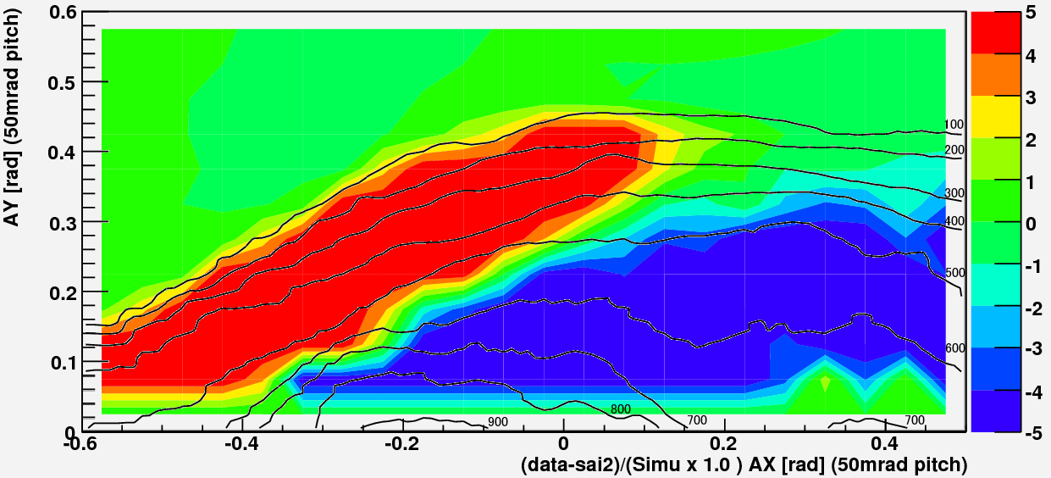
00
00
00
00
00
00
00
0000
00
Below %
zero is the spine direction Tan(azimuth) (rad)
Above %

Figure 5. Preliminary muon excess anomaly ratio from the expected number of muons when we assume the density 2.5g/cm³ uniform are represented as color variation in each direction by using 16% of effective area data. The red color region means more muons and the blue color region means less muons than expected. The blue color region doesn’t have enough statistics.

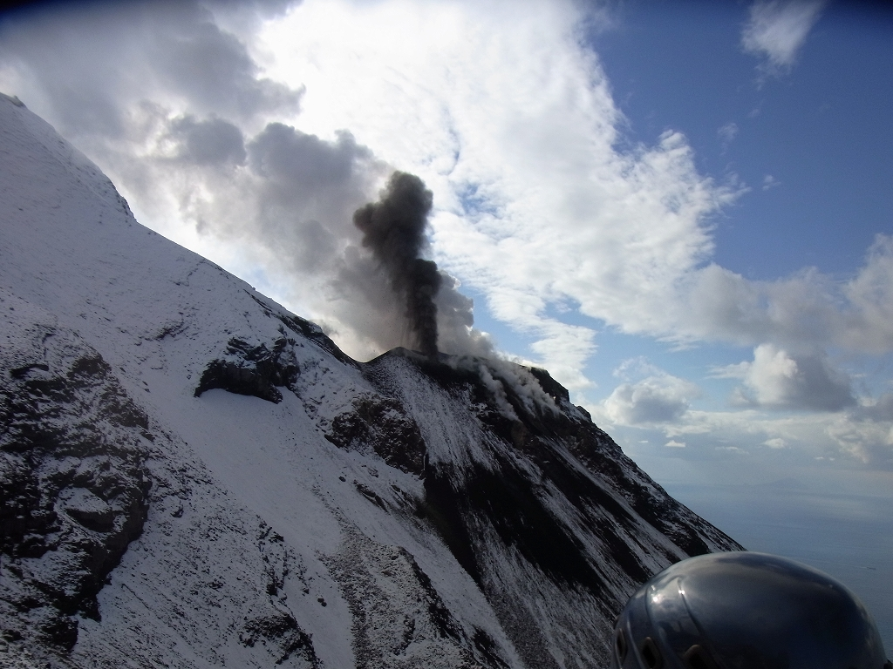
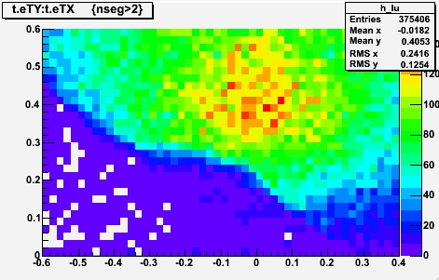
Figure 6. The photograph from detector place to the Stromboli vent is shown in the upper row and the number of detected muons is plotted in the lower row as very preliminary result.

Acknowledgments
The authors are deeply indebted to N. Nakamura and N. Naganawa of Nagoya University and H. Shimizu and T. Matsushima of Kyushu University for their valuable contributions. The Unzen lava dome and the Stromboli conduit observation was not done without P. Strolin, G. De Lellis, and V. Tioukov of the University of Napoli and C. Bozza of the University of Salerno, Italy. Special funding arrangements by S. Okubo and related people of ERI are acknowledged.

References
1. L.W. Alvarez, et al., Science 167 (1970) 832.
2. T. Nakamura et al., Nuclear Instruments and Methods in Physics Research A, 556, (2006) 80.
3. K. Morishima and T. Nakano, JINST Volume: 5 Article Number: P04011, 2010.
4. S. Aoki et al., ADVANCES IN SPACE RESEARCH, Vol 37, (2006)2120.
5. H. Tanaka at al., Earth and Planetary Science Letters 263 (2007) 104–113.
6. H. Tanaka at al., Nuclear Instruments and Methods in Physics Research A 575 (2007) 489–497.
7. H. Tanaka et al., American Journal of Science, Vol.308, P.843–850, September, 2008.
8. H. Tanaka et al., GEOPHYSICAL RESEARCH LETTERS, VOL. 34, L22311, (2007).
9. I. Yokoyama , Proc. Japan Acad., 78, Sec B Vol. 78(B), (2002)
10. H. Tanaka et al., GEOPHYSICAL RESEARCH LETTERS, VOL. 36, L01304, (2009).
11. H. Taira et al., JOURNAL OF GEOPHYSICAL RESEARCH, VOL. 115, B12332, (2010).
12. H. Tanaka et al., Earth and Planetary Science Letters 306 (2011) 156–162
13. T. Umakoshi et al., Journal of Volcanology and Geothermal Research 175 (2008) 91–99
14. H. Sato et al., Nature 360, 664 - 666 (17 December 1992).
15. S. Nakada et al., Journal of Volcanology and Geothermal Research Vol. 54, Issues 3–4, January 1993, Pages 319–333
16. S. Nakada et al., Geology; February 1995; v. 23; no. 2; p. 157–160
17. K. Ohta, Chinetsu, vol.33 No.4 1996
18. C. Bozza et al., Nuclear Instruments and Methods in Physics Research A 568 (2006) 578–587

